Year 4 Remote Learning Autumn
English
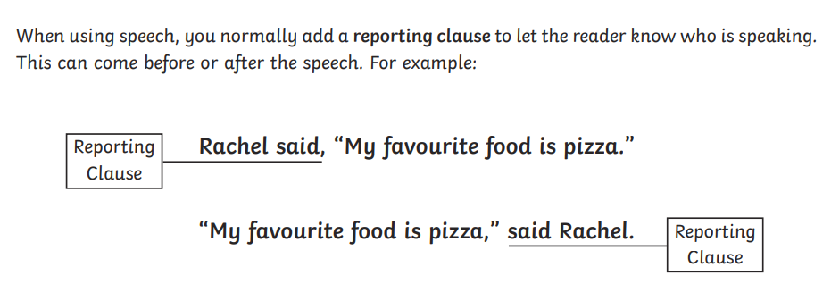
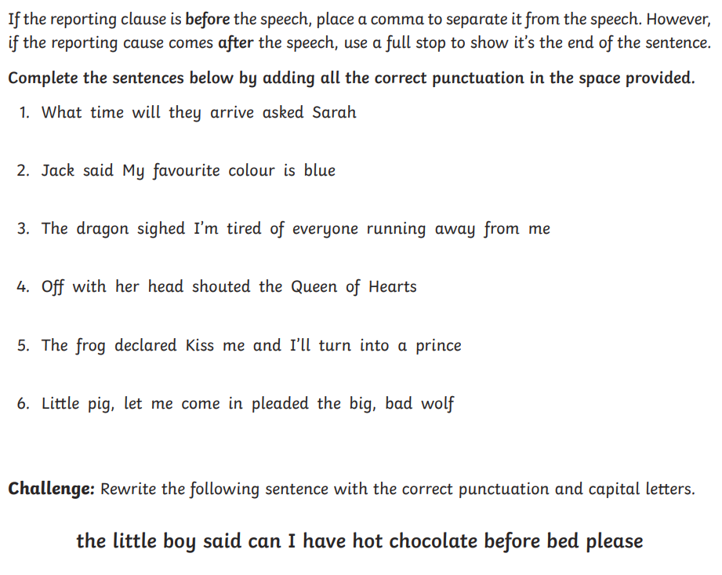

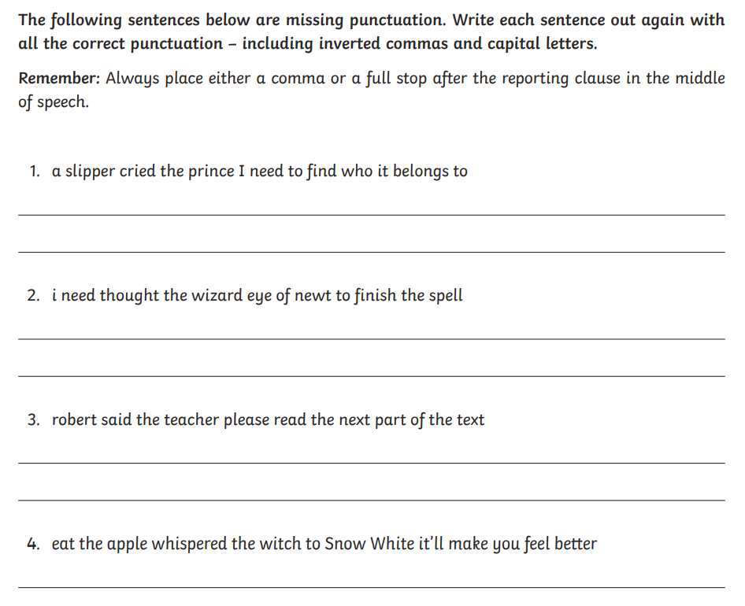
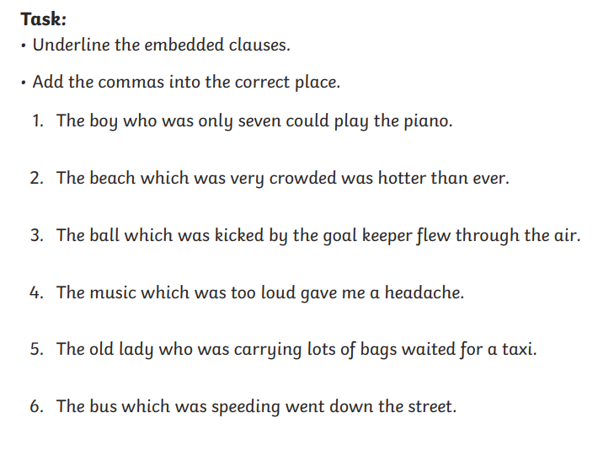

Maths

Column addition / subtraction:
345 + 139 =
458 + 123 =
987 – 457 =
450 + 450 =
673 – 658 =
Column method for multiplication:
25 x 8 =
36 x 4 =
85 x 6 =
91 x 4 =
Bus stop method for division:
369 ÷ 3 =
424 ÷ 4 =
856 ÷ 4 =
791 ÷ 5 =

Science
Think of your favourite animal. Describe its natural habitat. Create a food chain for your animal, explaining how it gets its energy from food.
Label the producer.

Topic
Imagine you are an Ancient Roman reporter. Write a newspaper report about what you have watched at the Colosseum.

Spelling

How many words can you think of with these prefixes:
Inter-
Anti-
Auto-

