


Year 2 Isolation Pack
This is your home learning pack during your isolation period.
It contains 14 days of work for Writing & Maths plus 4 Science and 4 Topic activities.

Maths
DAY 1 – Counting Forwards and Backwards within 20
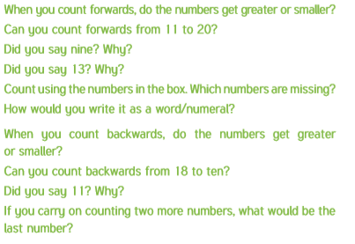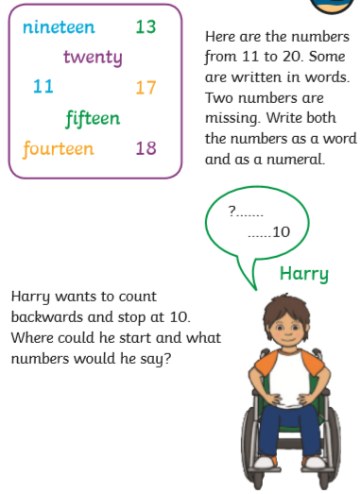
DAY 2 – Tens and Ones within 20
Task 1: Task 2:
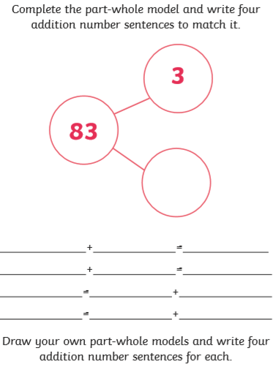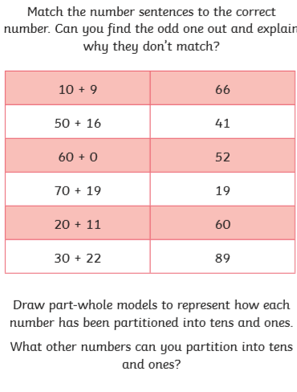

DAY 3 – Counting Forwards and Backwards within 50
Task 1: Task 2:
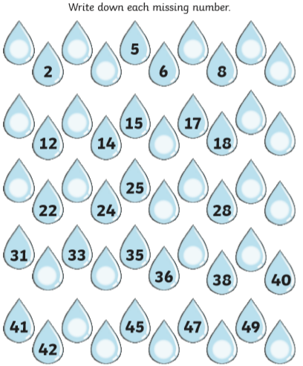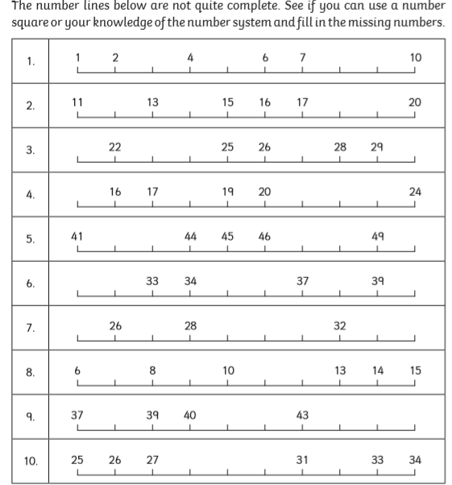

DAY 4 – Tens and Ones within 50
Task 1: Task 2: Which parts do you know? 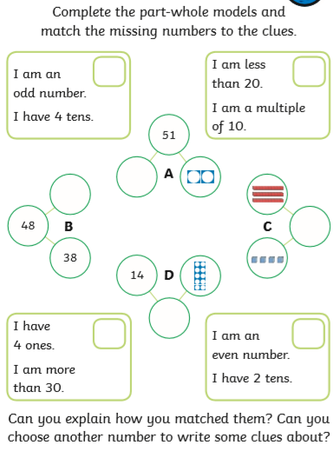 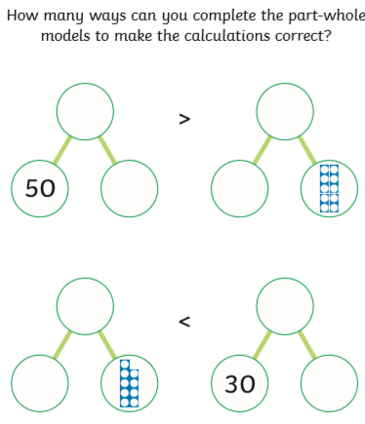

DAY 5 – Compare Numbers within 50
Task 1: Task 2:

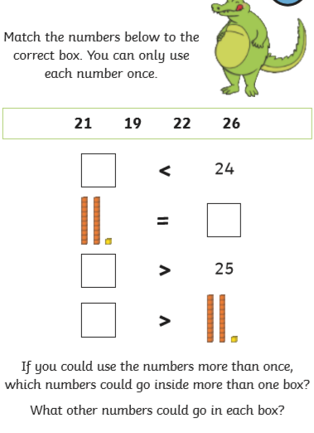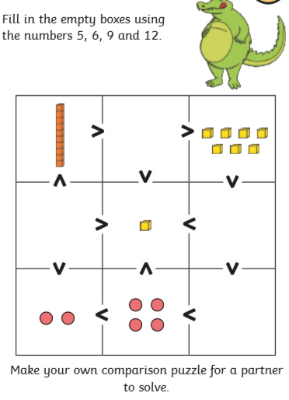
DAY 6 – Count Objects to 100
Task 1: Task 2:
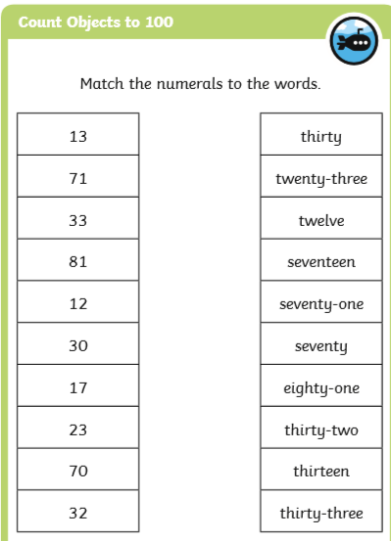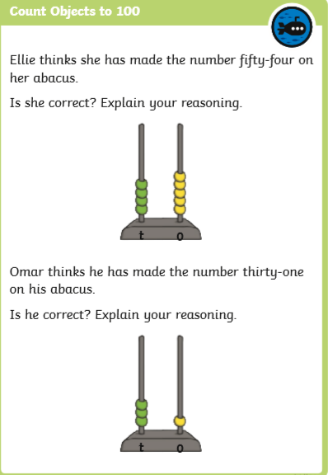

DAY 7 – Read and Write numbers to 100 in numerals and words
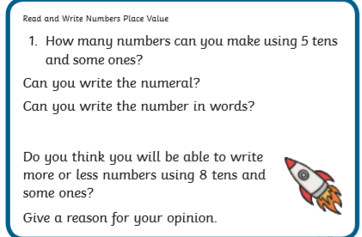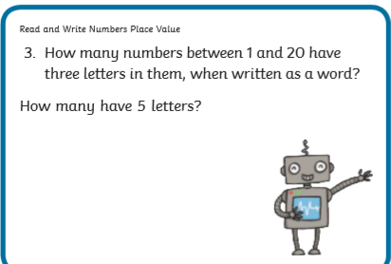
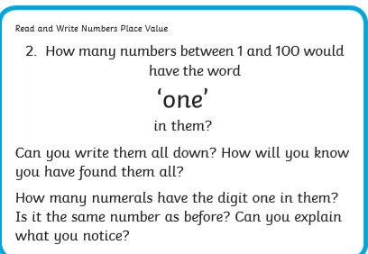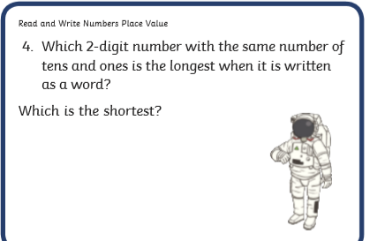

DAY 8 – Represent numbers to 100
Task 1: Task 2:
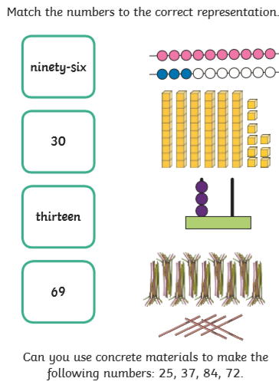
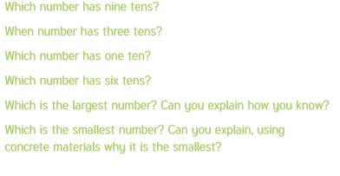

DAY 9 – Represent numbers to 100 (2)
Task 1: Draw circles in the tens frame to represent the number on the egg Task 2: Draw an arrow to show the following numbers on the
basket. Write the number in words. The first one has been done for you. 0-100 number lines.
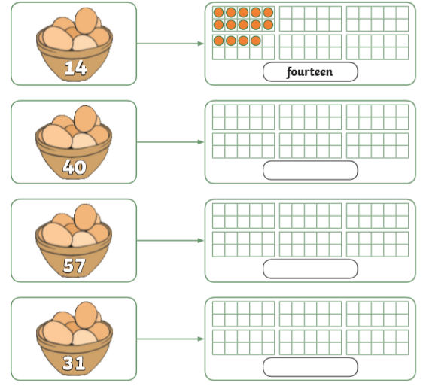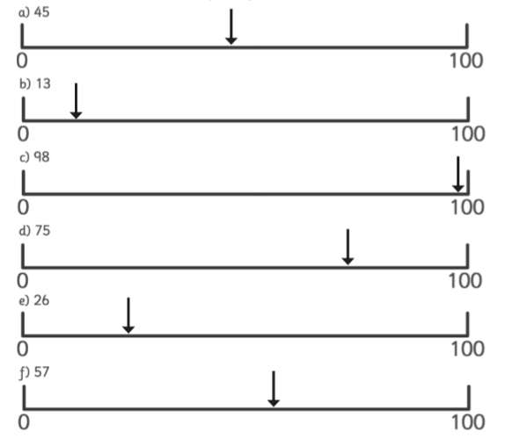

DAY 10 – Tens and Ones using a part-whole
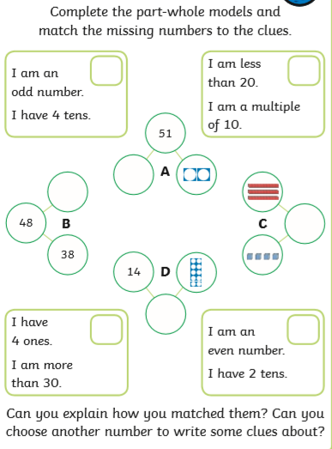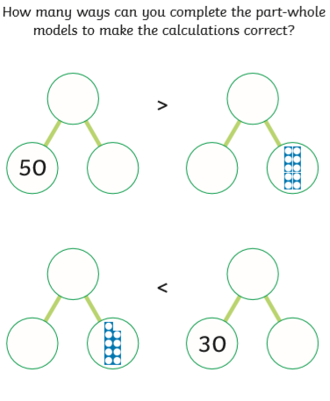

DAY 11 – Tens and Ones Using Addition
Task 1: Task 2:
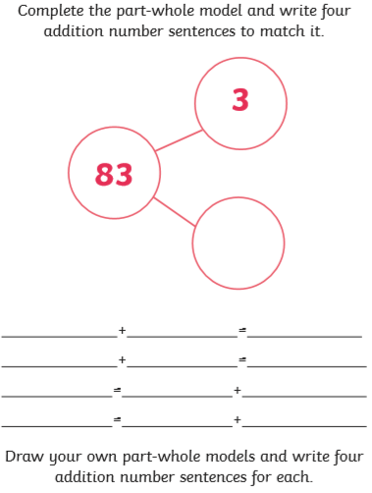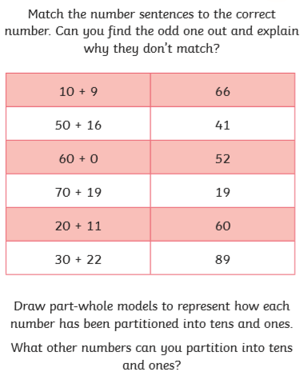

DAY 12 – Using a place value chart
Task 1: Task 2:
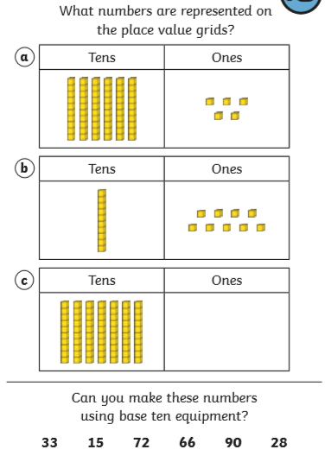
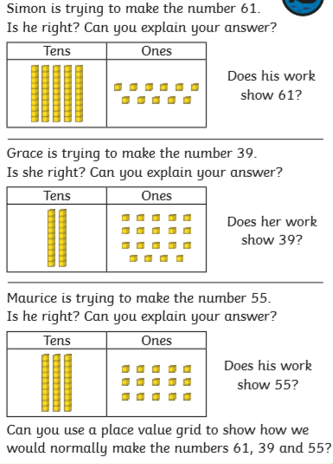

DAY 13 – Compare Objects
Task 1: Task 2: 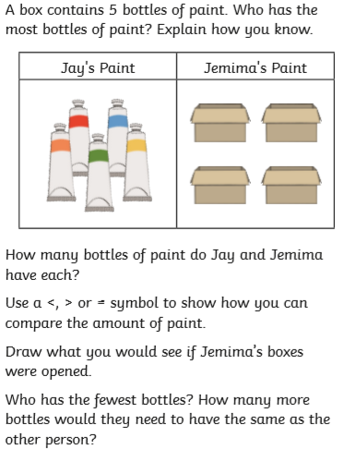 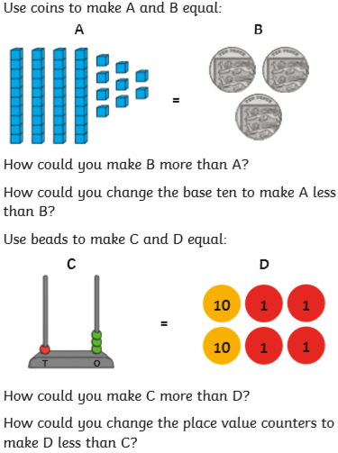

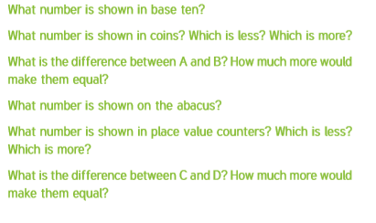

DAY 14 – Compare Numbers
Task 1: Task 2:
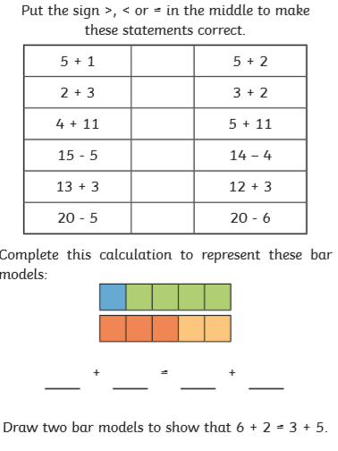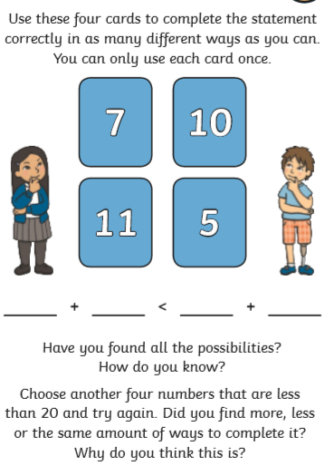

Writing

DAY 1: Comprehension
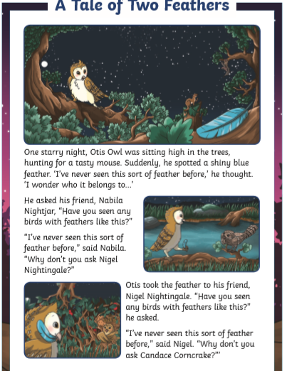
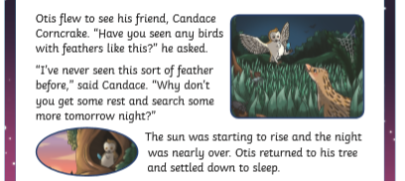

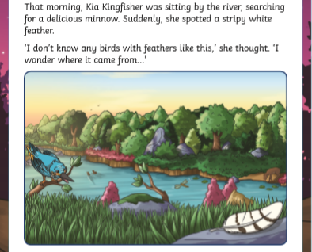
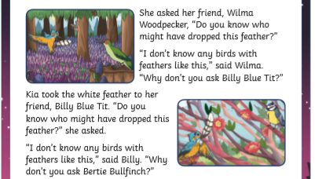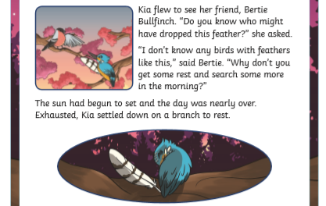
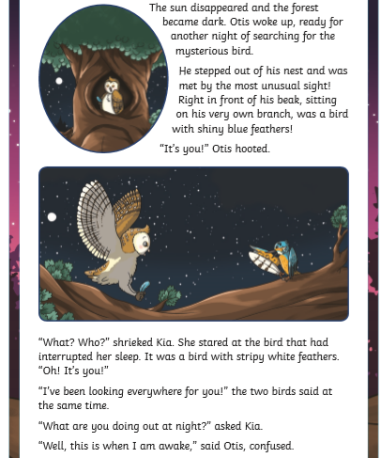
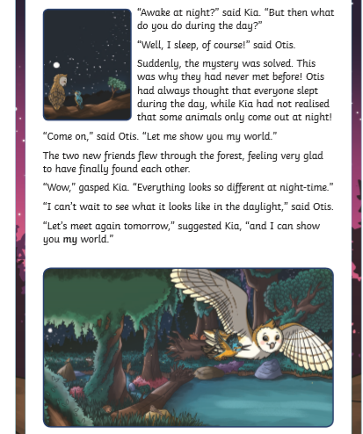
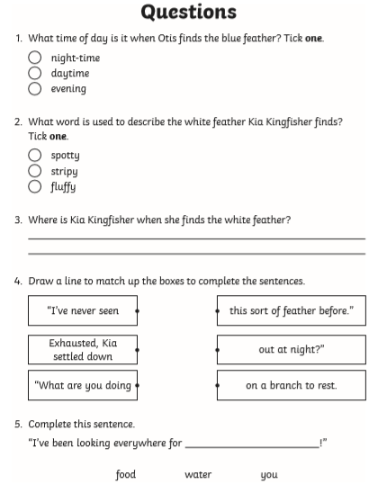
Challenge: Write a sentence to explain what nocturnal means. Then write a list of nocturnal animals.

DAY 2: Stories with a Familiar Setting
Book Focus: The Tiger Who Came to Tea by Judith Kerr
https://youtu.be/Lok2QdctuCg Listen to the story and see the book online.
Task: Cut out the pictures and sequence them into the correct order to show what happened in the story. Write sentences to describe what is happening in each picture.
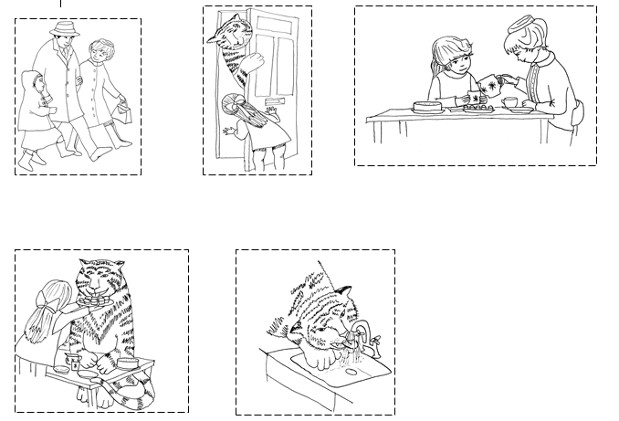


In your own words, explain if you like the story The Tiger Who Came to Tea:

DAY 3: Stories with a Familiar Setting
Book Focus: The Tiger Who Came to Tea by Judith Kerr
https://youtu.be/Lok2QdctuCg Read or listen to the story again.
Task: Here is the beginning of a story map for The Tiger who Came to Tea. Use the remaining space or your workbook to complete the story map.
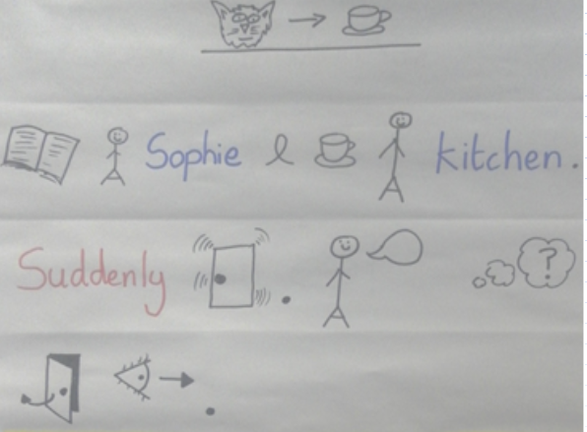

DAY 4: Stories with a Familiar Setting
Book Focus: The Tiger Who Came to Tea by Judith Kerr
https://youtu.be/Lok2QdctuCg Read or listen to the story again.
Task: Look at the pictures and think about what the characters might be thinking or saying. Write sentences to show what the characters say or think.
Sophie’s Mummy:

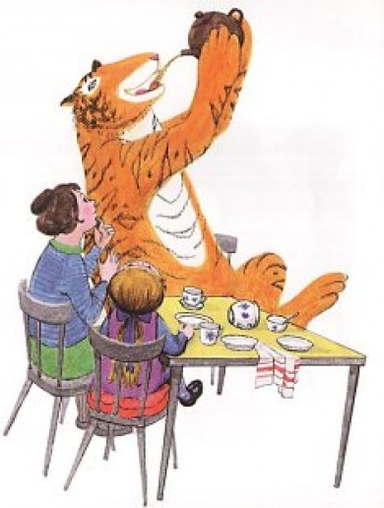

Sophie:
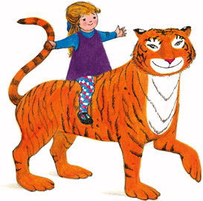

Tiger:

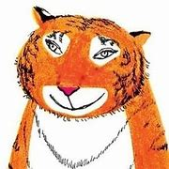
DAY 5: Stories with a Familiar Setting
Book Focus: The Tiger Who Came to Tea by Judith Kerr
https://youtu.be/Lok2QdctuCg Read or listen to the story again.
Task: Write an invitation to your friends. Ask them to come to your house for a tea party! You will need to include: Date, Time, Place, Dress Code and a Menu.
Invitation:
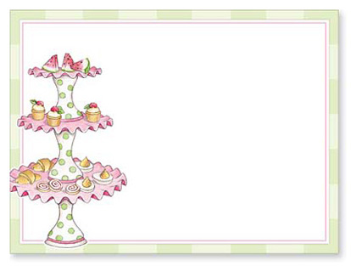
Menu: 
DAY 6: Stories with a Familiar Setting
Book Focus: The Tiger Who Came to Tea by Judith Kerr
https://youtu.be/Lok2QdctuCg Read or listen to the story again.
Task: Imagine you have just sat down to tea with your Mummy and the door bell rings. What character has come to visit you? What happens? Write your own story!
Planning:
Characters – Mummy, You, __________________
Setting – Kitchen
My story map:
My story:

DAY 7: Traditional Tales
Book Focus: The Ant and the Grasshopper
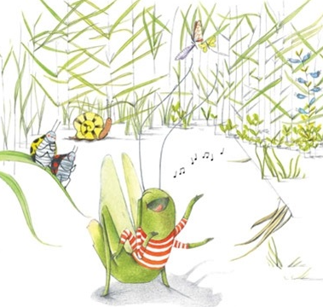
It was a glorious summer’s day. Grasshopper chirruped and sang sunny songs. Any was too busy to sing. He huffed…….and he puffed……..and he g-r-o-a-n-e-d…..as he hauled food away to his winter store.

Grasshopper smiled and lay back on a leaf, drowsy and dozing in the sun. After a while, he called out to Ant, “You’re working too hard!”
“I have to,” Ant panted “There’s so much to do, I must collect all this food for the winter”.
“But winter is ages away”, said Grasshopper “Enjoy the sunshine while you can!”
“Winter mat seem ages away,” replied Ant, “but it will come all too swiftly. If you don’t work now…..why, when the Sun has long gone and the Earth is sleeping, you will be cold and hungry.”
Grasshopper laughed and sang on. Ant huffed……and he puffed……and carried more corn.

Sure enough, winter crept over the Earth. Trees stood bare against the bleak sky. Snow dusted the fields. Tucked up snug in his little home, Ant looked at his food store and smiled. He had boxes galore, plenty to keep him fed until spring buds blossomed.

Outside, in a blustery gale, Grasshopper scrunched himself up, trying to shelter behind a leaf. But the wind blew through his trembling body, however tightly he curled. His tummy ached with hunger. At last, he fought through the wind to Ant’s house. “Ant! Help!” Grasshopper shouted.

Ant poked his head outside his door. “Grasshopper! You look frozen” he cried. “Come inside and get warm”.

“Thaw out by the stove” said Ant, “and I’ll make supper”.

Grasshopper beamed. He could almost taste the toasted corn already.

“Thank you kind, clever Ant,” he said, basking in the heat of the flames. “I promise, next summer, I’ll work too!”

DAY 8: Traditional Tales
Book Focus: The Ant and the Grasshopper
Task 1: Read the traditional tale then complete the activity.
My views about Ant and Grasshopper: __________________
_____________________________________________

I think________________________________________
_____________________________________________

because_______________________________________
_____________________________________________

Task 2: Create a story map for The Ant and the Grasshopper.

DAY 9: Traditional Tales
Book Focus: The Ant and the Grasshopper
Task: Today we explore the vocabulary used in the traditional tale.
Cut out the words and match the word to the correct picture to explain its meaning.
chirruped | swiftly | hauled | bleak
blustery gale | galore | snug | drowsy
stove | basking

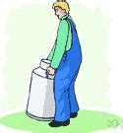
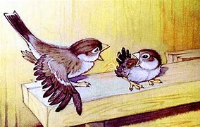
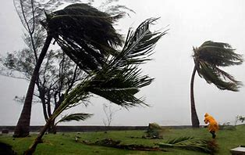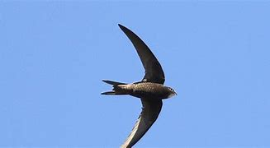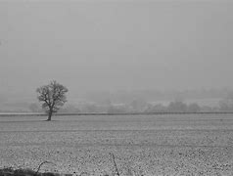
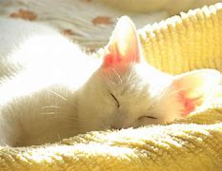
Chirruped means: _______________________________________________
_______________________________________________
Hauled means:
_______________________________________________
_______________________________________________
Drowsy means:
_______________________________________________
_______________________________________________
Bleak means:
_______________________________________________
_______________________________________________
Snug means:
_______________________________________________
_______________________________________________
Galore means:
_______________________________________________
_______________________________________________
Blustery gale means:
_______________________________________________
_______________________________________________
Stove means:
_______________________________________________
_______________________________________________
Basking means: _______________________________________________
_______________________________________________
DAY 10: Traditional Tales
Book Focus: The Ant and the Grasshopper
We are going to follow the structure of this traditional tale to rewrite our own story called The Frog and the Scorpion
Task: Today we are going to explore the characters of the frog and the scorpion. Decide who is working hard and who does not help. Then complete the speech bubbles to show what the characters are thinking and saying. 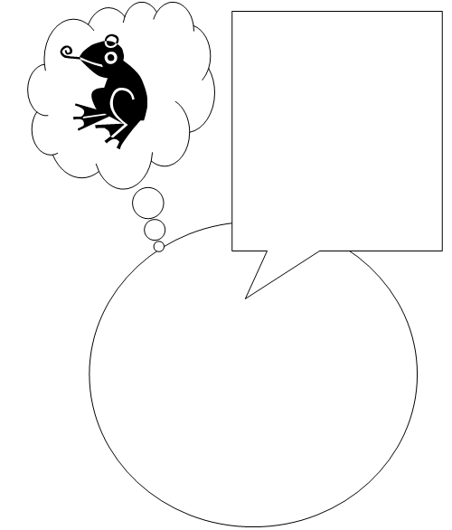
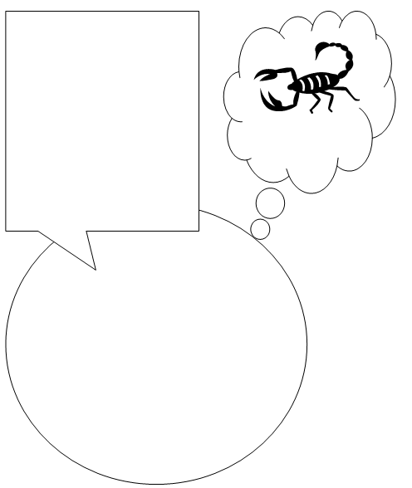
DAY 11: Traditional Tales
Book Focus: The Ant and the Grasshopper
Task: Today we will explore our two characters Frog and Scorpion. Draw what these 2 characters look like and write words to describe what they look like and what their characters are like.


DAY 12: Traditional Tales
Book Focus: The Ant and the Grasshopper
Task: Today we will begin to plan our own fable by creating a story map. What lessons did the ant and the grasshopper learn in the story? Your two characters (Frog & Scorpion) will also need to learn a lesson as this is the purpose of a fable.
Story Map
The moral of my story is going to be:

This is what happens:

DAY 13 & 14: Traditional Tales
Book Focus: The Ant and the Grasshopper
Task: In these next 2 sessions you need to follow your story map to write your own fable.

Science – 4 Tasks
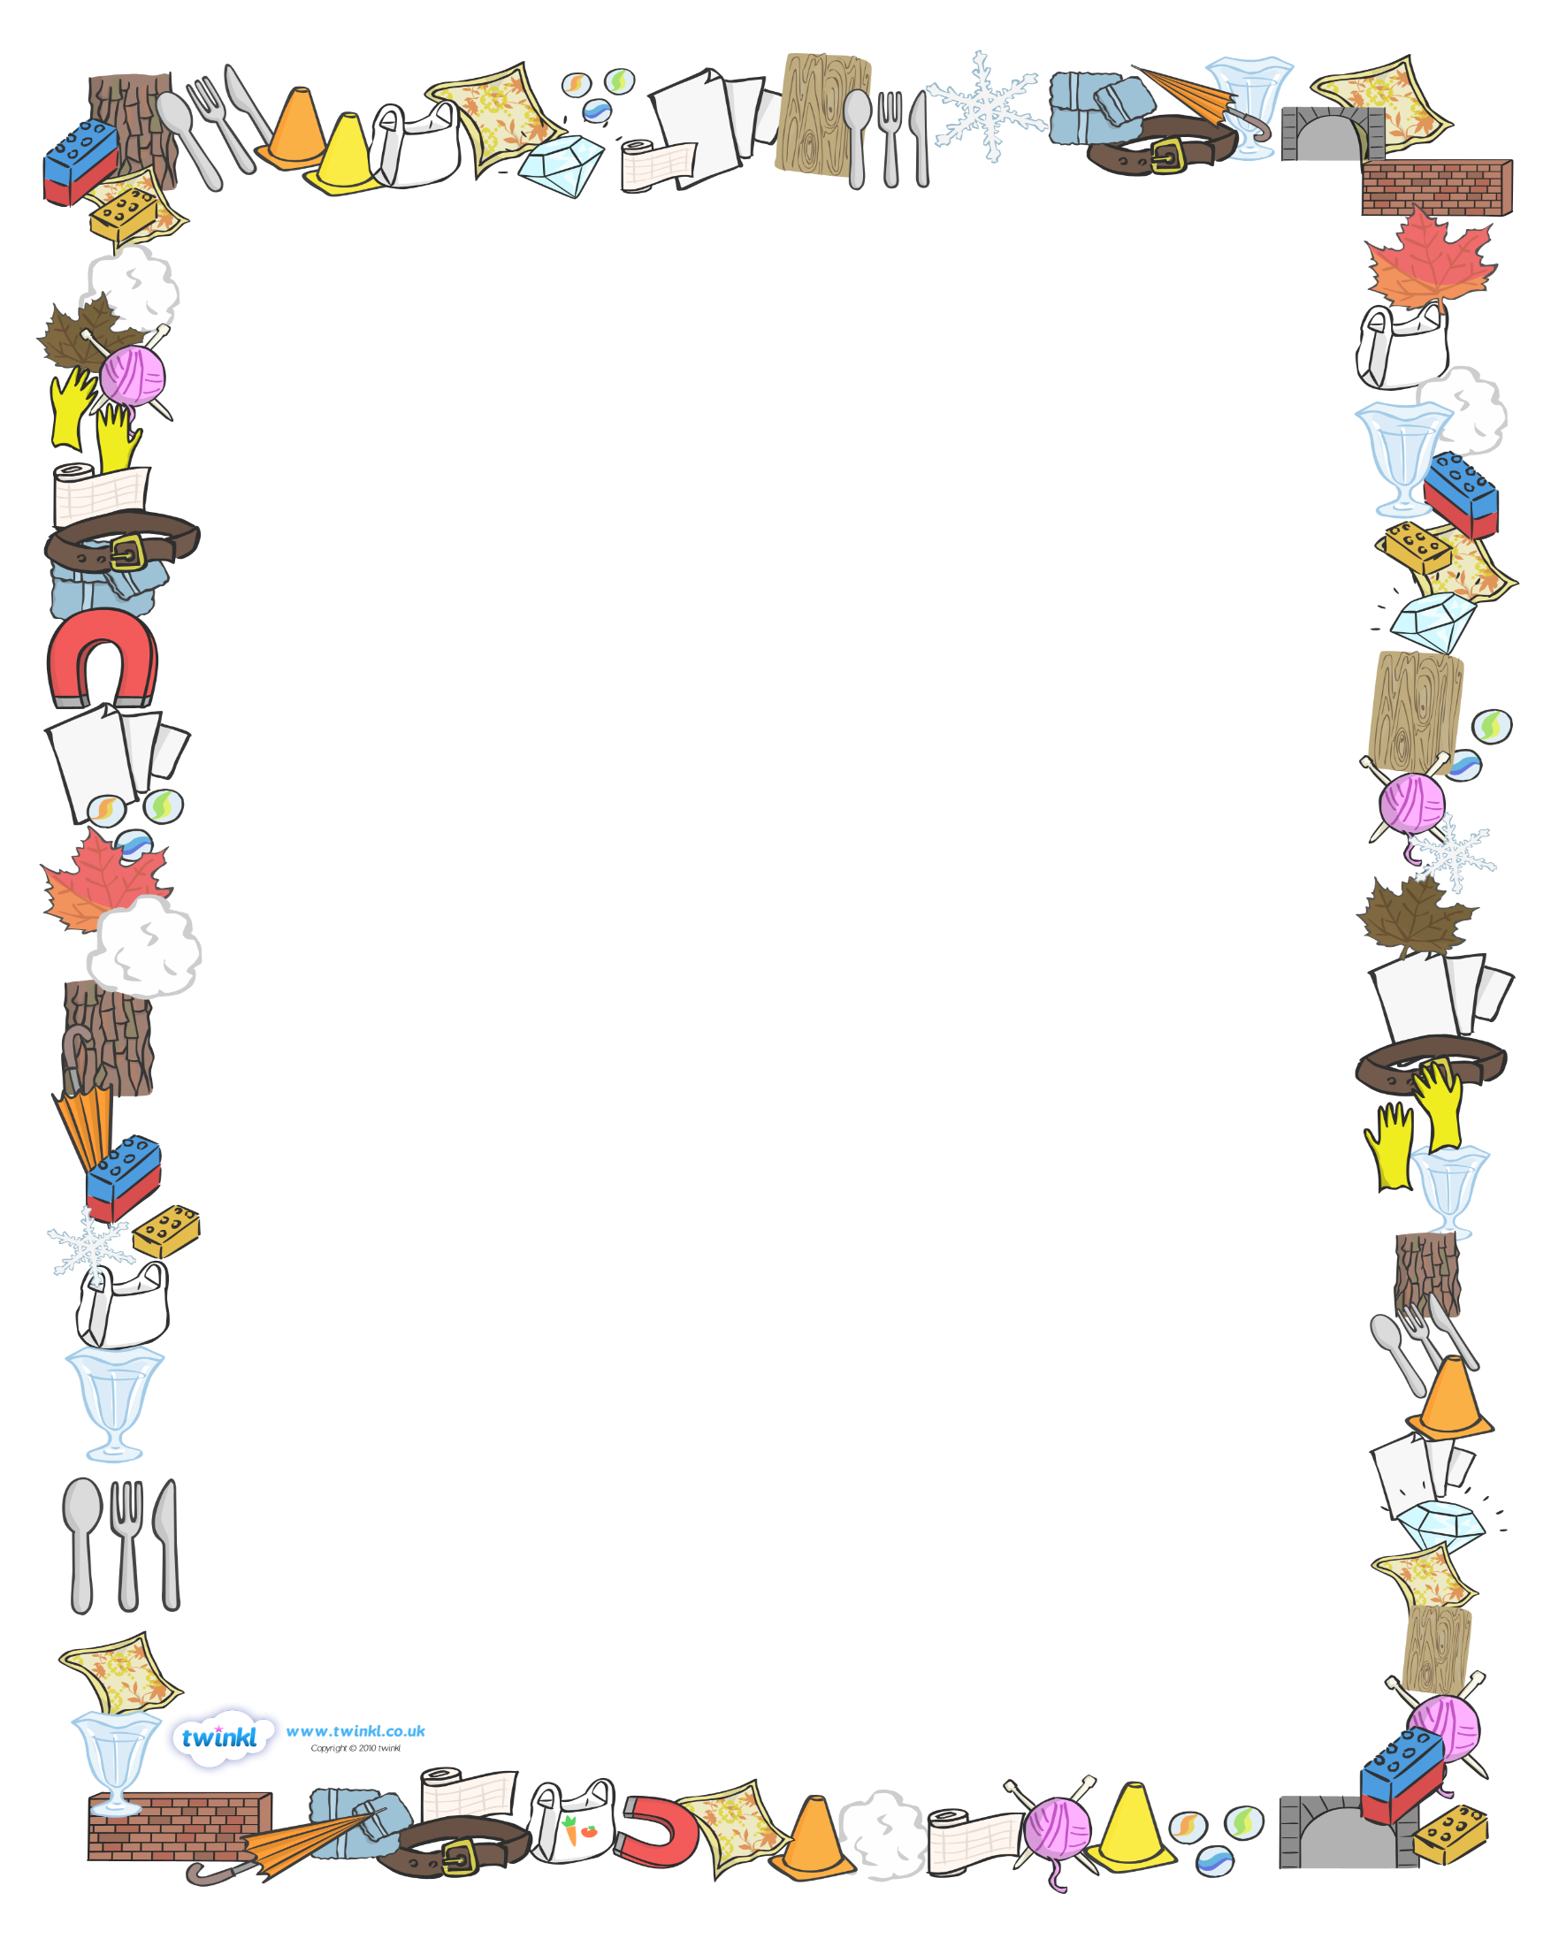
Task 1: To identify everyday materials

Look at objects below and label them with the correct material. Use the word bank to help you.

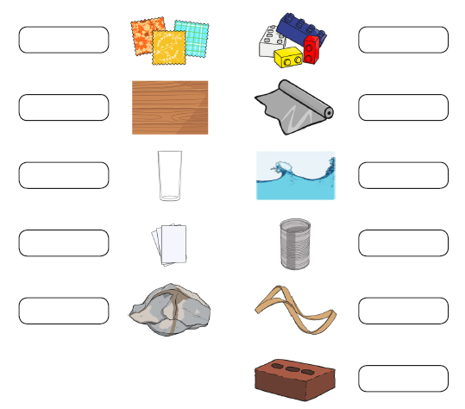
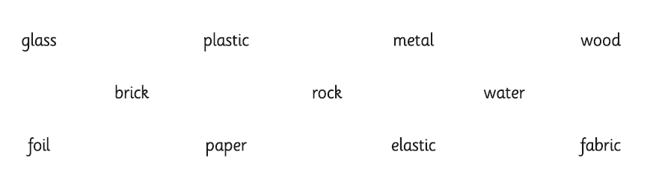

Task 2: To compare the suitability of materials
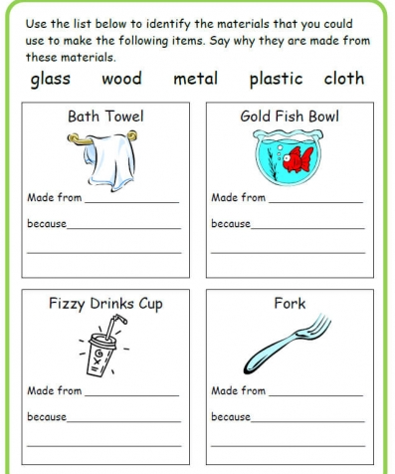
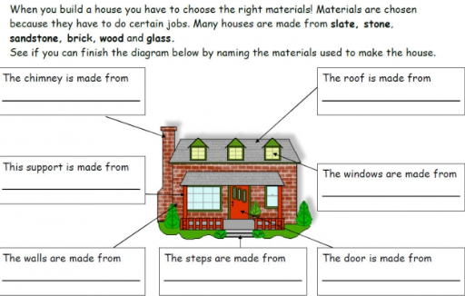

Task 3: To understand the properties of materials
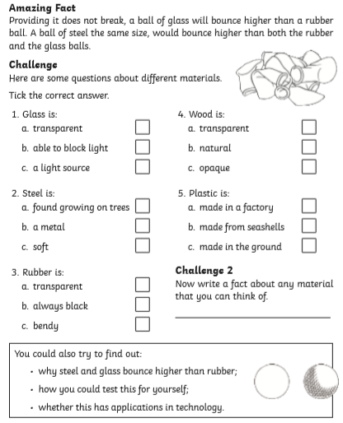
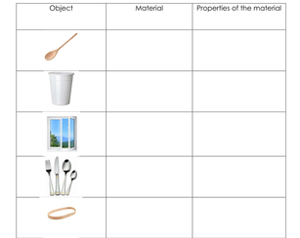
Task 4: Find materials around the house 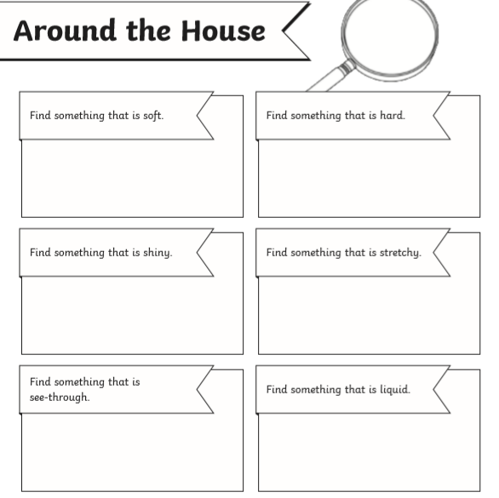
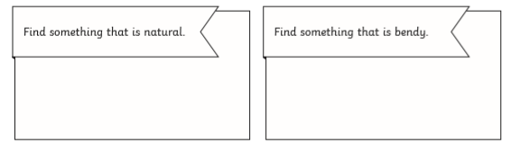

Topic – 4 Tasks
Task 1: To understand and sequence the story of Grace Darling
https://www.bbc.co.uk/teach/class-clips-video/true-stories-grace-darling/z4y7pg8
Watch the video of Grace Darling retell her life story and describe the night she and her father rowed out in their boats to rescue nine sailors.
Discuss with your adult: What do you think life for Grace was like, living in a lighthouse?
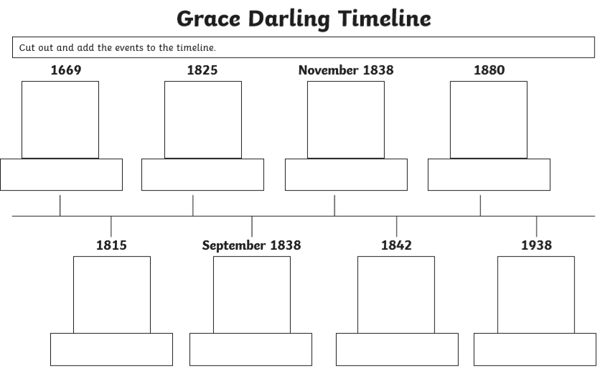
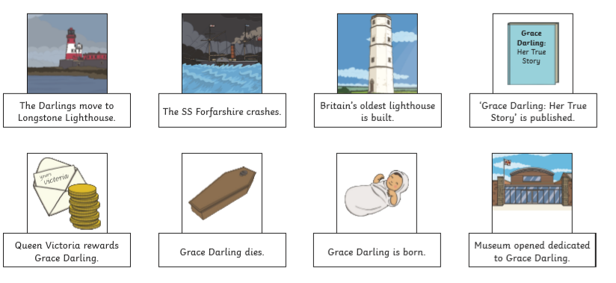

Task 2: To compare the RNLI from today and the past
Task: Read the fact page about the RNLI and life for Grace Darling. Write a short diary entry as though you are Grace on the day of the rescue. Consider in your entry what sort of equipment her family might have wished for to help them with their rescue.
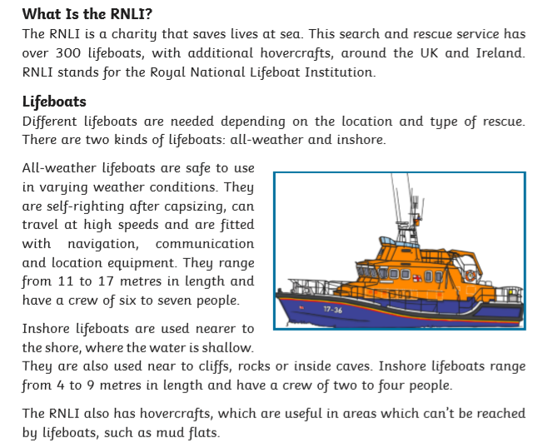
Now read about what life was like for Grace Darling living in the lighthouse:
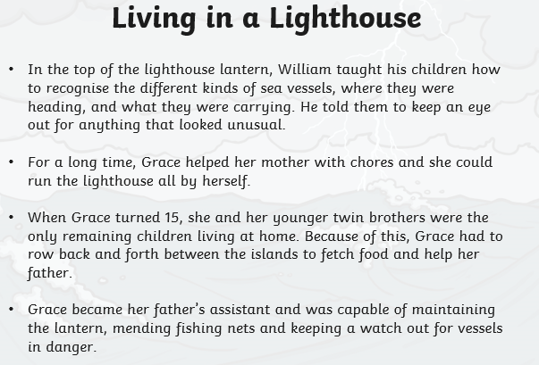

My Diary Entry as Grace Darling

Task 3: To learn about the life of Tim Berners Lee.
Read the facts about Tim Berners Lee. Then complete the fact file to identify the significant events and achievements in his life.
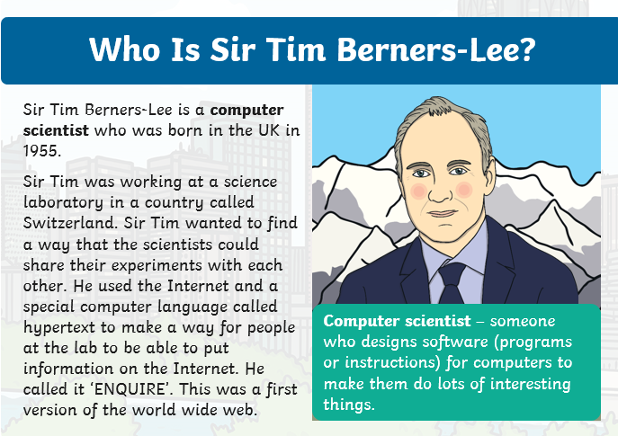


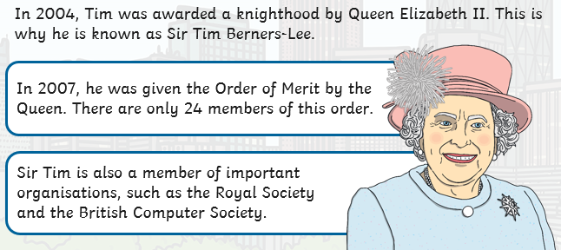

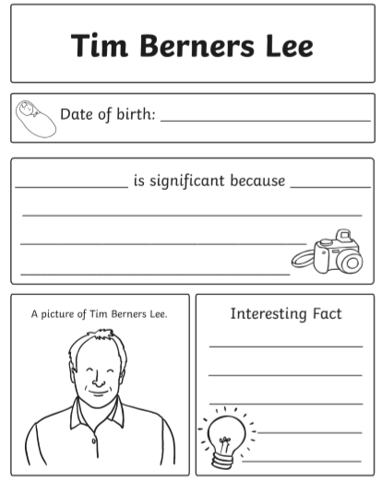

Task 4: To know about the life and work of William Caxton
https://primaryfacts.com/3019/william-caxton-facts-and-information/
Ask an adult to help you read through the fact page above about William Caxton. Read the additional facts below. Then complete the fact file to identify the significant events and achievements in his life.


