


Year 2 Isolation Pack
This is your home learning pack for your isolation period during the Summer Term.
It contains 14 days of work for Writing & Maths, plus 4 Science, 4 Topic and 2 PE activities.

Maths - 10 tasks Task 2: Complete the maths stories below:
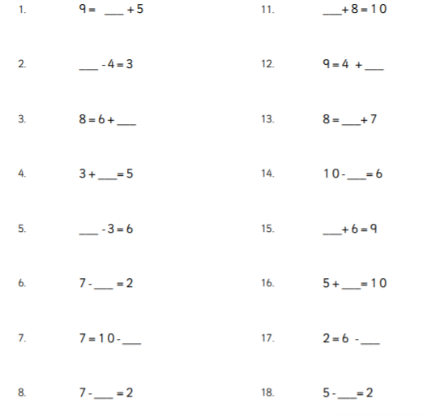
Day 1 - Task 1 – Missing numbers
Task 1: Fill in the missing numbers in these calculations. You
can use the opposite operation or the inverse to help you. e.g. for
the first question you can work it out by doing 12 - 6 = 6

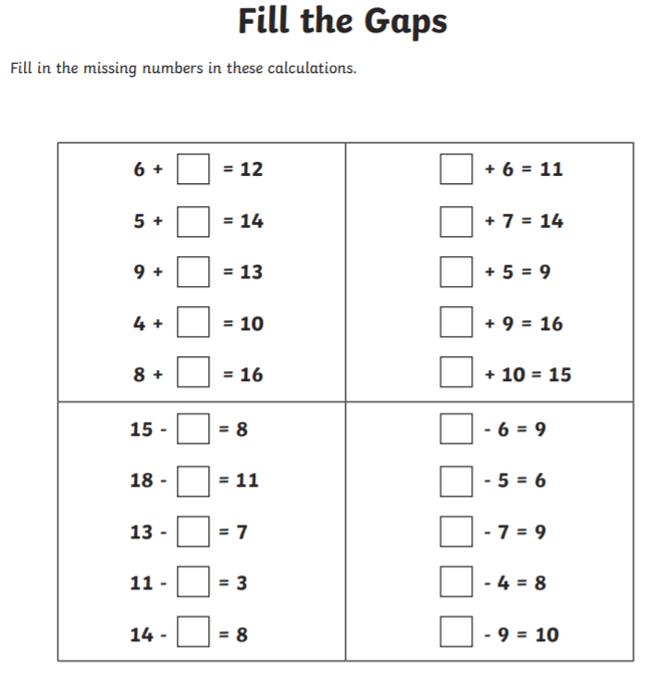

Day 2 – Odd and even numbers
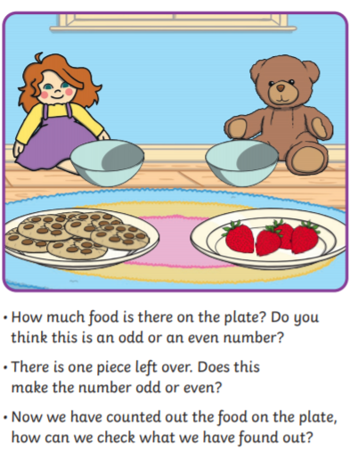
Task 1: Task 2:
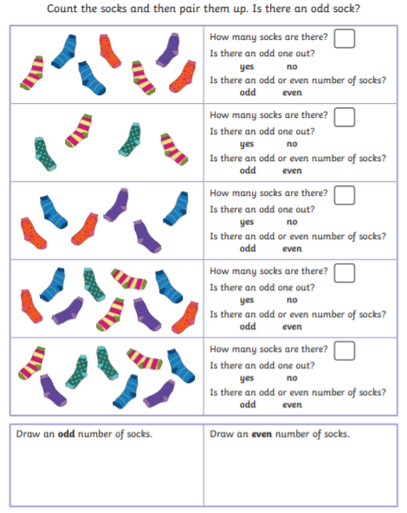
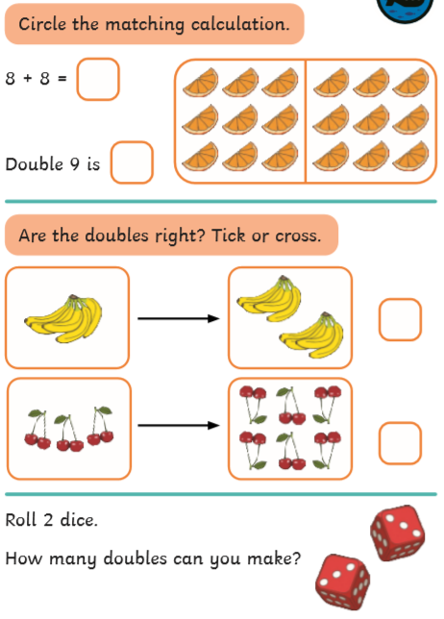
Day 3 – Doubling and halving Task 2:
Task 1 – Can you double and half the numbers
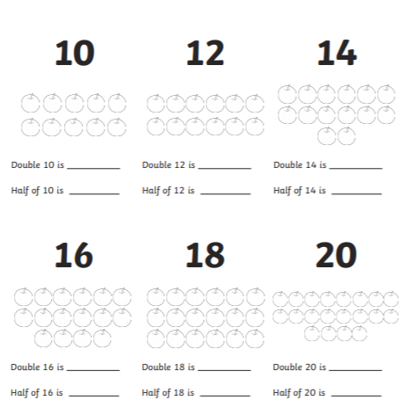
shown? You can use the pictures to help.
Day 4 – Addition
Task 1: Task 2:
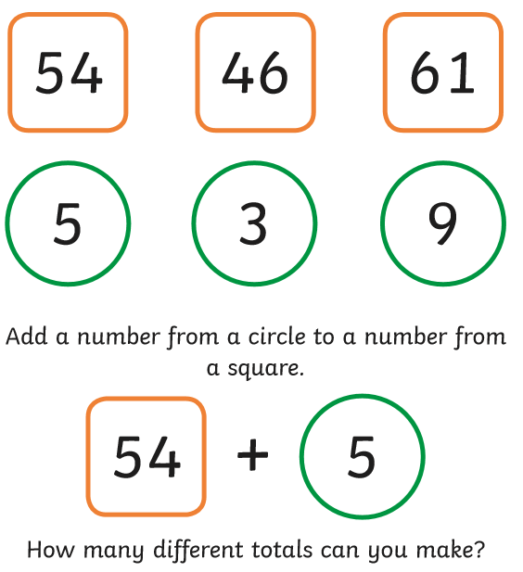
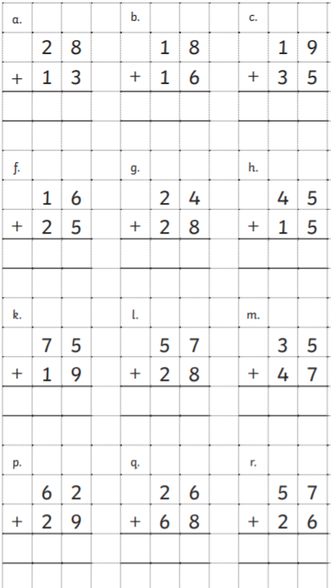
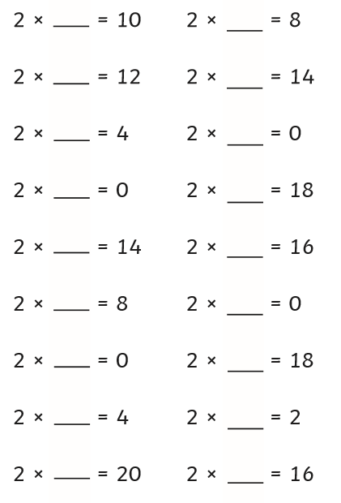
Day 5 – Multiplying by 2 Task 2: Complete the Maths stories below
Task 1
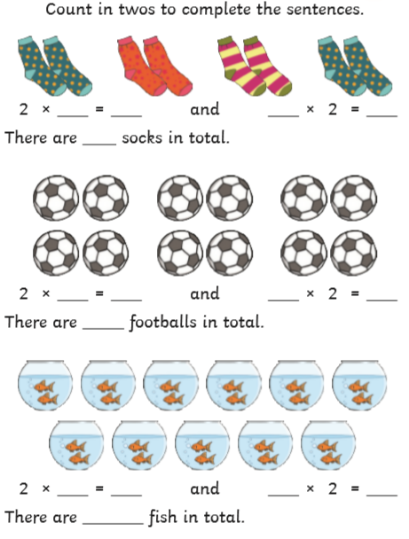
Day 6 – Shapes
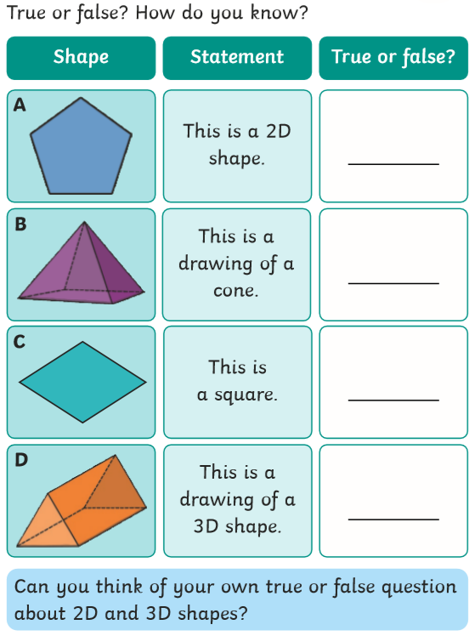
Task 1: Task 2:
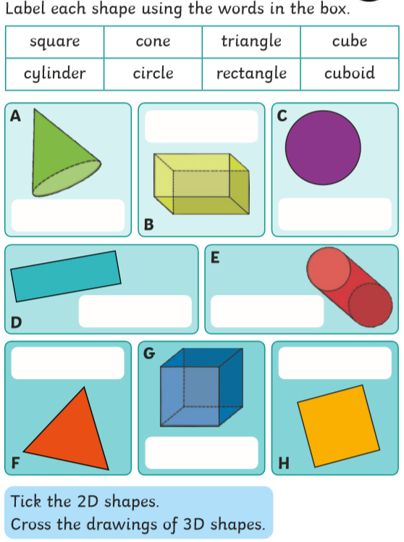
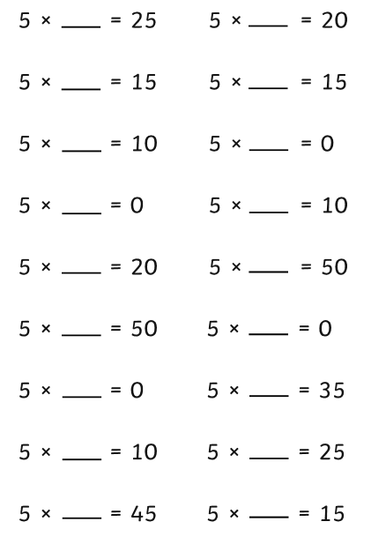
Day 7 – Multiply by 5 Task 2: Complete the Maths stories below
Task 1
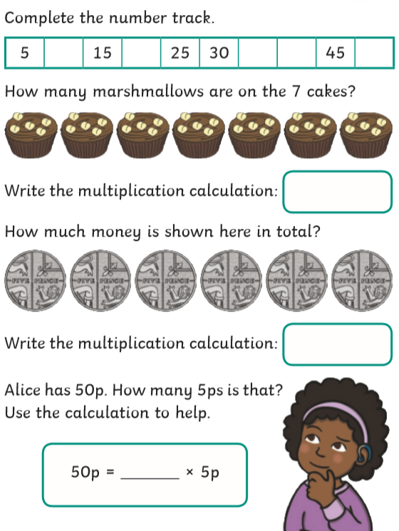
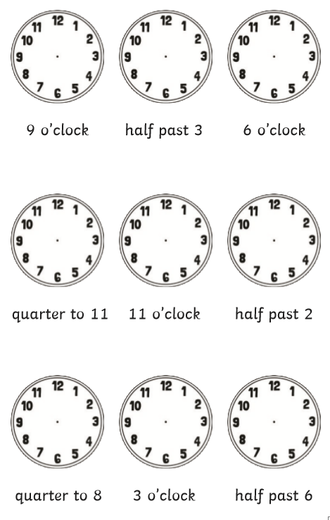
Day 8 – Time Task 2:
Task 1:
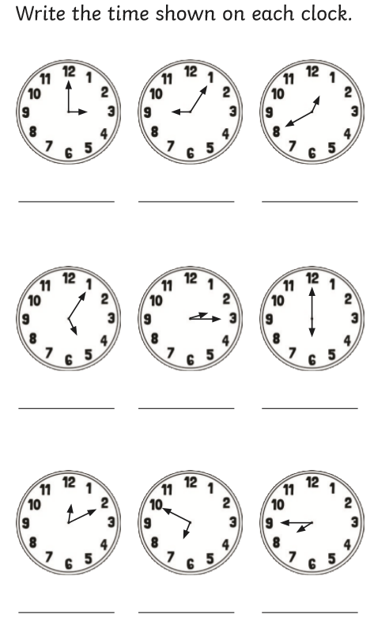
Day 9 – Subtraction
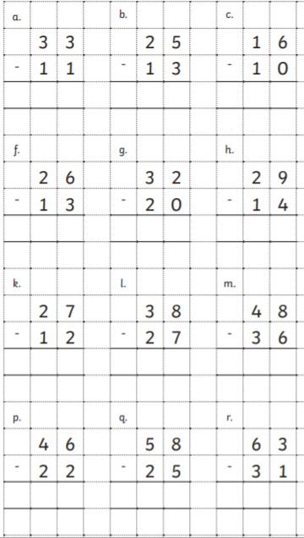
Task 1: Task 2: 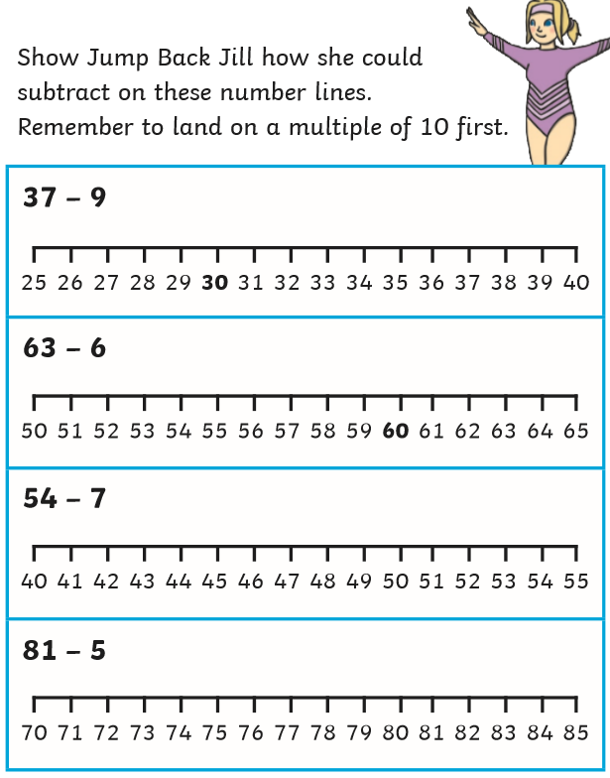

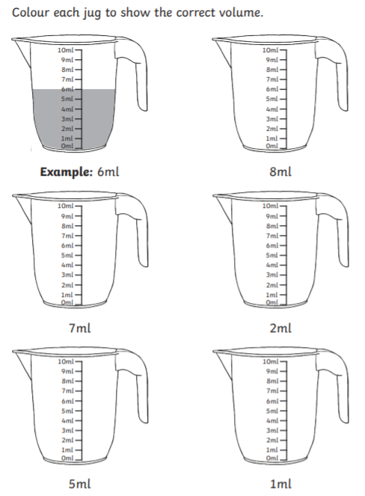
Day 10 – Measurement Task 2:
Task 1:
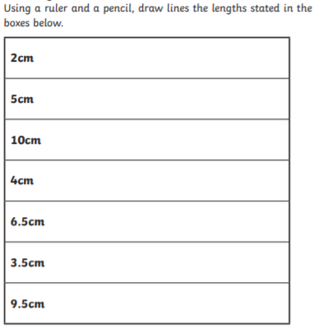
Day 11 – Multiplying by 10 Task 2:
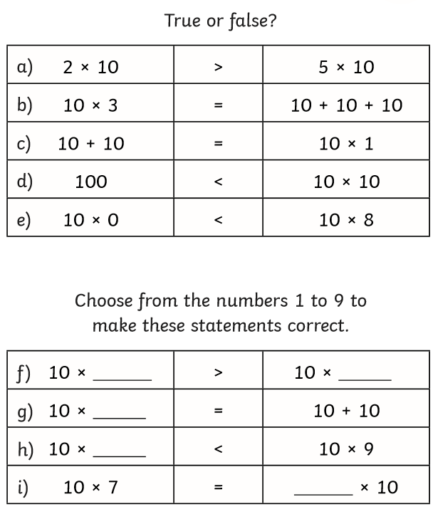
Task 1
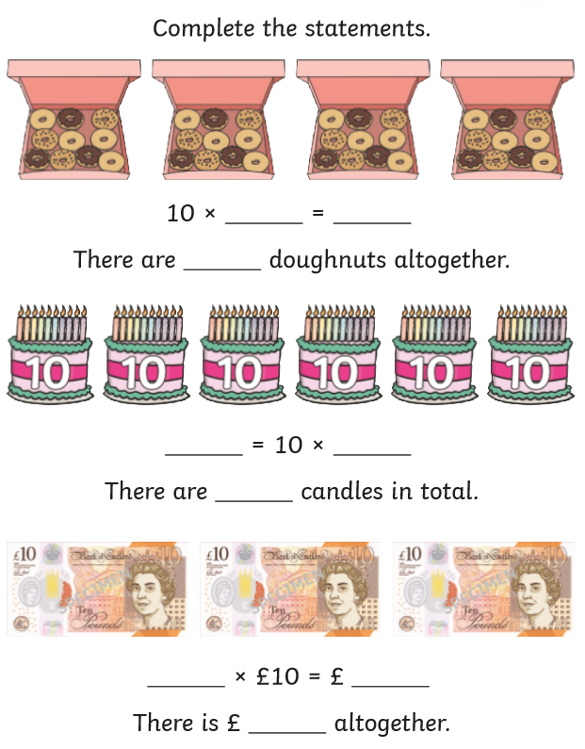

Day 12 – Division by 2 Task 2:
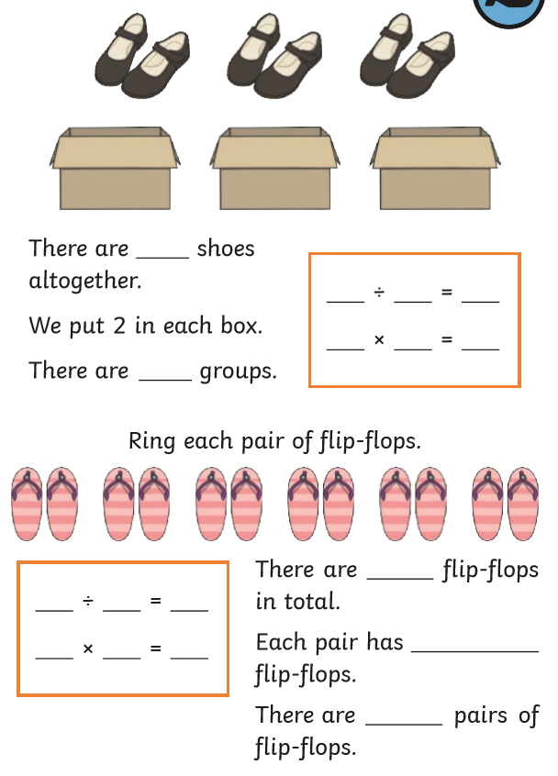
Task 1
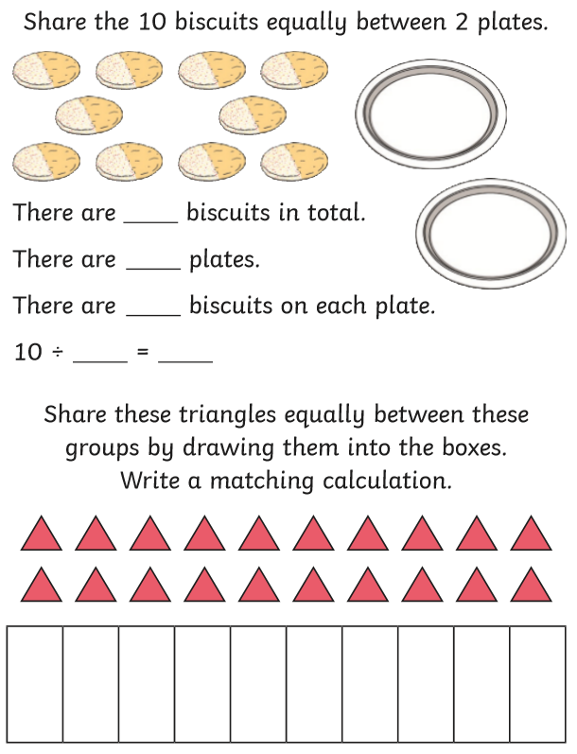
Day 13 – Symmetry Task 2:
Task 1 – Tick the shapes below that have a Draw a line of symmetry in each of the shapes
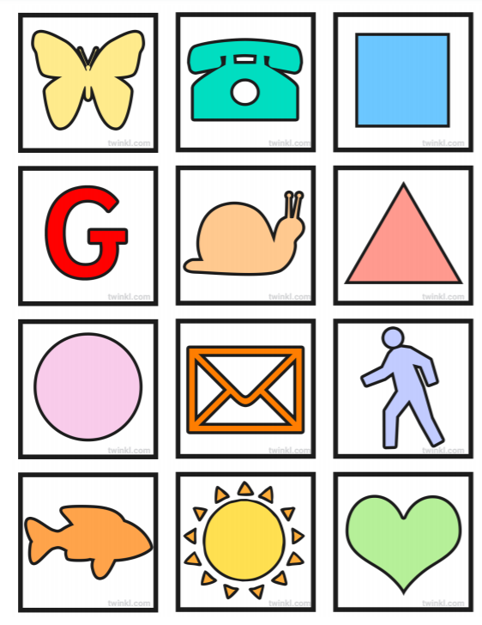
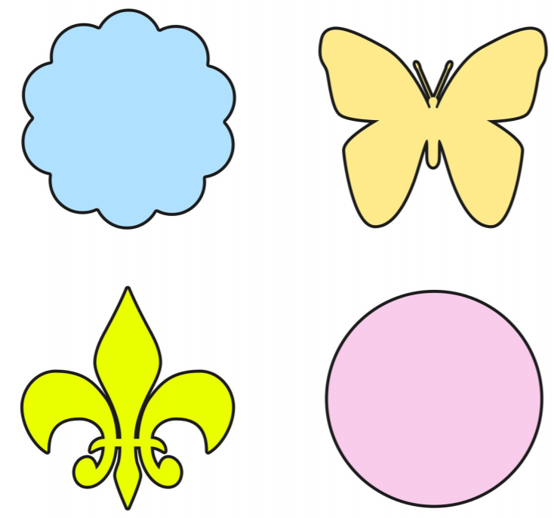
Line of symmetry

Do any shapes have more than one line of symmetry?

Day 14 – Interpret pictograms Task 2:
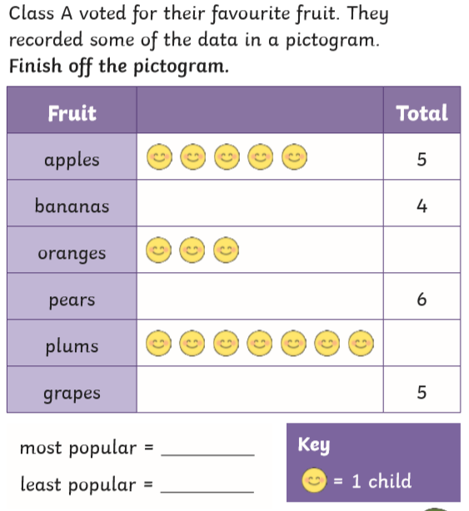
Task 1
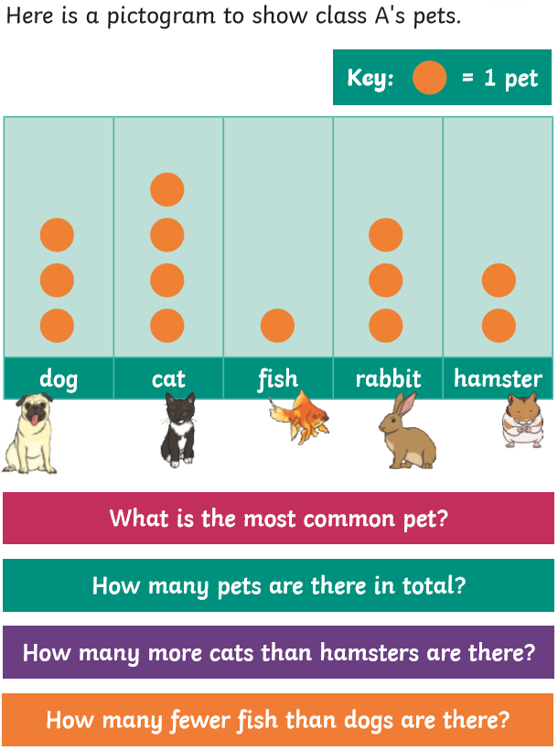

English
DAY 1: Comprehension
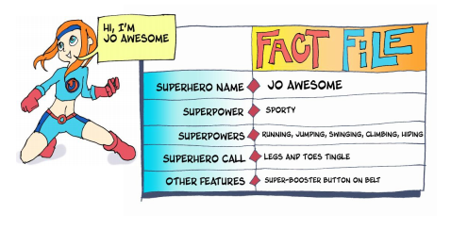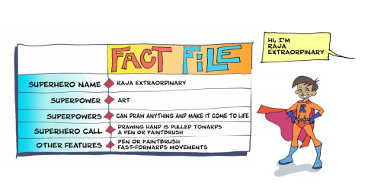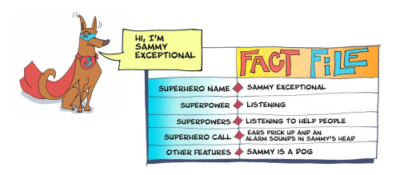
Questions:
- Can you name the Three Superheros?
_____________________________________________________________________________________
- What is Raja’s superpower?
_____________________________________________________________________________________
- How does Jo Awesome detect that someone is in need of her help?
_____________________________________________________________________________________
- What is Sammy Exceptional’s superpowers?
_____________________________________________________________________________________
- What other Superhero features has Raja Extraordinary ?
_____________________________________________________________________________________
- How would you know Sammy Exceptional is receiving a ‘Superhero Call’?
_______________________________________________________________________________________

DAY 2: Text mapping – Drawing images to retell the story
Story Focus: Playground Rescue
https://soundcloud.com/talkforwriting/playground/s-UJObMpzawKu Listen to the story as you read along.
Task: Create a text map or sequence of images to help you retell the story Playground Rescue.
Playground Rescue It was an ordinary day. Jo was on her own in the backyard, kicking a football into the makeshift goal that she’d once scratched into the wall with the edge of a sharp stone. She was dreaming of a time when she would play for the local football team again. Raja was covered in paint. She’d been busy occupying her brothers and sisters while her mum tried to get her work done, and Sammy, in the meantime, slept soundly in his basket. One of his enormous ears had flopped over his eye, his favourite squeaky bacon toy was trapped beneath a podgy paw and his droopy eyelids flickered as he chased wasps in his dreams. Activity in the local park was ordinary too, or so it seemed. Children played on the playground whilst adults chattered, groups of teenagers were gathering, and joggers sprinted along the paths. “HELP! HELP!” came a sudden shout from the playground. Jo’s legs and feet began to tingle. Raja’s drawing hand pulled her towards a paint brush and Sammy stretched, turned over noisily and went back to sleep! As Jo and Raja left their homes, they changed. Jo Awesome’s blue cape glided behind her as she dashed towards the park, activating her super-booster to help her get there more quickly. Raja Extraordinary’s red cuffs glowed as he desperately held onto the flying paintbrush. They arrived at the park at the same time, “What’s the problem?” panted Jo. 5 © Talk for Writing “Follow me!” Raja called over her shoulder as the paintbrush dragged her towards the playground. As Raja and Jo reached the edge of the playground, they could see that a crowd had gathered at the bottom of the spider’s web climbing frame. Children giggled and pointed, and adults stared up in silence. “Look!” whispered Jo, nodding her head towards the top of the spider’s web. Raja followed her gaze up to a small, snivelling child who was dangling from the top of the climbing frame with one hand, about to fall! “This one’s mine!” declared Jo … Quick as a flash, Raja painted a mini trampoline which Jo used to bounce up and over the crowd and then grabbed the child as she somersaulted them both down to safety. With the crowd’s whoops and cheers buzzing in their ears, Jo raced home while Raja flew back to her house on the flying carpet she’d painted. Jo returned to ordinary Jo playing keepy-uppy in the back yard and Raja returned to ordinary Raja cleaning up the painting mess she’d left behind. And as for Sammy, an alarm sounded in his head and his ears pricked up. Someone somewhere was crying. They needed to talk and Sammy Exceptional to listen…

DAY 3: Stories with a Familiar Setting
Story Focus: Playground Rescue
Read or listen to the story again. https://soundcloud.com/talkforwriting/playground/s-UJObMpzawKu
Task: Find the words in the story and work out their correct meaning. Join the words up to their meaning below.
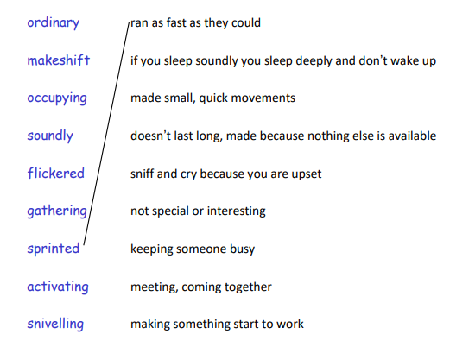

DAY 4: Personal opinion
Book Focus: Playground Rescue
Read or listen to the story again.
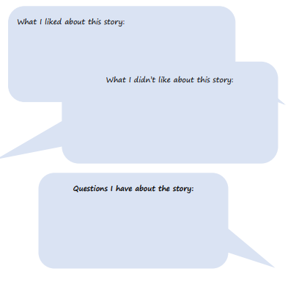
Task: Now that you have looked at the story and the meanings of the words. Can you add your response to these headings:

DAY 5: Comprehension
Book Focus: Playground Rescue
Task: Read or listen to the story again and answer the questions below on the Playground Rescue.
- What is special about Jo, Raja and Sammy?
______________________________________________________________________________________________
- The story talks about Raja’s family. Who is in her family?
______________________________________________________________________________________________
- Describe what you think Jo’s house is like based on what you have read. Make sure to include plenty of adjectives.
__________________________________________________________________________________________________________________________________________________________________________________________________________________________________________________________________________________________
- i) A park is the setting for the story. Can you describe the setting?
______________________________________________________________________________________________________________________________________________________________________________________________________________________________________________________________________________________________________________________________________________________________________________________________________________________________________________________________________________________
ii) Can you think of another story that has the same setting?
______________________________________________________________________________________________
- How do you think the crowd at the bottom of the climbing frame felt when the child had been rescued?
______________________________________________________________________________________________
______________________________________________________________________________________________

DAY 6: Creative Challenge
Book Focus: Playground Rescue
Read or listen to the story again.

Task: Can you complete your own Superhero fact file as if You were a Superhero? Think about your superhero name as well as your superpowers. Use the adjective list below to help you. Write a short description of your character using plenty of adjectives on the lines provided.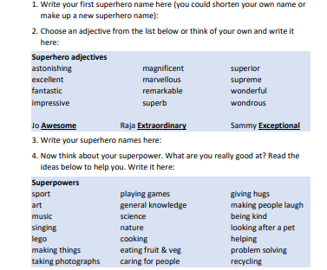
Now think about your ‘Super hero call’ – this is and how you would know when someone needs your help. What sort of things might happen or what signs would you see?
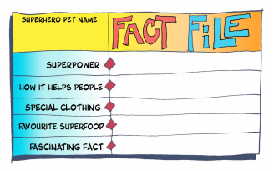

DAY 7: Planning your Independent story
Story Focus: Playground Rescue
Imagine you are a superhero and something happens whereby another character needs your help. Using your knowledge from Playground Rescue story, you are going to write your own version with the character you created in the previous lesson. Firstly, we need to plan and think about our story structure and plot pattern by completing a boxing up grid. In the introduction of Playground Rescue they say Who the character(s) is and what they are doing. Then they explain the problem. Next think about the resolution (how your character will solve the problem) and finally what happens at the end- is all well?
Remember, you do not need to write full sentences in your plan just simple bullet points to help you sequence your ideas.
Use the sample below
Planning:
Characters –__________________________________
Setting – _______________________________________
My Plan (boxing up grid)_:
 | Playground Rescue | My story
Opening | - Jo played football at home  - Raja was painting.  - Sammy slept
Build Up | - People playing /talking at local park. Then a shout for help
Problem | - Boy falling from climbing frame
Resolution | - The superhero’s received their ‘superhero call’  - Raja drew a trampoline  - Jo bounced and grabbed the child
Ending | - They returned home and continued their activities

DAY 8: Writing your story
Story Focus: Playground Rescue

Story map:
My story:
______________________________________
______________________________________
______________________________________
______________________________________
______________________________________
______________________________________
______________________________________
______________________________________
_____________________________________
______________________________________
______________________________________
______________________________________
______________________________________
______________________________________
______________________________________
_____________________________________
_____________________________________
____________________________________
_____________________________________
_____________________________________
_____________________________________
_____________________________________
_____________________________________
______________________________________


DAY 9: Poetry and Imagery
Text Focus: Poem – Quangle Wangle’s Hat by Edward Lear
First of all, do you know what a is? That’s right, it’s a piece of writing in which the words are chosen for their sound. Some poems are serious, and some are fun; some tell a story and others are just nonsense (full of unreal things or just silly). In this booklet, we are going to read a nonsense poem called The Quangle Wangle’s Hat by Edward Lear.
Before we read this poem we are going to make some predictions. Think about the title of this poem. Nobody know what a Quangle Wangle is- isn’t it a strange name. In the poem, it says that the Quangle Wangle sits on the top of a tree, What do you think a Quangle Wangle could look like?
Task
Draw an image of a Quangle Wangle and use the lines below to describe what you think the Quangle Wangle looks like.
e.g, I think the Quangle Wangle has long, sharp, gripping claws and a curved, orange, speckled beak.

___________________________________________________________________ ___________________________________________________________________________________________________________________
________________________________________________________________________________________________________________________________________________________________________________________________________________________________________

DAY 10: Poetry- Comprehension
Poetry Focus: The Quangle Wangle’s Hat
Listen to a recording of the poem here: https://soundcloud.com/talkforwriting/quangle/s-x9rd3d4h6c2
You can also watch a video of the poem being read by Griff Rhys Jones here: https://www.youtube.com/watch?v=Ttv4H8YZ9HE
Now that you’ve had a think, it’s time to read the first verse of the poem.

The Quangle Wangle’s Hat
On the top of the Crumpetty Tree
The Quangle Wangle sat
, But his face you could not see,
On account of his Beaver Hat.
For his Hat was a hundred and two feet wide,
With ribbons and bibbons on every side
And bells, and buttons, and loops, and lace,
So that nobody ever could see the face
Of the Quangle Wangle Quee.

Task 1: Draw his hat

The Quangle Wangle said  To himself on the Crumpetty Tree:  “Jam; and jelly; and bread;  Are the best of food for me!  But the longer I live on this Crumpetty Tree  The plainer than ever it seems to me  That very few people come this way  And that life on the whole is far from gay!”  Said the Quangle Wangle Quee. | But there came to the Crumpetty Tree,  Mr. and Mrs. Canary;  And they said, — “Did ever you see  Any spot so charmingly airy?  May we build a nest on your lovely Hat?  Mr. Quangle Wangle, grant us that!  O please let us come and build a nest  Of whatever material suits you best,  Mr. Quangle Wangle Quee!” | And besides, to the Crumpetty Tree  Came the Stork, the Duck, and the Owl;  The Snail, and the Bumble-Bee,  The Frog, and the Fimble Fowl;  (The Fimble Fowl, with a corkscrew leg;) And all of them said: “We humbly beg, We may build our homes on your lovely Hat: Mr. Quangle Wangle, grant us that! Mr. Quangle Wangle Quee!”

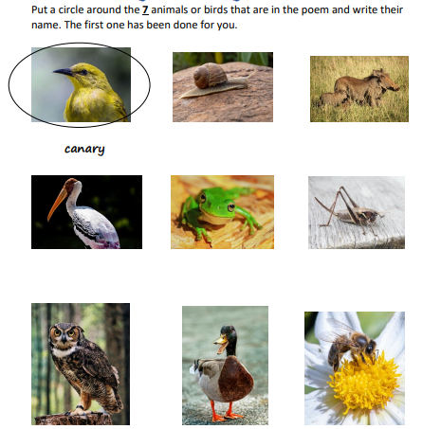
Task 2

And the Golden Grouse came there, Task 3
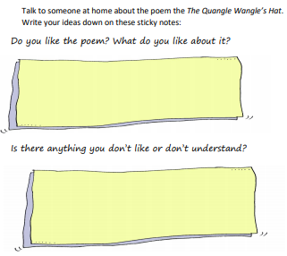
And the Pobble who has no toes,
And the small Olympian bear,
And the Dong with a luminous nose.
And the Blue Baboon, who played the flute,
And the Orient Calf from the Land of Tute,
And the Attery Squash, and the Bisky Bat,
All came and built on the lovely Hat
Of the Quangle Wangle Quee.

And the Quangle Wangle said
To himself on the Crumpetty Tree:
“When all these creatures move
What a wonderful noise there’ll be!”
And at night by the light of the Mulberry moon
They danced to the Flute of the Blue Baboon,
On the broad green leaves of the Crumpetty Tree,
And all were as happy as happy could be,
With the Quangle Wangle Quee.

DAY 11: Poetry- Vocabulary
Poetry Focus: The Quangle Wangle’s Hat
You can watch a video of the poem being read by Griff Rhys Jones here: https://www.youtube.com/watch?v=Ttv4H8YZ9HE
Looking at the vocabulary in this text – some words are made up just to rhyme but others highlighted have definitions listed below. Can you find where these words are in the powm and work out what they mean and join them up to their meaning. Task 1 Task 2 : Chose two words and put them into a sentence
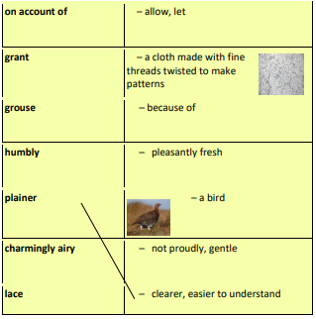
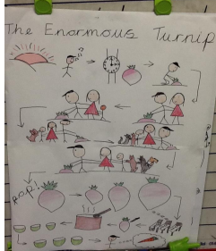
DAY 12: Poetry- Story Mapping
Poetry Focus: The Quangle Wangle’s Hat
You can watch a video of the poem being read by Griff Rhys Jones here: https://www.youtube.com/watch?v=Ttv4H8YZ9HE
Here is a story map. Can you work out what the story is from looking at the text map?
Can you see which bits of the story has been included in the map?
Task Now your challenge is to create a text map for the first verse of The Quangle Wangle’s Hat. Make sure to read the text slowly and draw a picture for each new idea. If you like you could continue and do the whole poem!
The Quangle Wangle’s Hat
On the top of the Crumpetty Tree
The Quangle Wangle sat
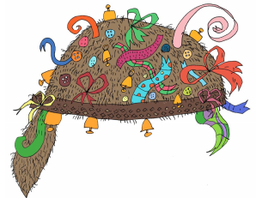
, But his face you could not see,
On account of his Beaver Hat.
For his Hat was a hundred and two feet wide,
With ribbons and bibbons on every side
And bells, and buttons, and loops, and lace,
So that nobody ever could see the face
Of the Quangle Wangle Quee.

Task : Text Mapping

DAY 13: Character description
Poetry Focus: The Quangle Wangle’s Hat
You can rewatch a video of the poem being read by Griff Rhys Jones here: https://www.youtube.com/watch?v=Ttv4H8YZ9HE or read back the poem above.
Did you notice that in this poem there are a lot of creatures mentioned? Some of the creatures you may be familiar with but others are made up characters. Here is a description of one of them:
The Pobble who has no toes A Pobble looks like an enormous mermaid . It has a large, round head, dark, curly hair (that looks wet), and walks awkwardly on the sea-green, scaley fin-tail that starts at its thick waist. Its body is covered in moss and algae which causes a slightly fishy smell. A Pobble does not speak but uses its amazing eyes and squeaks like a dolphin to communicate.
Did you see all the highlighted words? These are all examples of adjectives (words that describe a person,place, animal or thing).
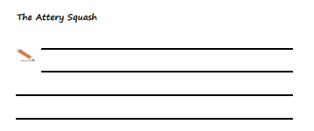
Task 1
Now you are going to imagine what one of the other characters looks like from the poem – The Attery Squash. Think about what they look like and other things like what they may smell or sound like. Use the template of the Pobble description to help. You may wish to innovate it. The second task it to draw an image of this character.

____________________________________________________________________________________________________
DAY 14:
Poetry Focus: The Quangle Wangle’s Hat
Read this simile poem . A simile is when you compare one thing to another by using AS or LIKE , for example, As bald as an egg, eyes like lightbulbs.
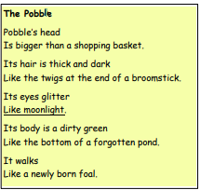
Task 1 : Can you circle the similes in this poem?
Now can you write a similar poem using similes to describe the Attery Squash or another creature of your choice in this poem. Think about using similes to describe their head, hair/features/fur etc , eyes, ears , legs, arms or feet.

Now it’s time to write your poem like The Pobble one to the left. Don’t forget the title

Science – 4 Tasks
Task 1: To know about living things and their habitats
Find out lots of information by watching the videos at https://www.bbc.co.uk/bitesize/topics/zx882hv
Complete the fact file activity and then create your own habitat – you could draw a picture and colour it in or create one using arts and crafts items from around your house.
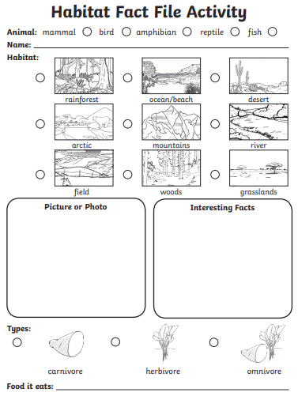

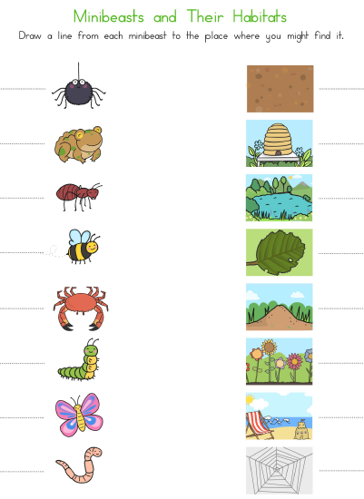
Task 2: To identify habitats

Task 3: To understand about living things and their habitats
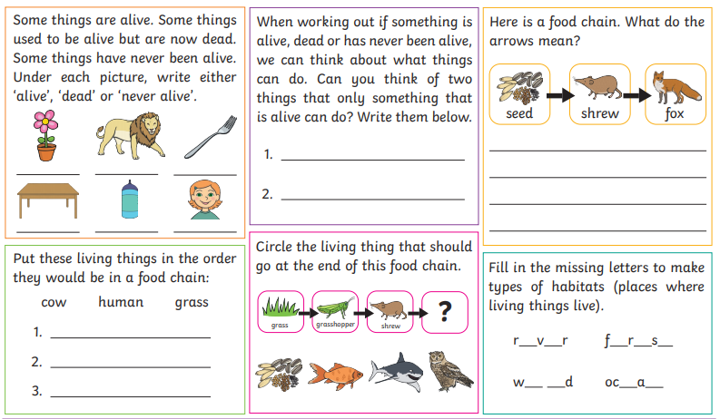
Find out lots of information by watching the videos at https://www.bbc.co.uk/bitesize/topics/zx882hv

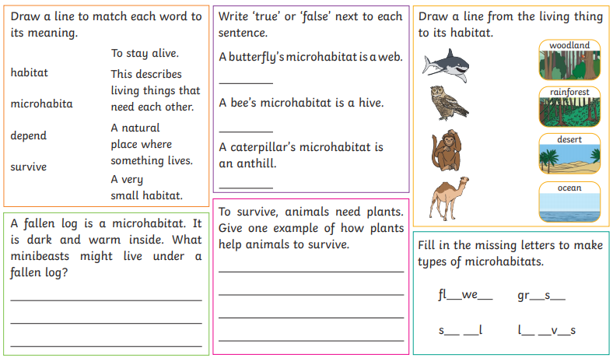

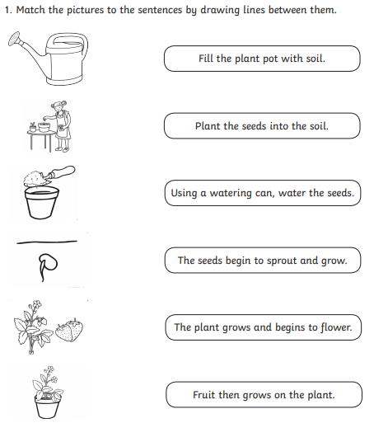
Task 4: To understand about plants

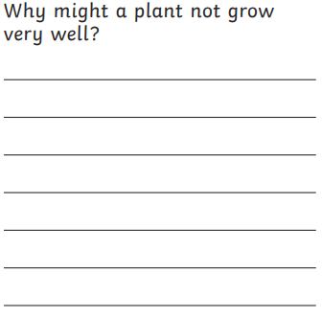

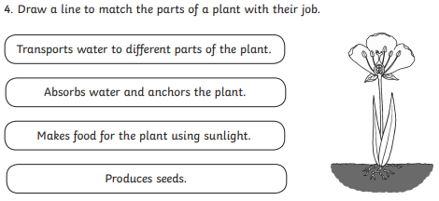
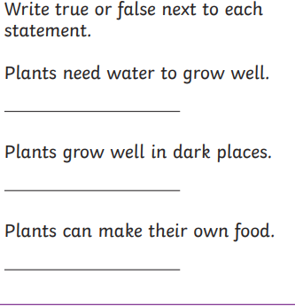
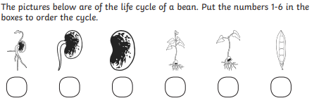

PE – 2 Tasks
Week 1
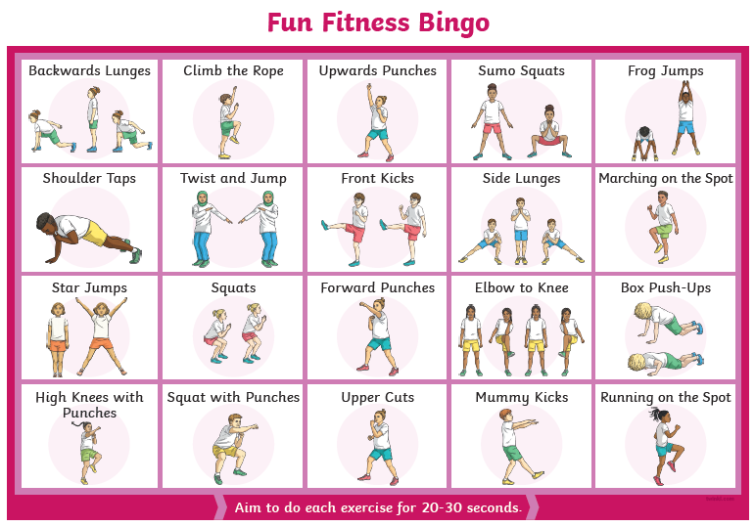

Week 2
There are lots of PE with Joe Wicks workouts available for you to take part in on YouTube. Just search PE with Joe Wicks.
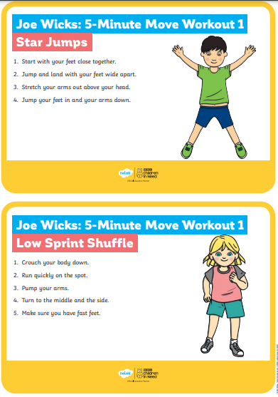
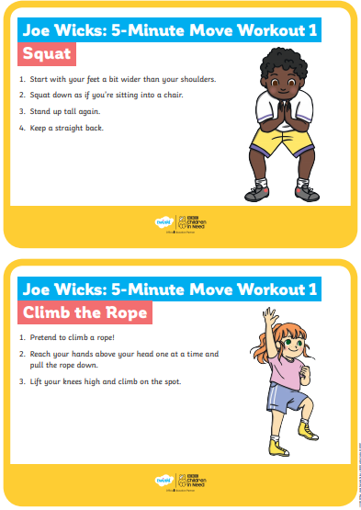
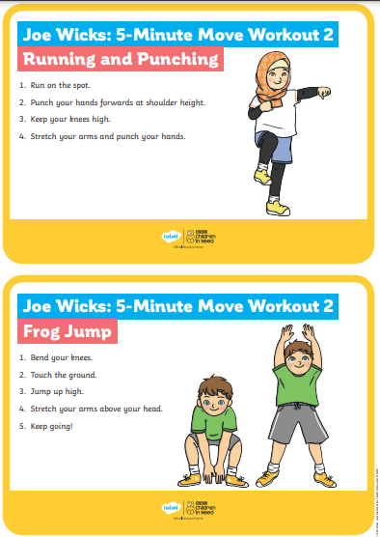

Topic – 4 Tasks
Task 1: To create a picture in the style of Monet
Look at the picture below on London by Monet. Can you create your own version of this?
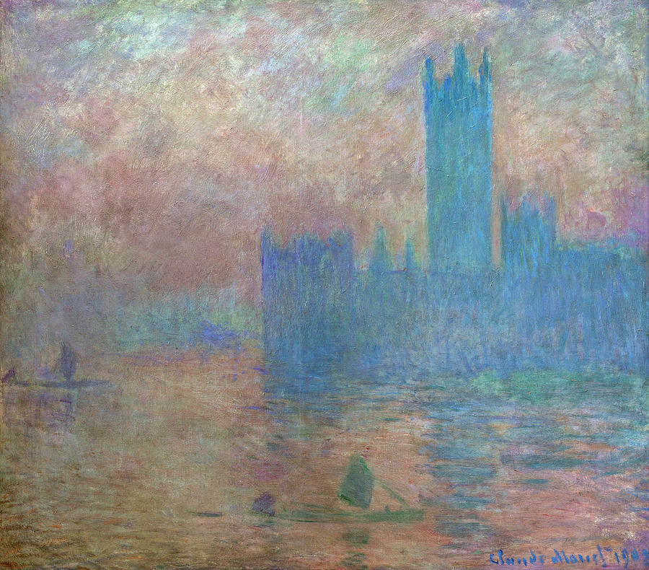

Task 2: To know about the ancient and modern-day Olympics
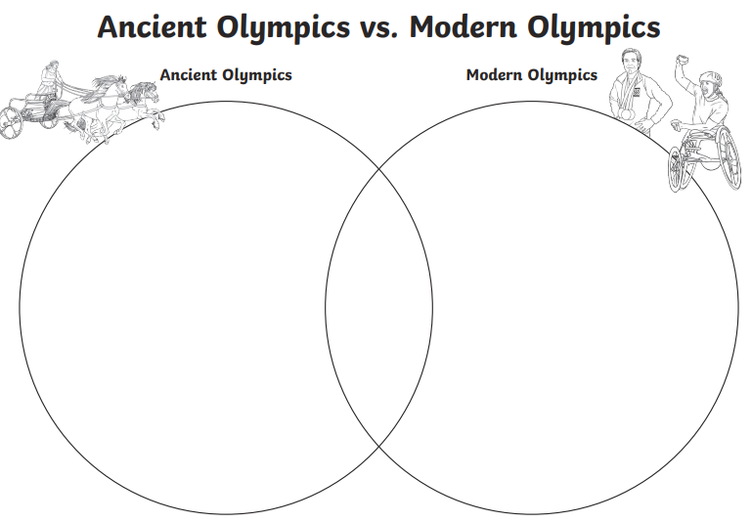
There are lots of videos and information online to help you complete this activity.

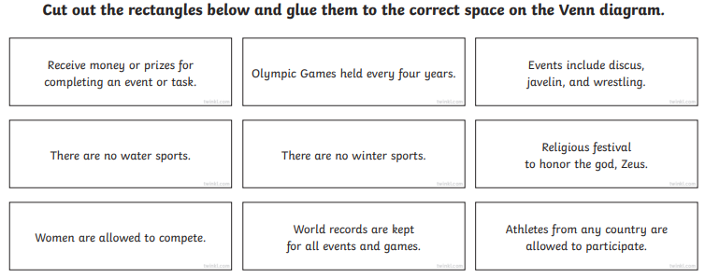

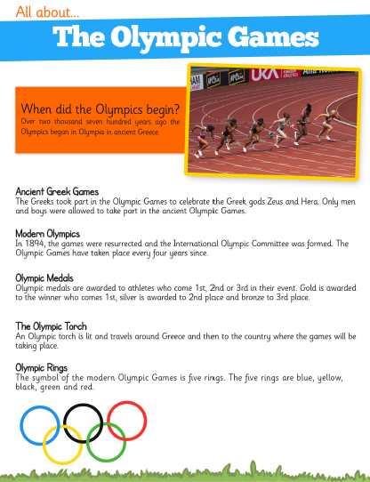
Task 3: To know about the Olympic games

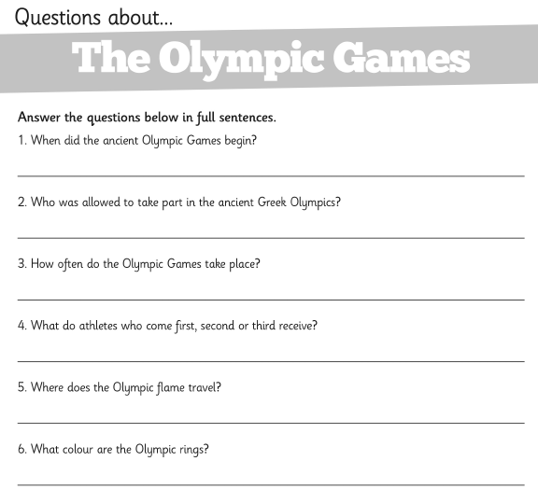

Task 4: To know about the UK
https://www.bbc.co.uk/teach/class-clips-video/pshe-eyfs-ks1-go-jetters-uk-places-and-landmarks/zkyjkmn
Find out some information about a landmark in each of the UKs countries. Draw a picture of it and then list some facts that you have learnt.


