


Year 1 Isolation Pack
This is your home learning pack during your isolation period.
It contains 14 days of work for Writing & Maths plus 4 Science and 4 Topic activities.

Maths
DAY 1 – Sorting Up to 10 objects

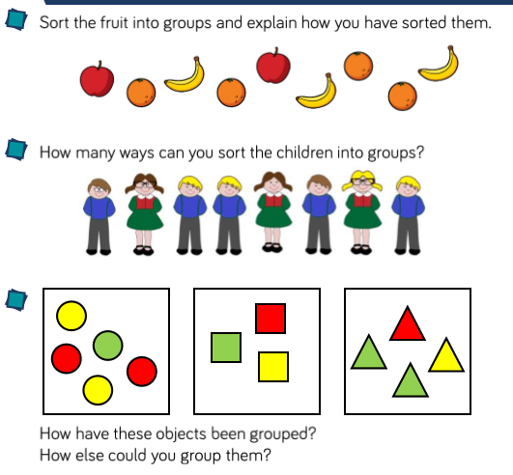
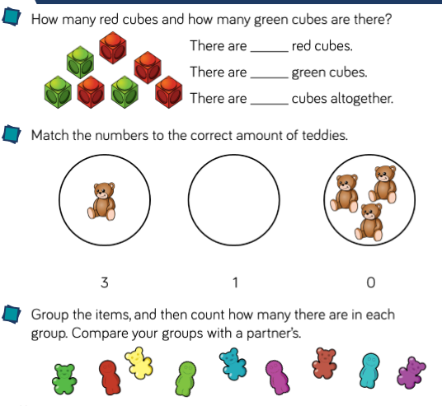

DAY 2 – Count objects to 10
Activity 1: 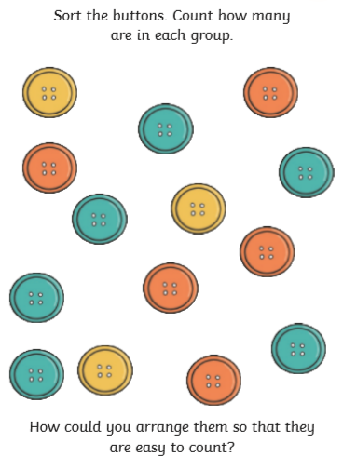
Activity 2: 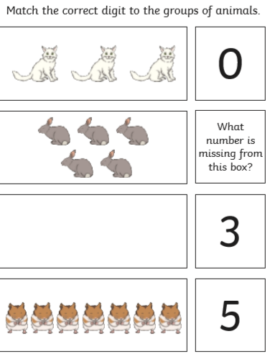
DAY 3 – Count objects from a group of 10 Task 1:
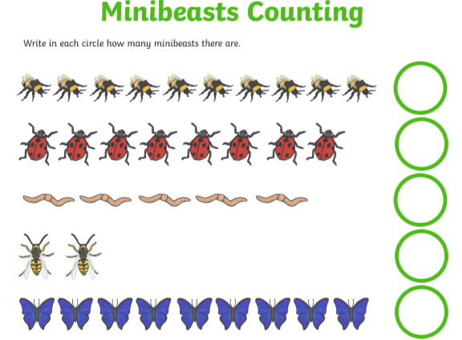
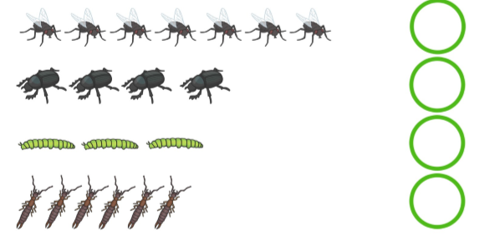
Task 2:
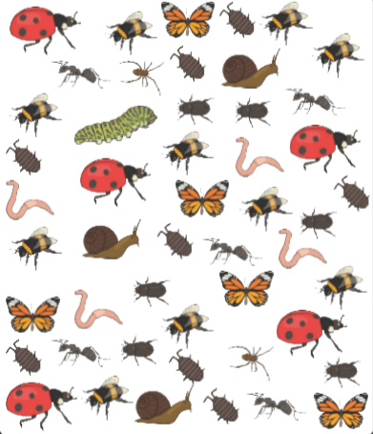
How Many?

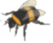
DAY 4 – Represent up to 10 objects – Task 1:
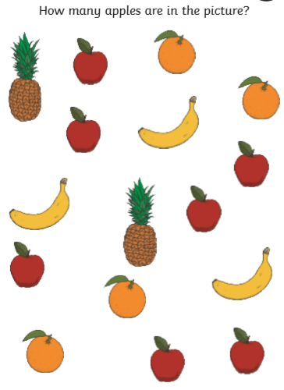
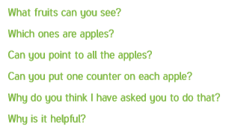
Task 2:
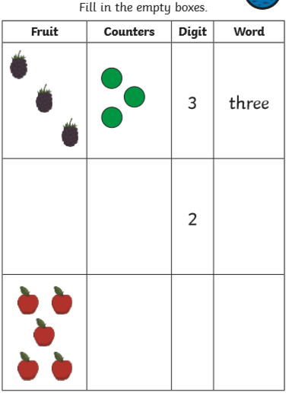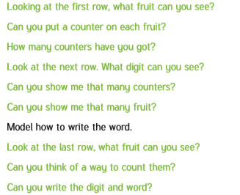
DAY 5 – Represent numbers to 10 – Task:

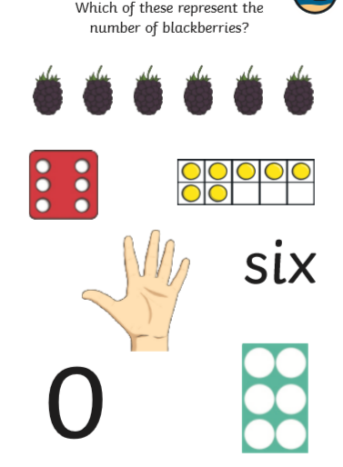

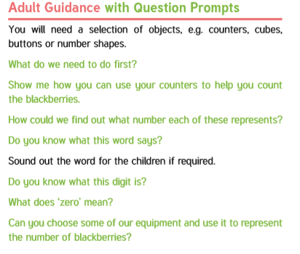

DAY 6 – Count Forwards to 10 – Task:
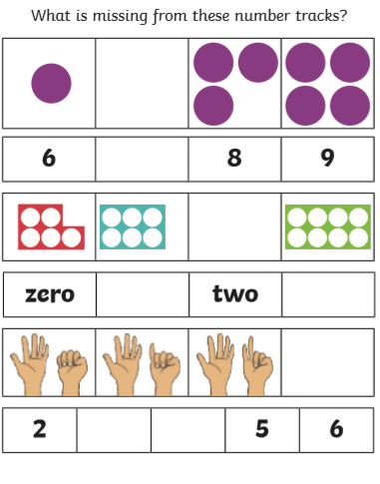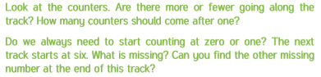
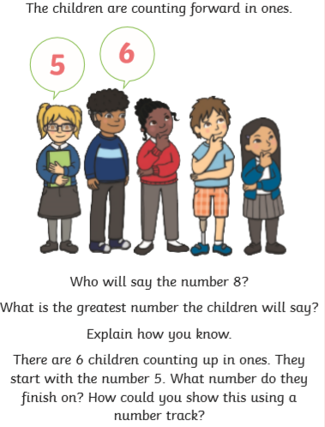

DAY 7 – Count Backwards from 10
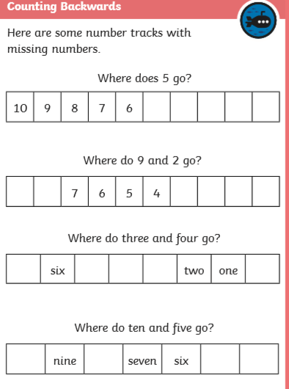
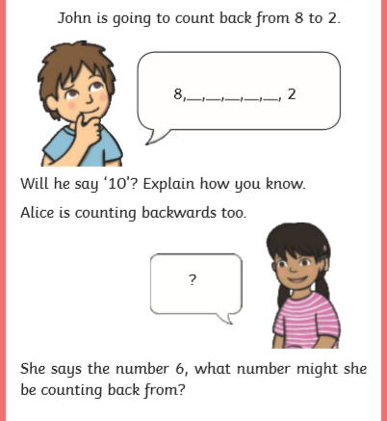

DAY 8 – Count One More for Numbers within 10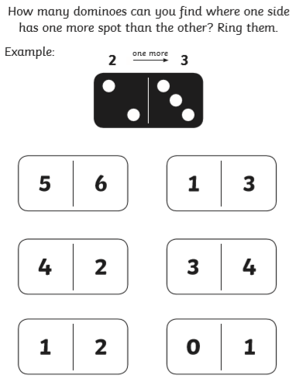
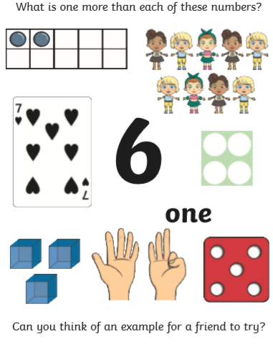

DAY 9 – Count One Less for Numbers within 10

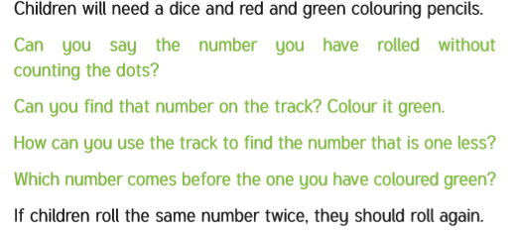
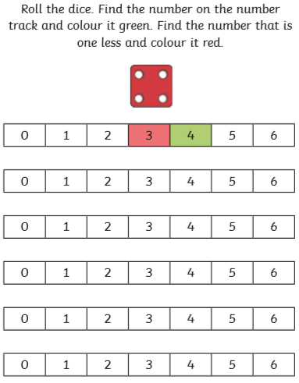
DAY 10 – Counting to 20
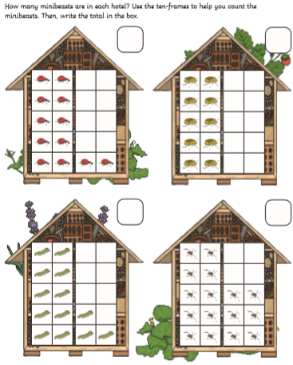
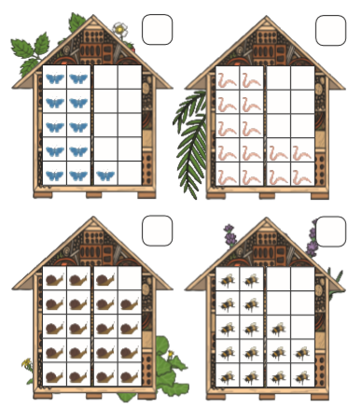
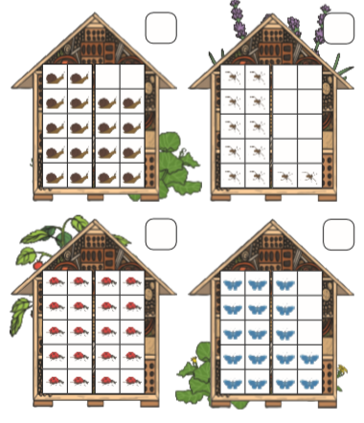
DAY 11 – Number System (1)
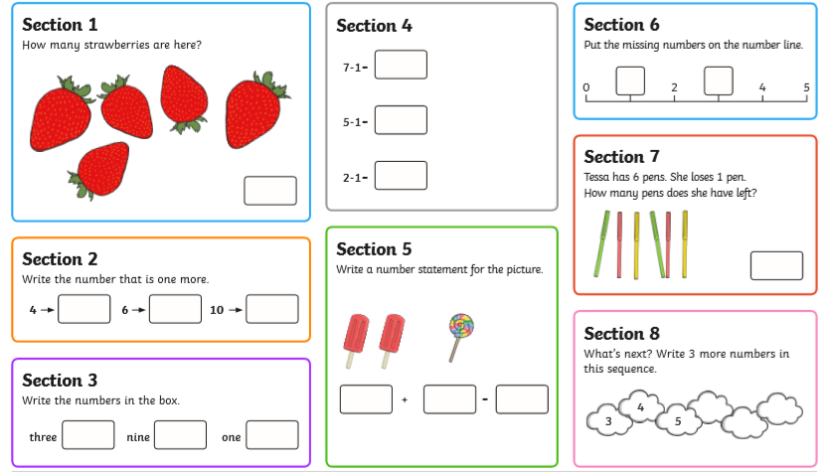
DAY 12 – Number Bonds to 10
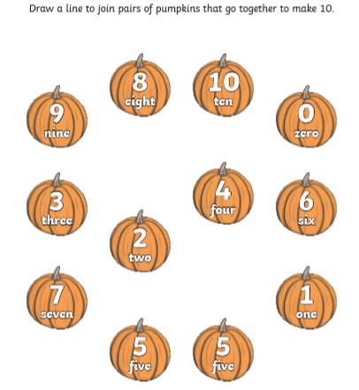

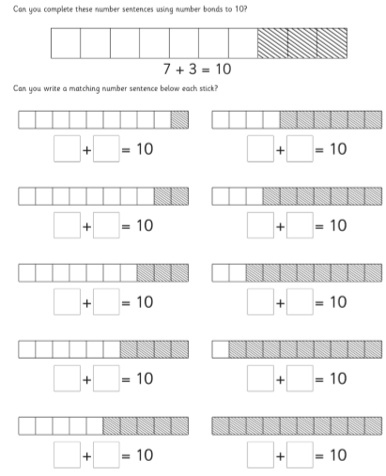
DAY 13 – Task 1: 2d Shape Hunt

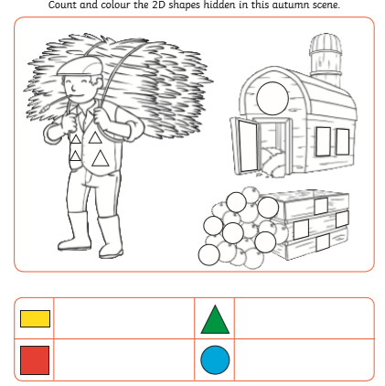
Task 2: Complete the Activity Mat:

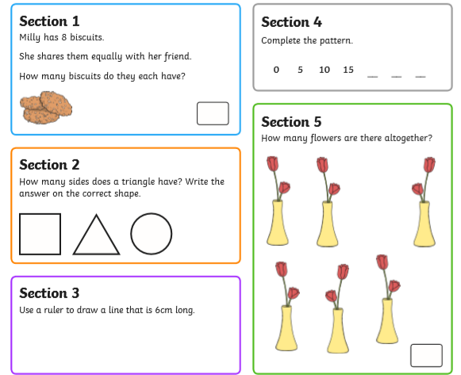

DAY 14 – Task: Number System (2)

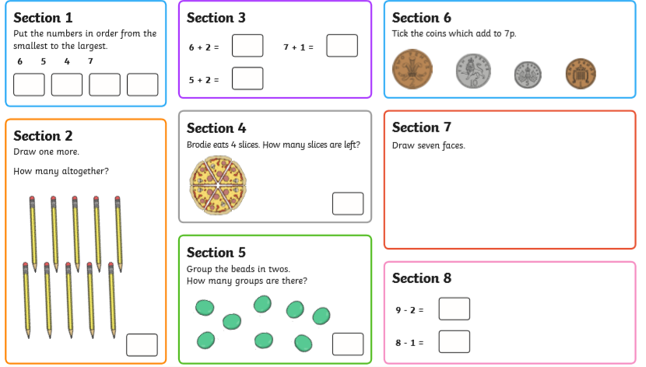
Writing
DAY 1: CVC Words
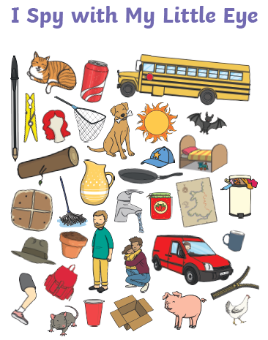
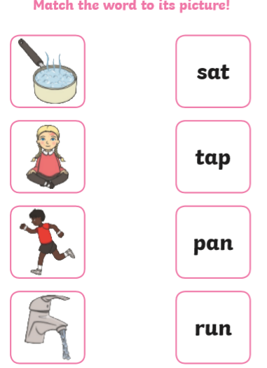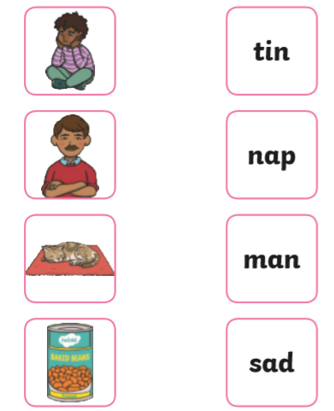
TASK 2: Write the cvc words – What can you see?

--------------------------
----- --------------------------
--------------------------
----- --------------------------
--------------------------
----- --------------------------
--------------------------
----- --------------------------
--------------------------
----- --------------------------
--------------------------
----- --------------------------
--------------------------
--------------------------
--------------------------
DAY 2: CVC Words
TASK 1: 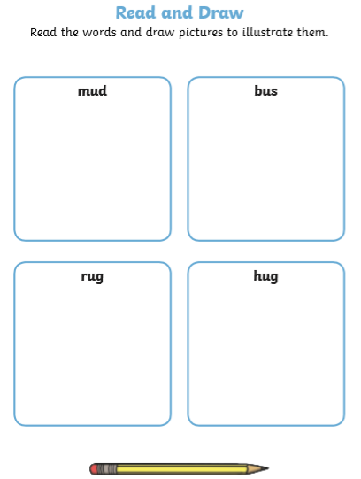

TASK 2: WORD BUILDING
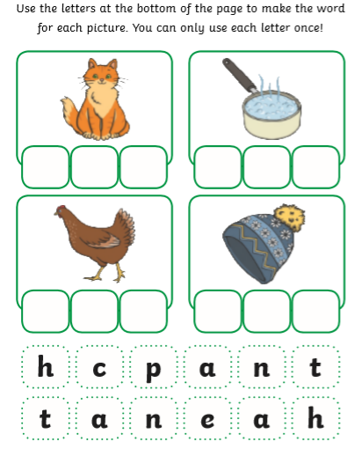
DAY 3: Spell and read CVC words
Task 1:
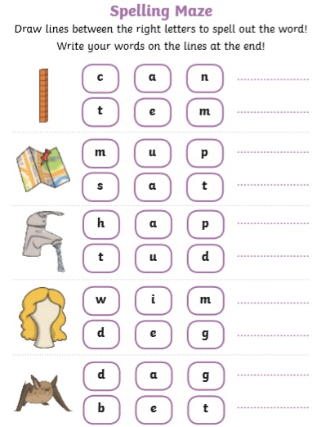
Task 2:
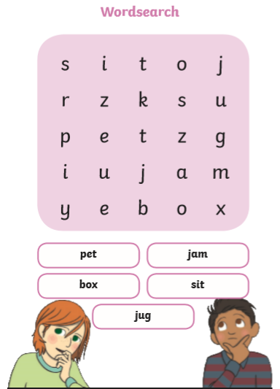
DAY 4: Common Exception Words – FOCUS: THE

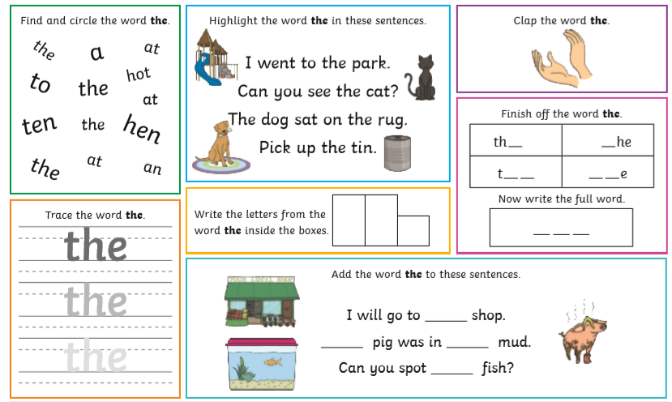
DAY 5: Common Exception Words – FOCUS: WAS
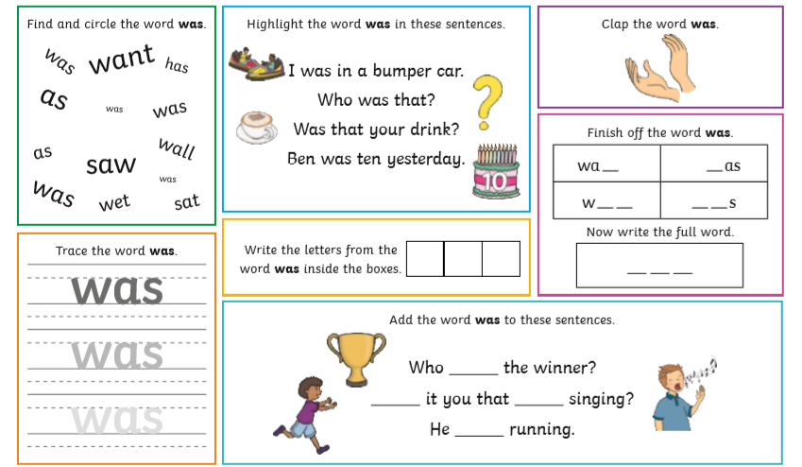
DAY 6: Word Building
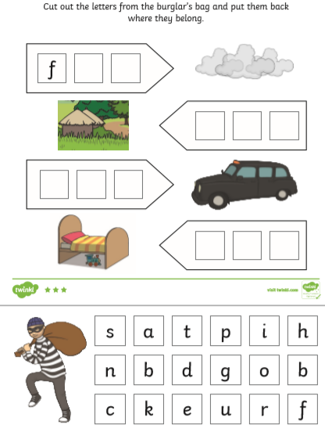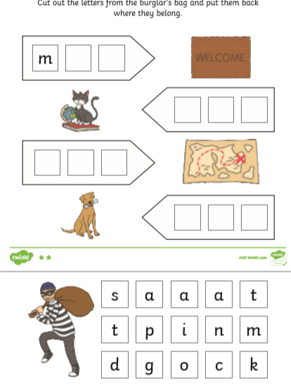
DAY 7: Sentence Building
Task 1: Ask an adult to cut out each card. Task 2: Write the sentences you have made on the
What sentences can you make? Read them to lines. Remember use a capital letter and a full stop.
an adult.
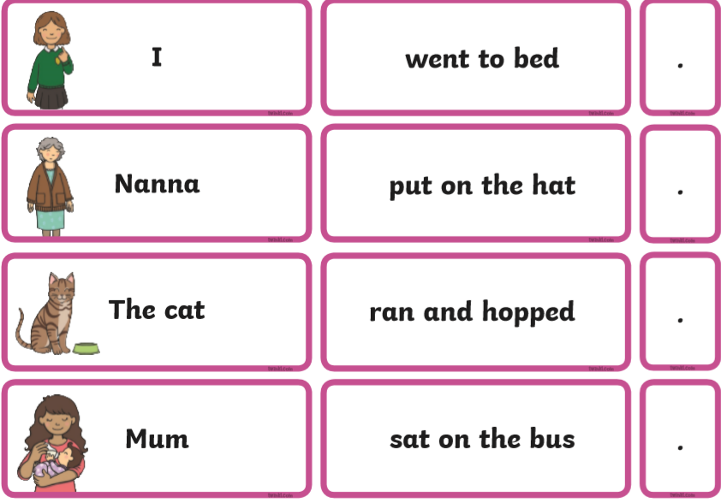

DAY 8: High Frequency Words
Focus: About
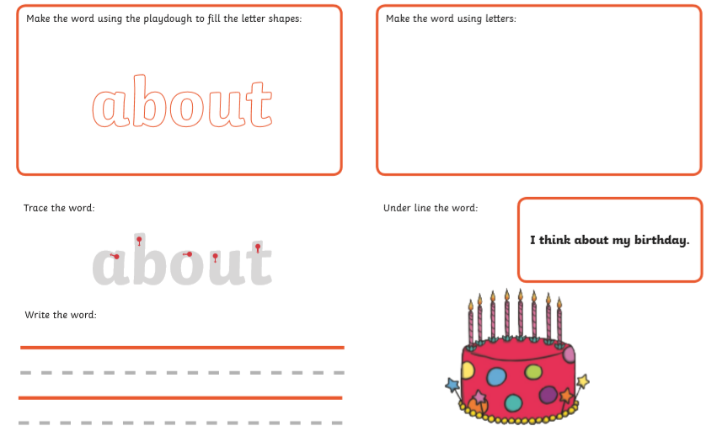
DAY 9: High Frequency Words
Focus: Big
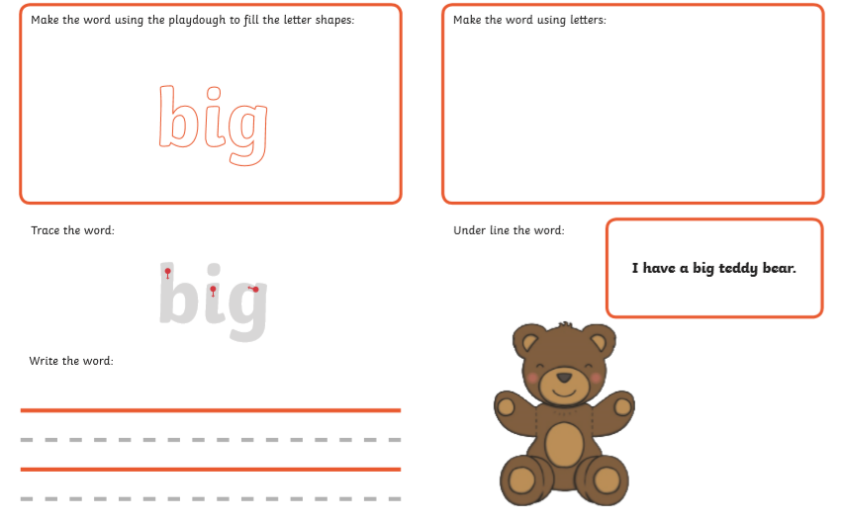
DAY 10: High Frequency Words
Focus: Came
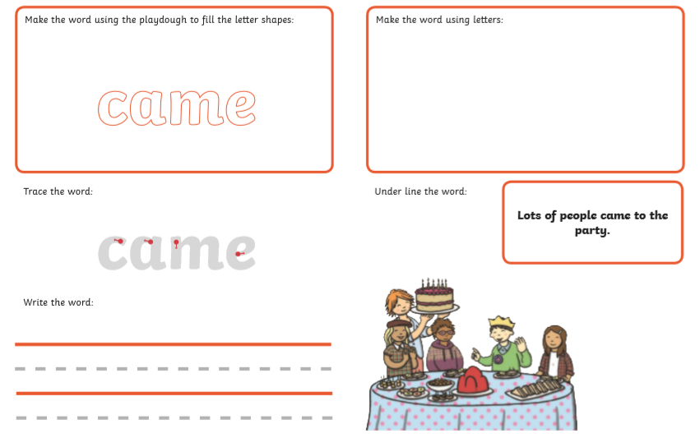
Monkey | banana
ostrich | 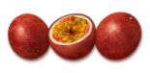  guava
zebra  | orange
elephant 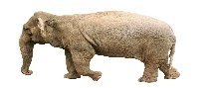 | 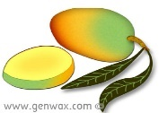  mango
giraffe | pineapple
antelope | avocado
parrot | passion fruit 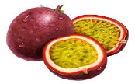
goat | 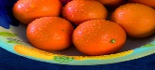  tangerines
DAY 11: Story Focus – Handa’s Surprise by Eileen Brown
Read the story - https://youtu.be/QqdXBhyORug
Task 1: Match the correct animal to the correct fruit.
Task 2: Cut out the puppets and use them to re-tell the story.
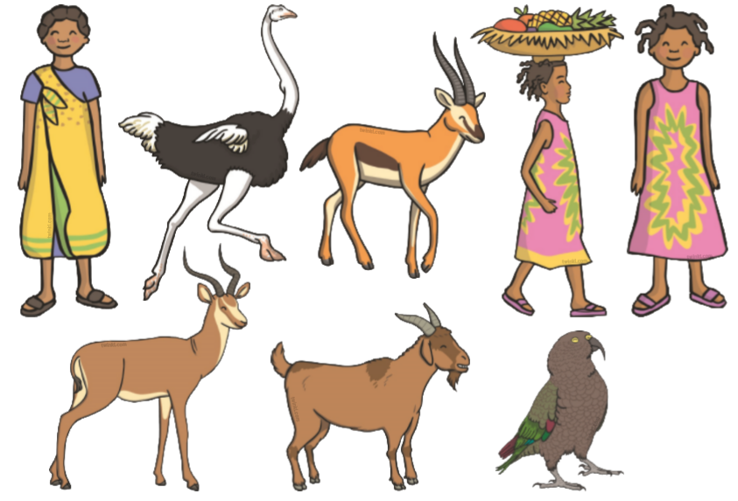
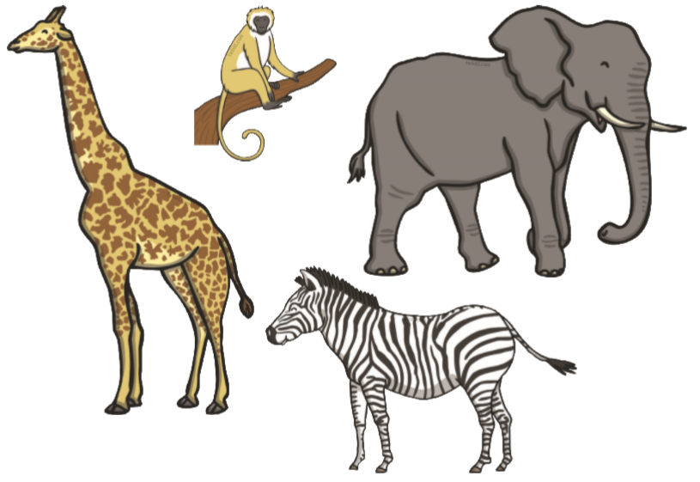
DAY 12: Story Focus – Handa’s Surprise by Eileen Brown
Read the story - https://youtu.be/QqdXBhyORug
Task: Describe the fruit in the basket. Use key words and write a sentence if you can. Then colour in the fruit.
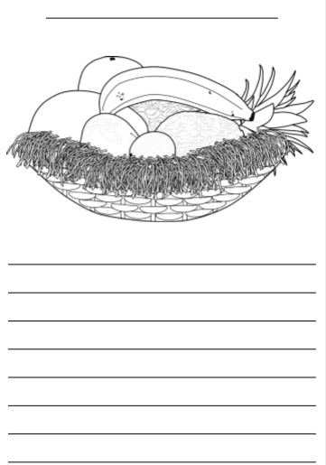
DAY 13: Story Focus – Handa’s Surprise by Eileen Brown
Task: Sequence the pictures to re-tell the story.
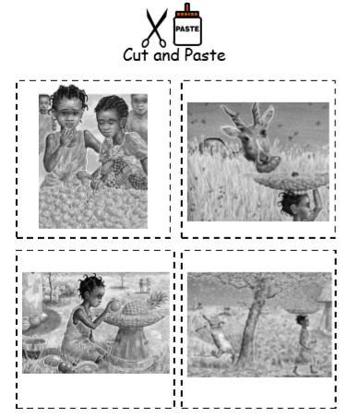
Can you write key words or a sentence for each picture?
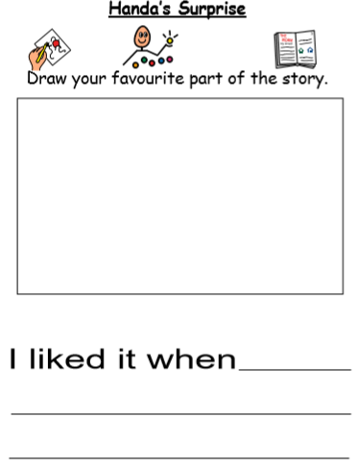
DAY 14: Story Focus – Handa’s Surprise by Eileen Brown
Task 2:
Write some descriptive sentences about the story
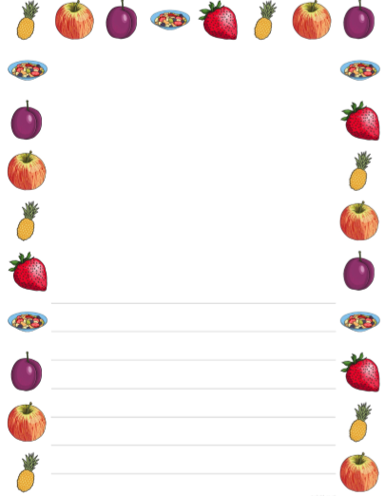
Science – 4 Tasks
Task 1: Seasonal Changes - Sort the clothes for the correct season.
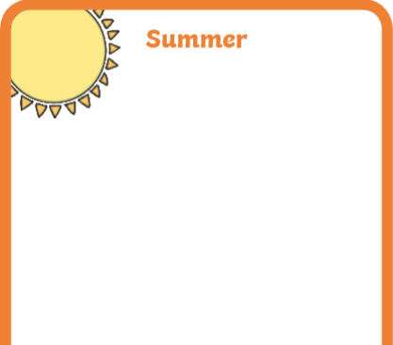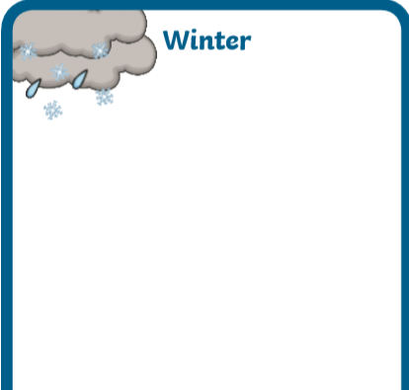
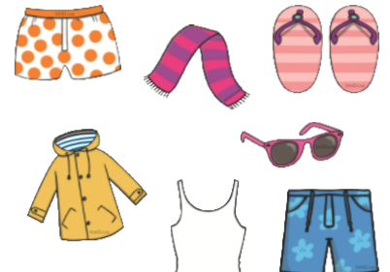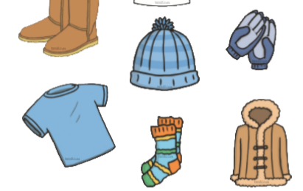
Task 2: Labelling & Naming Materials
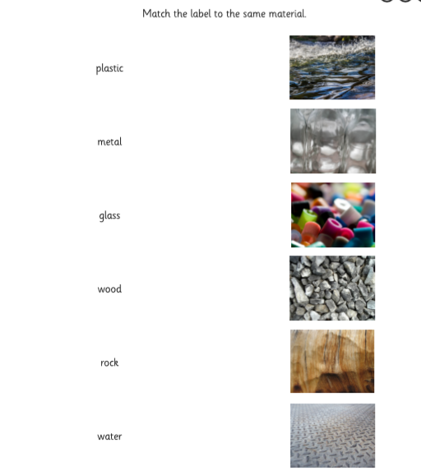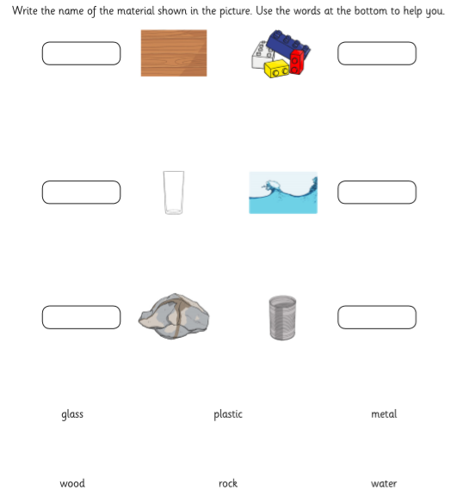

Task 3: Grouping Materials
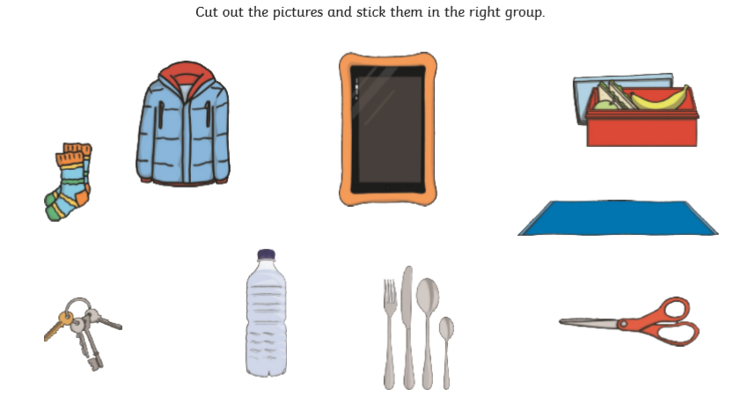
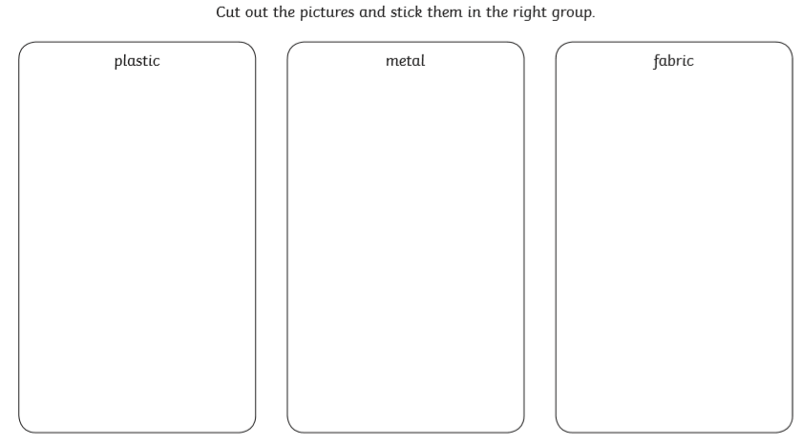
Task 4: Describing Materials
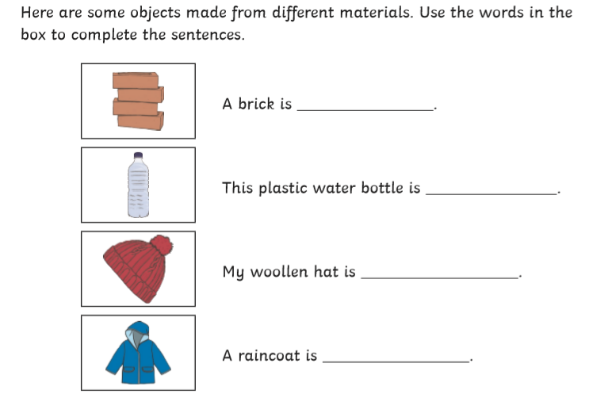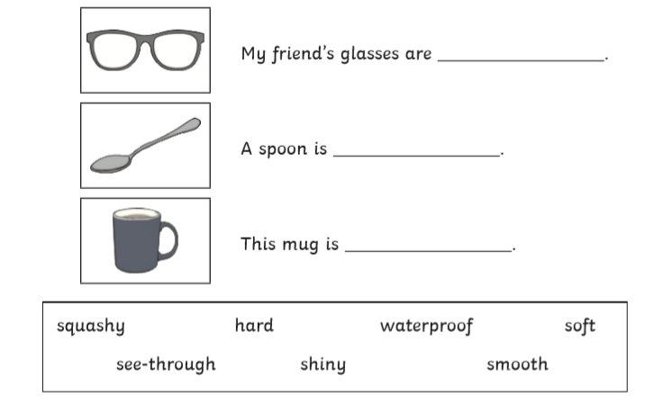

Topic – 4 Tasks
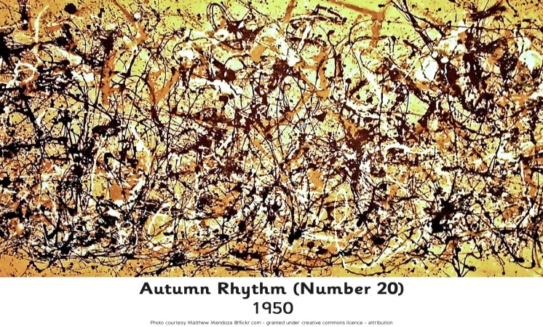
Task 1: Look at art work by Jackson Pollock. Create your own interpretation of his artwork
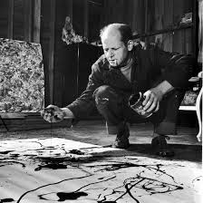

Have a go

Topic - Task 2:
To identify the UK and London on a map

Colour in the UK on this map of the world. Draw a circle to show where London is and then label it on the map.

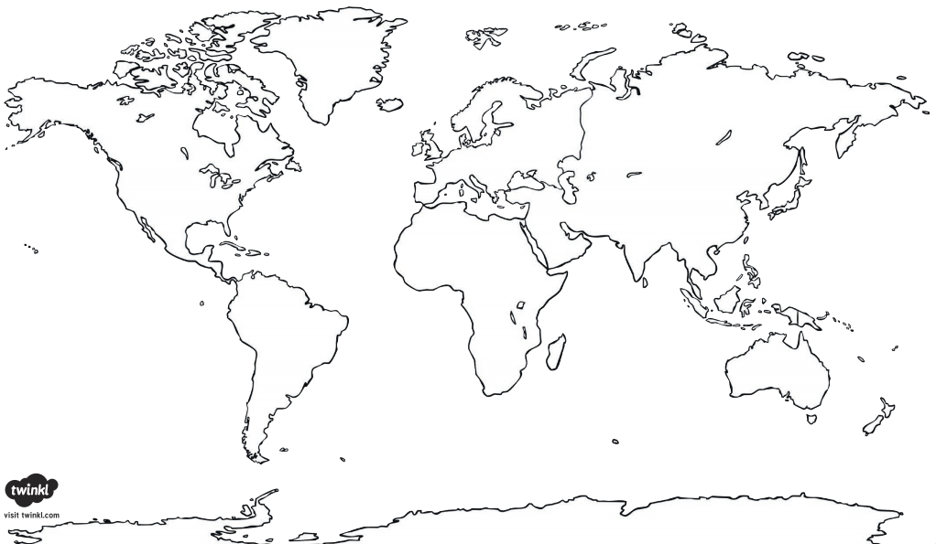

Topic - Task 3:
https://www.youtube.com/watch?v=VarSSAwiimU Watch this video recalling the story of ‘The Great Fire of London’.

Read the question and circle the correct answer.

Where did the fire begin?
What were houses made from?
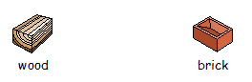
Why did the fire spread?
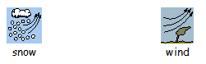

What did the fire burn? 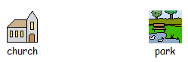
How did people escape?
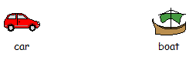

How long did the fire burn for? 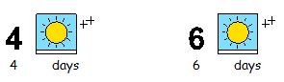
Topic
Task 4: To write a recount about the Great Fire of London
http://www.fireoflondon.org.uk/story/the-fire/ Work through this interactive story of The Great Fire of London. Ask an adult to help you read the facts. Now write up the story of the fire.


