Monday- interpreting data
Starter- Work through one set of questions- green, orange or red.
10% of 168= | 35 % of 1628= | 17 % of 2178
130.5+ 108.3= | 1207 + 210.03= | 1024.51-163.7=
Write out 8 times table | 2+(3x4)–5= | 5+(7+5)x3=
2
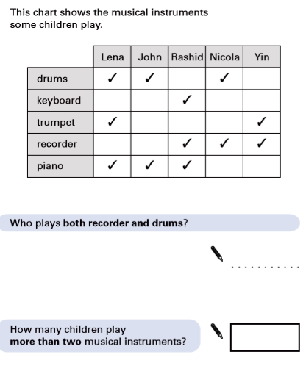
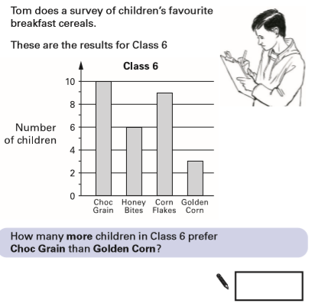
1

3
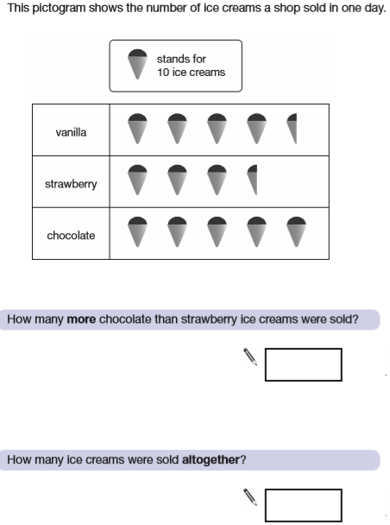

4
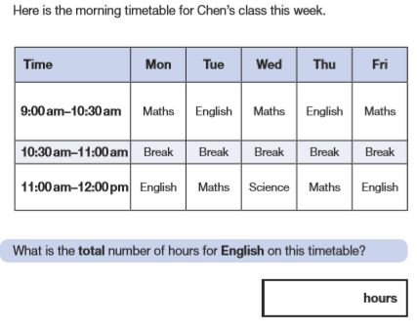
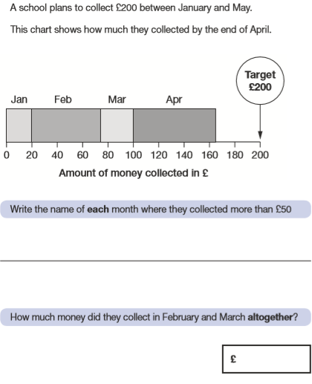
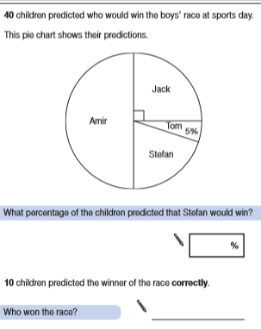
6
5
7
8
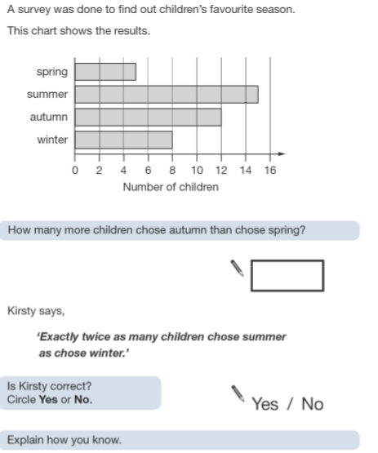
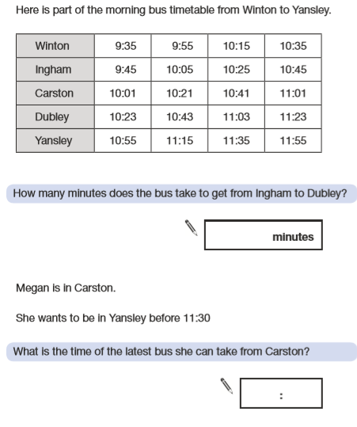
Tuesday- Measure
Starter- Work through one set of questions- green, orange or red.
Write 0.25, 0.50 and 0.75 as a percentage | Write 0.1, 0.25 and 0.75 as a percentage | Write 0.1, 0.2 and 0.45 as a percentage
148 x 100= | 181.45 x 100= | 60.702 x 1000=
Write out 7 times table | 1/2 - 2/7= | 2/6 – 2/9=
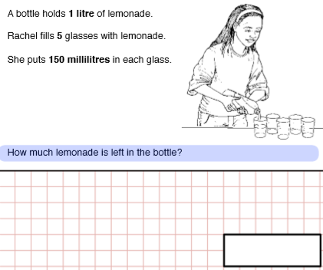
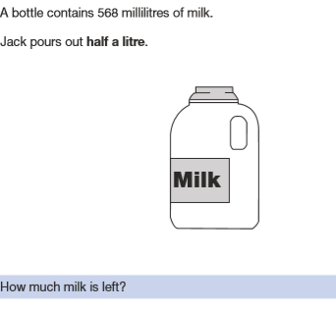
2
1
4
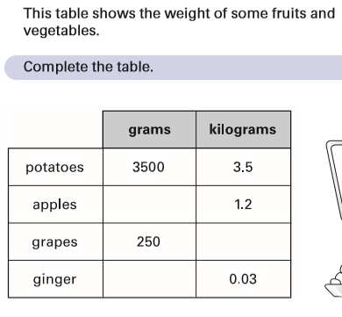
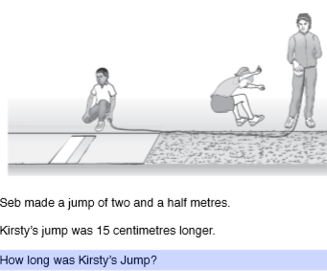
3

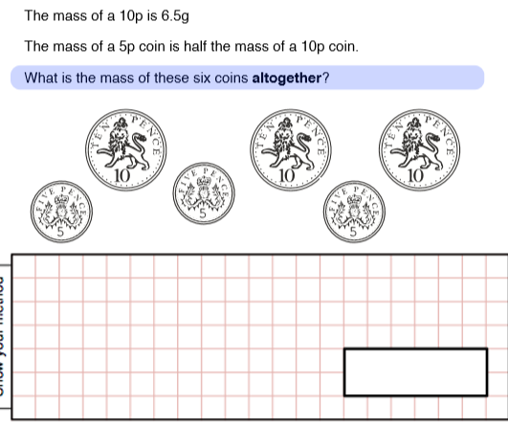
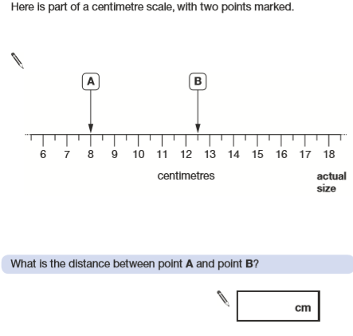
6
5

8
7
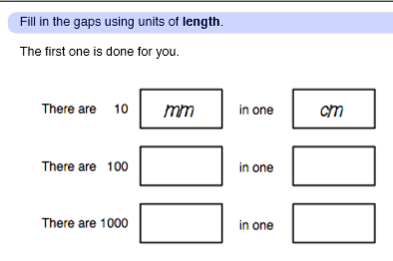
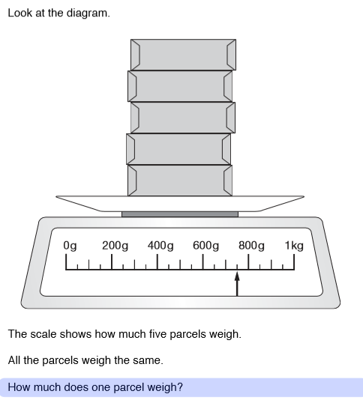

Wednesday- fractions
Starter- Work through one set of questions- green, orange or red.
Write 1/2, 1/4 and 1/10 as a percentage | Write 1/4, 1/5 and 1/10 as a percentage | Write 1/5, 3/5 and 4/10 as a percentage
Find 1/2 of 10, 100 and 1000 | 2/5 of 2745= | 3/7 of 3654=
Write out 6 times table | Round to nearest 10  218  1053 | Round to nearest 10  106.4  1098
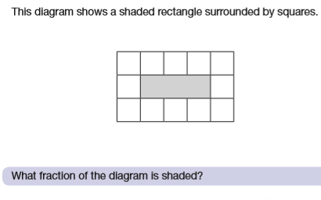
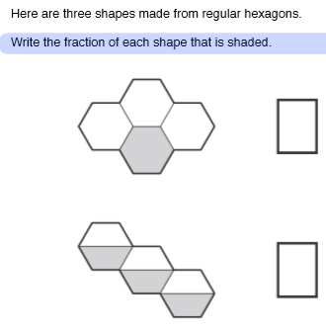
2
1
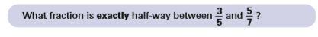
4
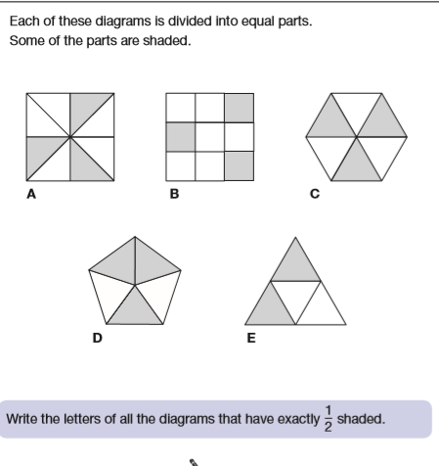
3

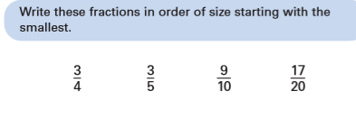
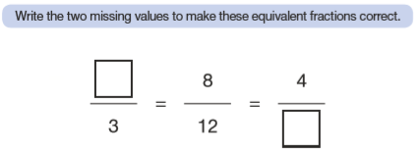
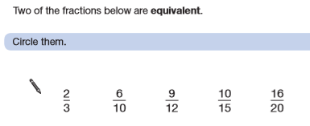
5
6
7

Thursday- fact families
Starter- Work through one set of questions- green, orange or red.
106.4+63.7= | A + B= 21  Write possible value of A and B | 2A + B= 19  Write possible value of A and B
734.2-83.9= | 16% of 1026= | 27% of 1327=
Write out 9 times table | 1824 divided by 8 | 1724 divided by 12

Use your times table knowledge to create your own fact families. Use only one line from a times table and see how many related maths facts you can create. Try to create multiplication and division facts. There are lots to make!

For example:
3x4=12 (one line chosen from 3 times table)
30x 4= 120
30x40= 1200
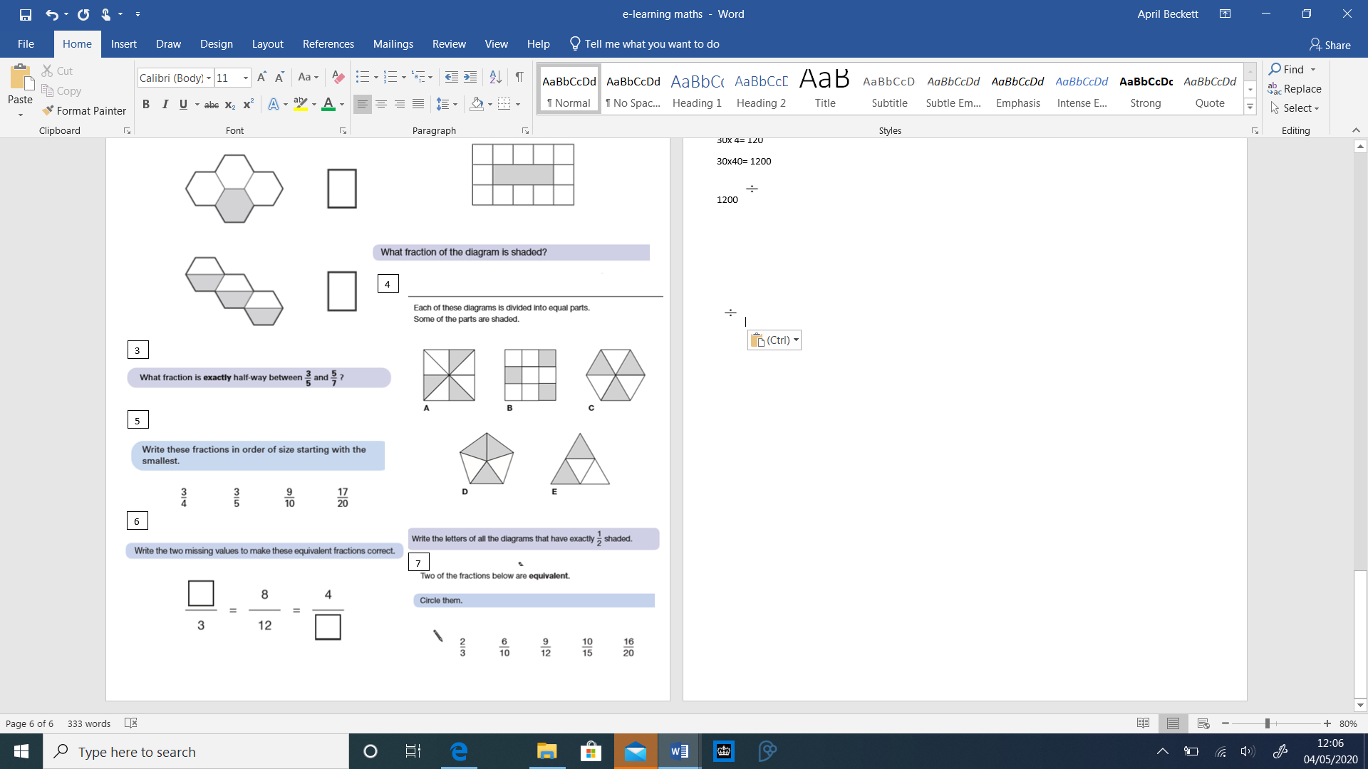
1200 40= 30
120 40= 3
There are lots more facts you can make.

Mrs Taylor’s set- create a fact family for one line of 4 times tables and one for 8 times table.
Mrs Clarke’s set- create a fact family for one line of 6 times tables and one for 9 times table.
Miss Tiffin and Mrs Wilding’s set- create a fact family for one line of 7 times tables and one for 12 times table.

Friday- geometry
Starter- Work through one set of questions- green, orange or red.
365 divided by 5 | £24.86- £5.09= | £21.34 + £17.89 + £1.98=
£4.52 + 97p= | Common multiple of 7 and 8 | Lowest common multiple of 6 and 8
2.18 x 100= | 2/5 + 3/4= | 3/4 x 2=
2
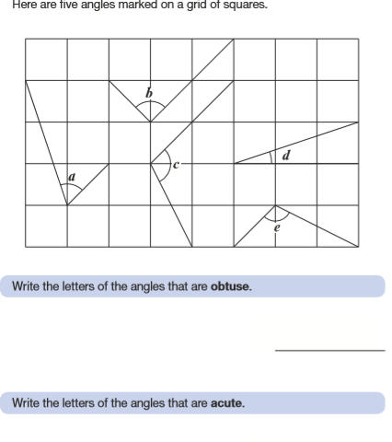
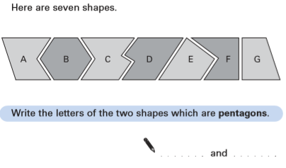
1
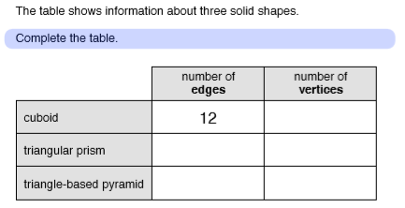
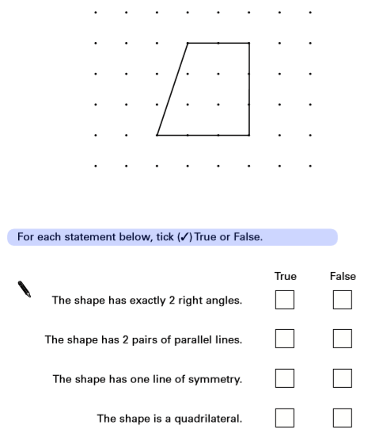
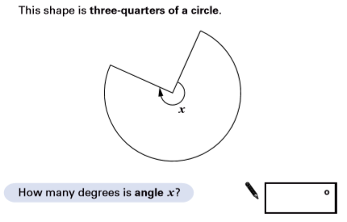
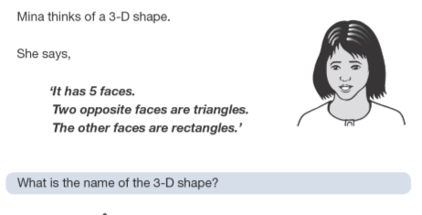
6
5
4
3

