Monday

- 5762 - 3241 =
- (27+9) + (4x8) =
- 95 – (3x9) =
- (12x6) ÷ (30-27) =

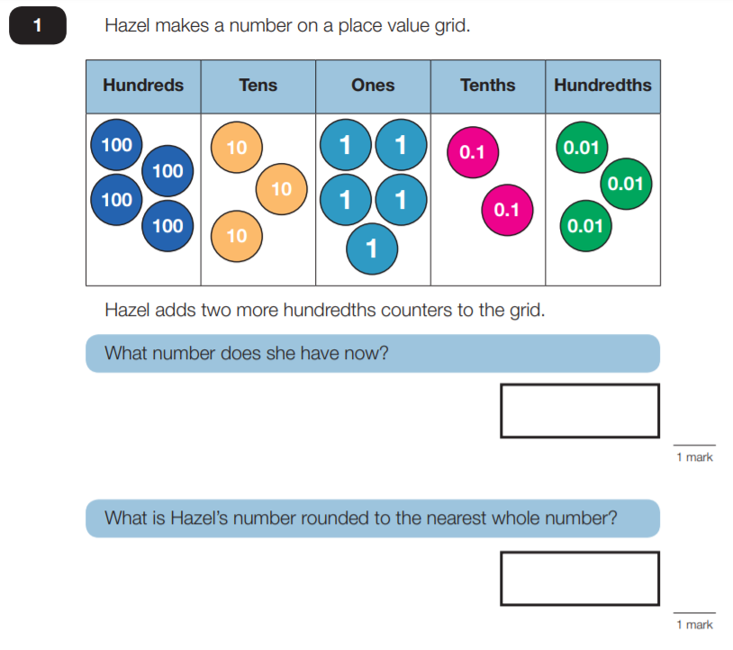
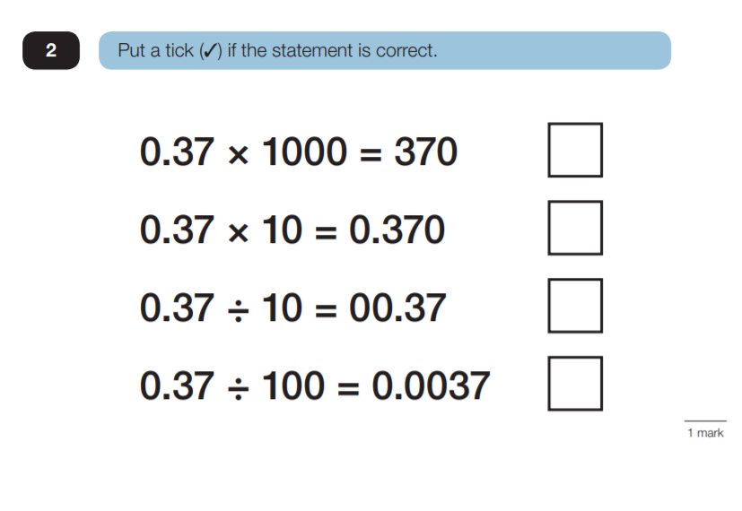
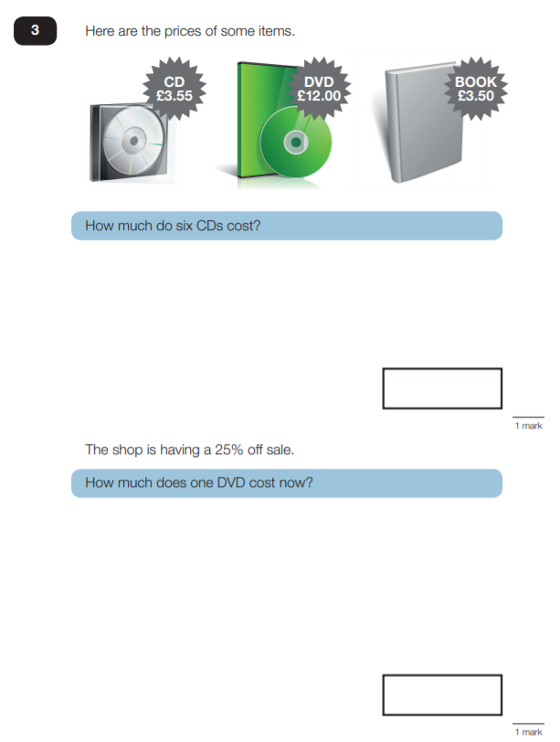

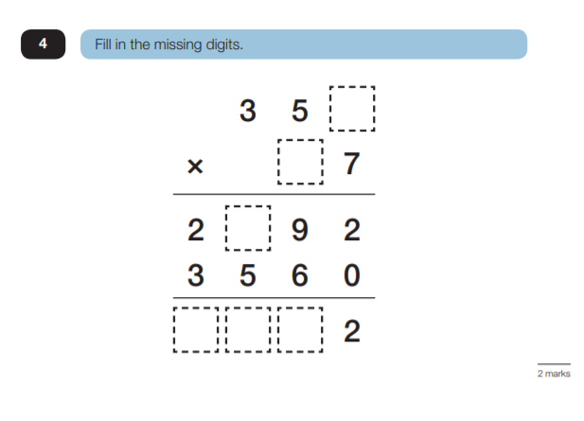
Tuesday

- 85 – (4x7) =
- 3645 + 21.6 =
- 5975 ÷ 7 =
- (31+9) x (14-5) =

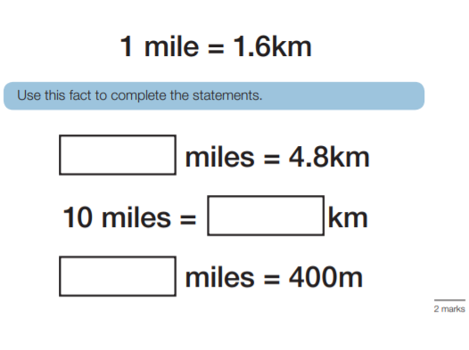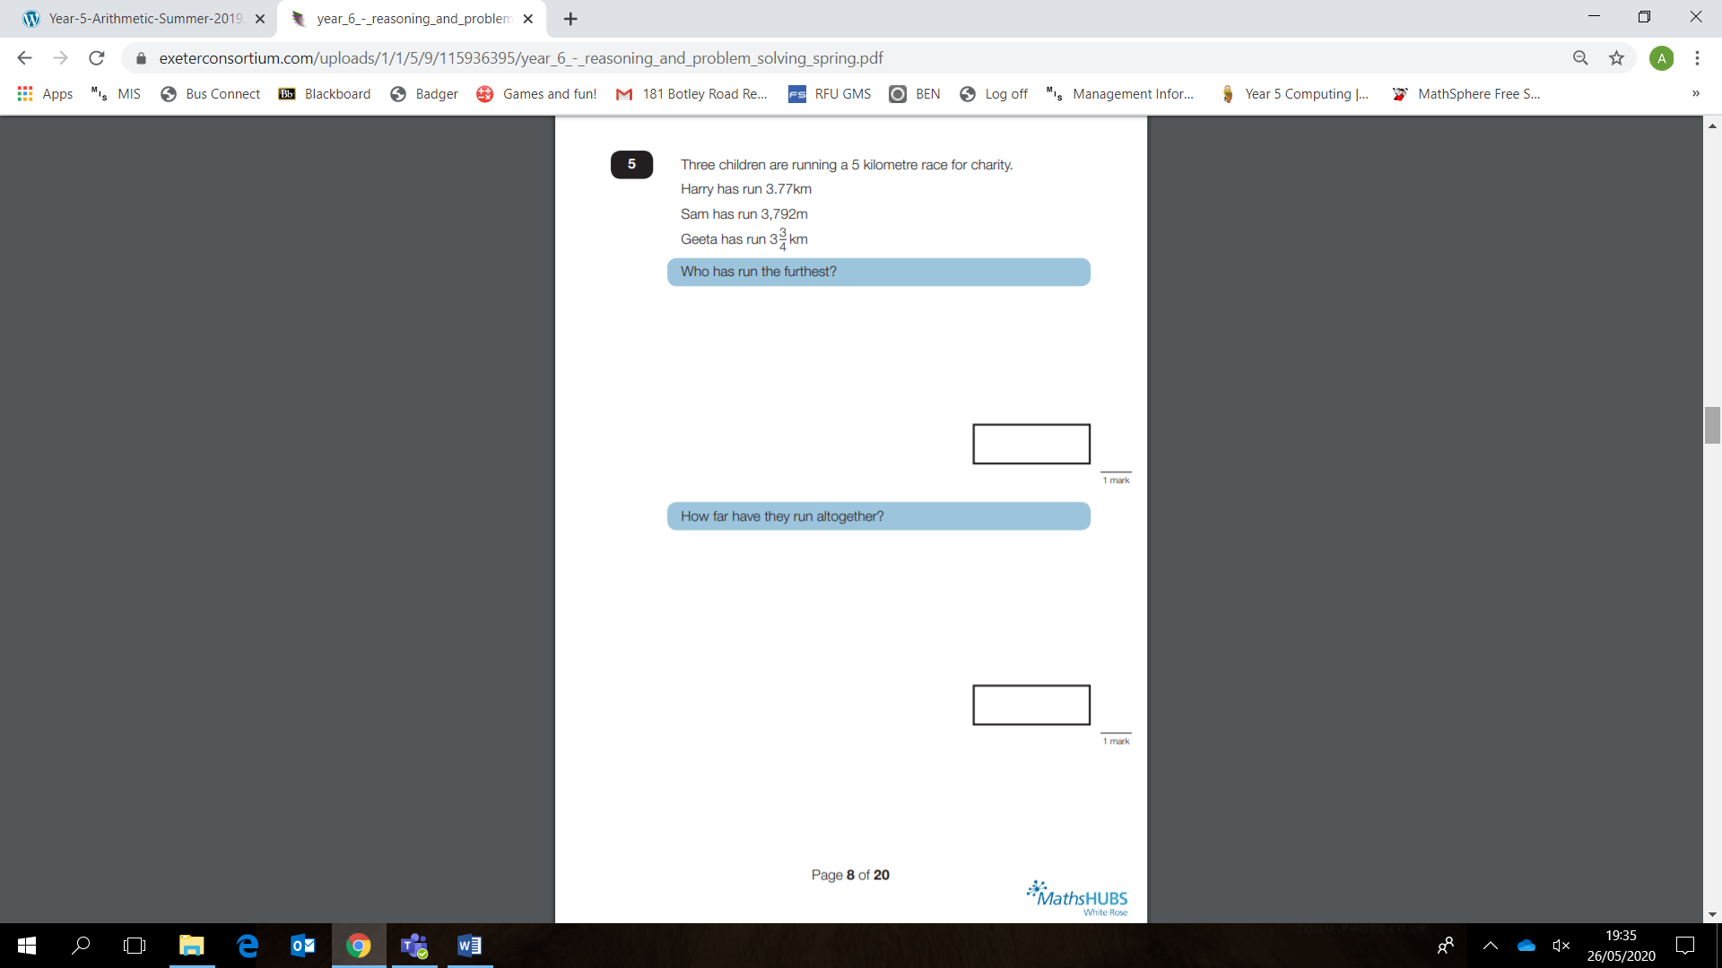
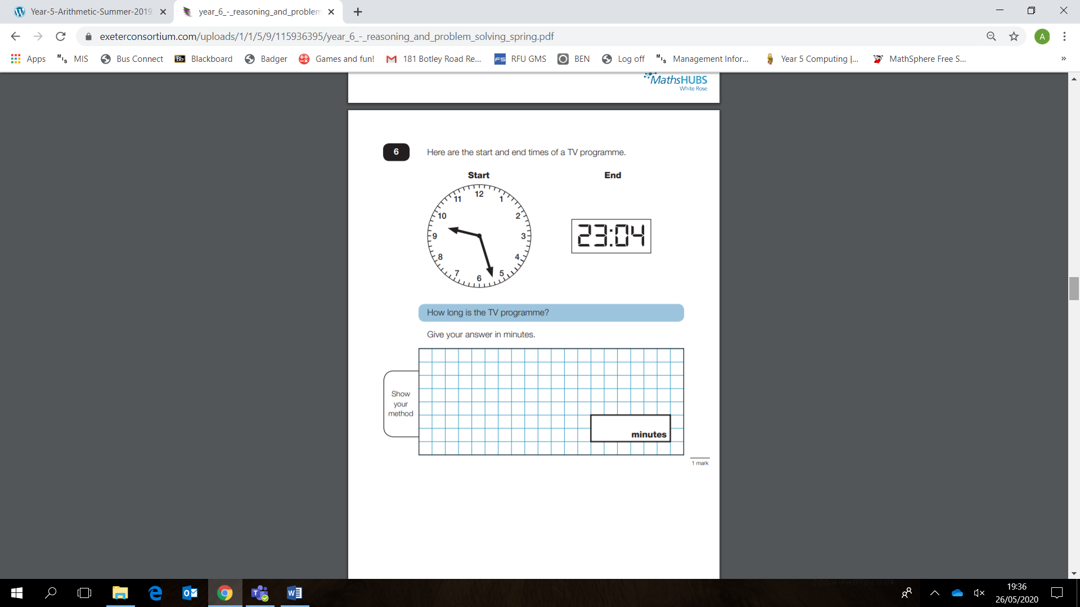
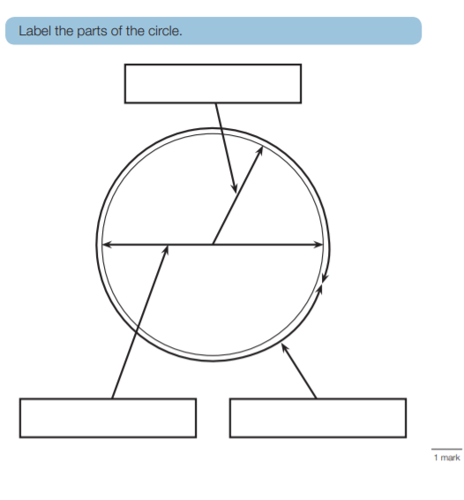
Wednesday

1. (214+318) ÷ (72-68) =
2. 5436 + 86 =
3. 56 – (7x8) =
4. 54 x 100 =

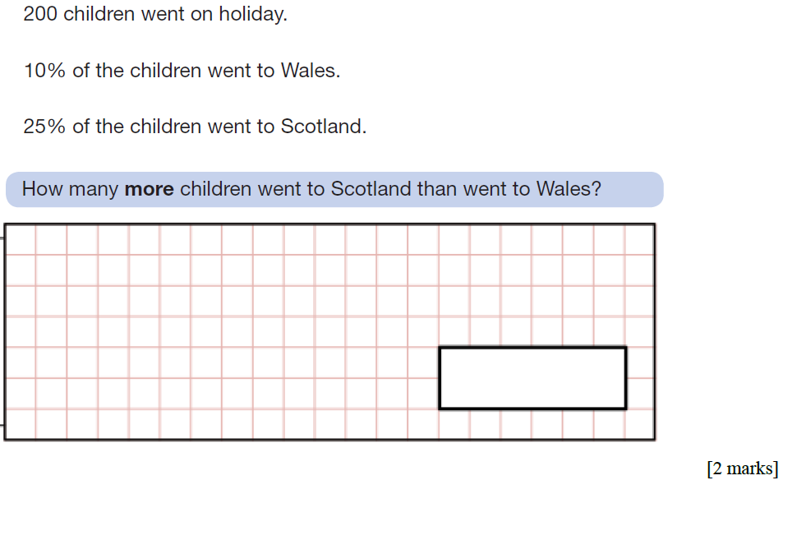
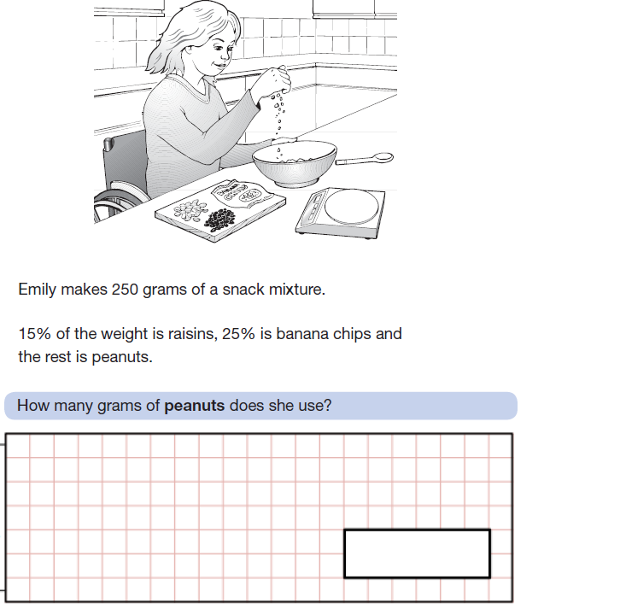

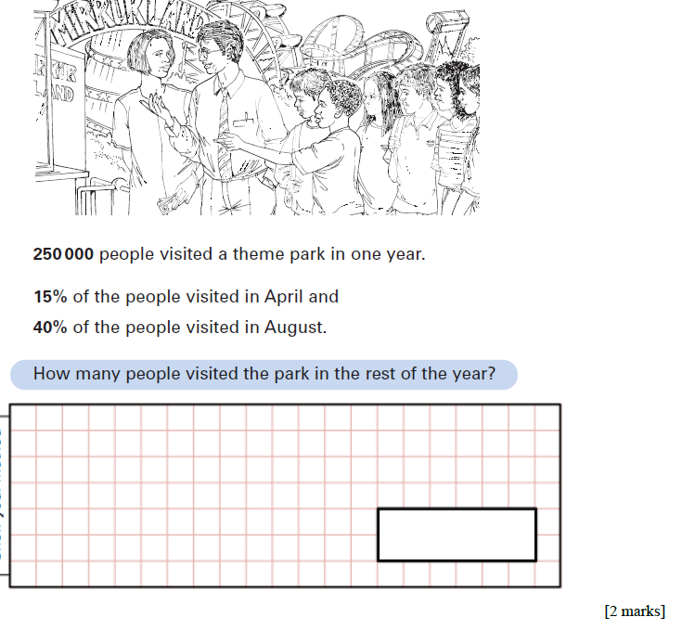

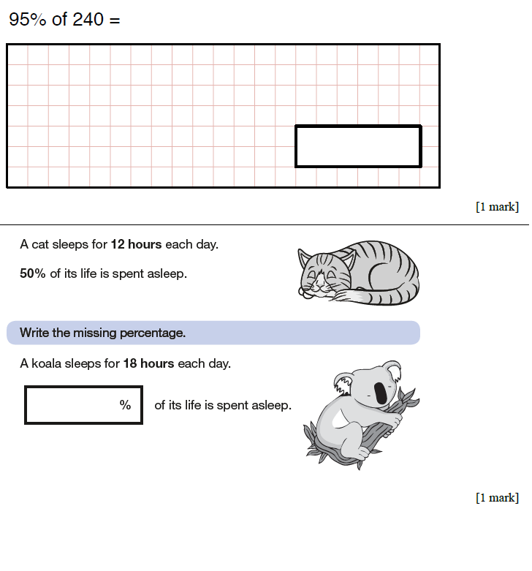

Thursday

TT Rockstars

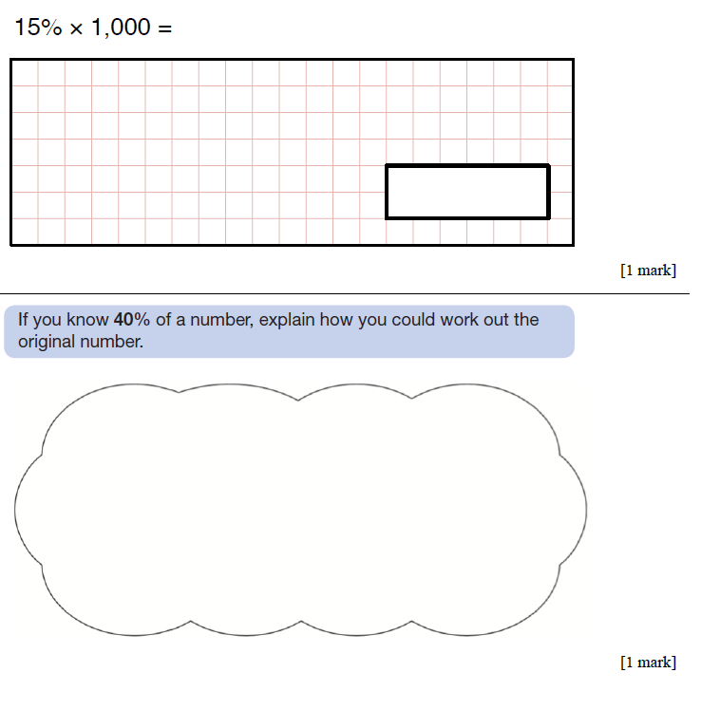

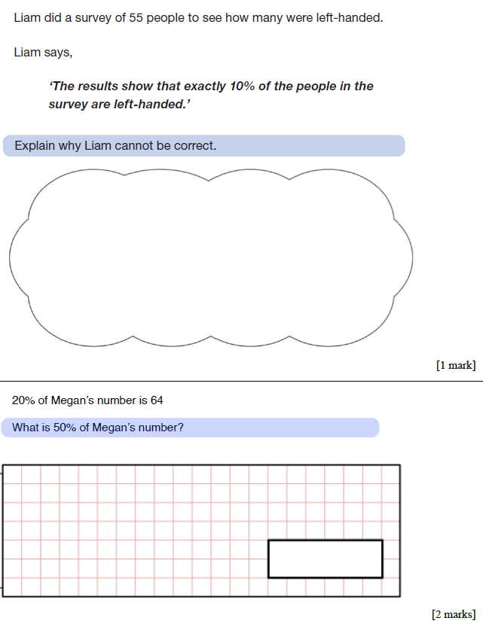

Friday

- 51 x 23=
- (11x9) ÷ (27÷3) =
- 3124 + 67.2 =
- 78 / 10=
- 2.3 x 1000=



