Monday: Planning
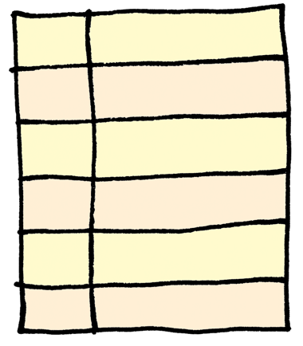
Now we are going to organise our ideas into a box-up planner to help structure your writing. Remember you can pick different topics than appearance, habitat and diet and also you can have your quotation in a different section. I have left the right-hand column blank as you might want to have 2, 3, 4, 5 or 6 different sections so draw your own lines!

Structure of monster information text | Your ideas
Title of monster
Opening hook – to make the reader interested in finding out more.
Fascinating fact for interest
Habitat
Information about the area the creature lives in
Appearance
Information about what the creature looks like including evidence
Diet
Information about what the creature eats
Warnings and advice to the reader

Tuesday: Talk your plan through

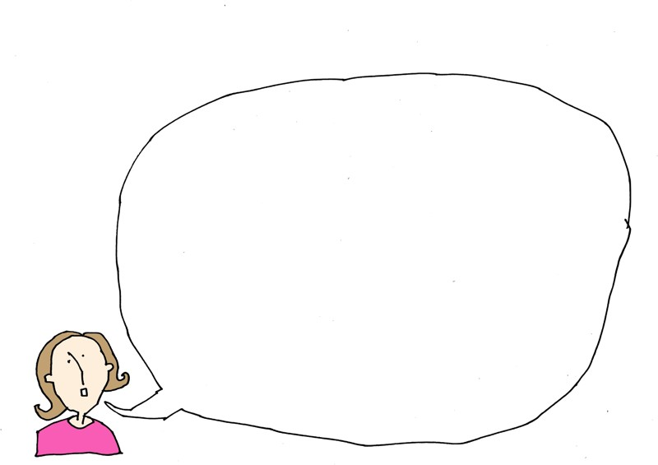
It is really important to have a good read through your plan to make sure that it makes sense. Why not read it aloud to someone in your house and see if they have any suggestions for how to improve it.

Wednesday: It’s time to write your monster report

To help you with your writing, you have lots of different things to help you:

    - The original text about monsters
    - The toolkit for reporting information
    - Your ideas page
    - Your diagram
    - The vocabulary we learned from the model
    - And most importantly, your plan

Draft your ideas on one piece of paper and edit it so you really like the words you have chosen. Read it through again to check spelling and punctuation and then write your final draft.

Thursday: Draw a map of your monster’s land
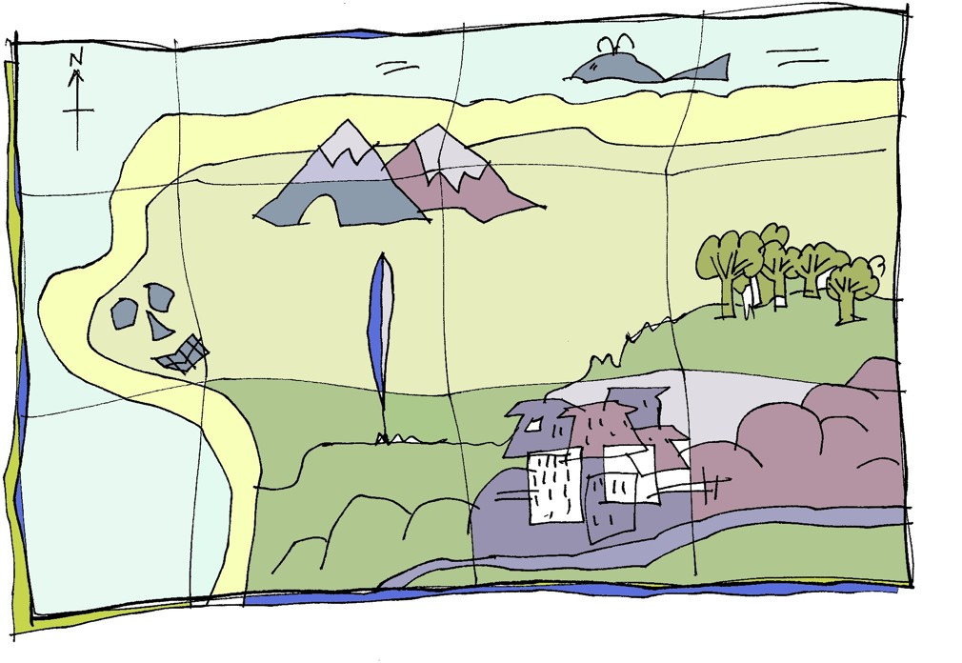
One of my favourite things about reading children’s books is when you find a map right at the beginning of the land in the story. I keep referring to the map as they talk about the different locations and settings in the story. I am sure that you have done the same. I thought it would be a great idea for you to design and draw your own map of where your giant lives.

★ Step 1: draw the outline of your map
★ Step 2: fill in the landmarks: trees, rivers, boulders, mountains, volcano, cities, sea, swamps
★ Step 3: make up names for the different areas of your map
★ Step 4: stain the map to make it look old by using a used (and cool) tea bag to turn the paper brown. You don’t need to get it that wet for it to change colour
★ Step 5: When it is dry, cut or rip the edges of the paper to make it look old and worn. A small hole in the middle of the map can look great
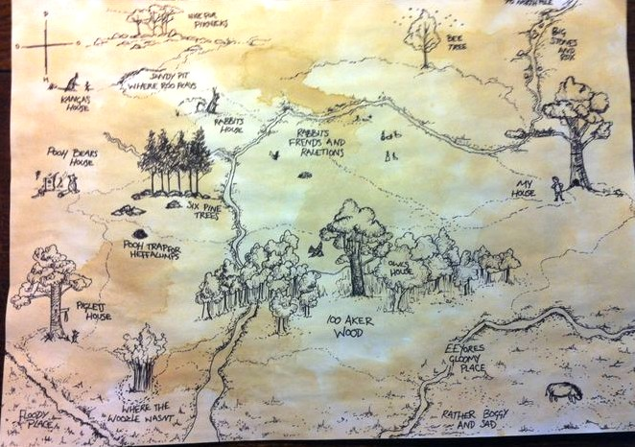

Friday: Giving feedback

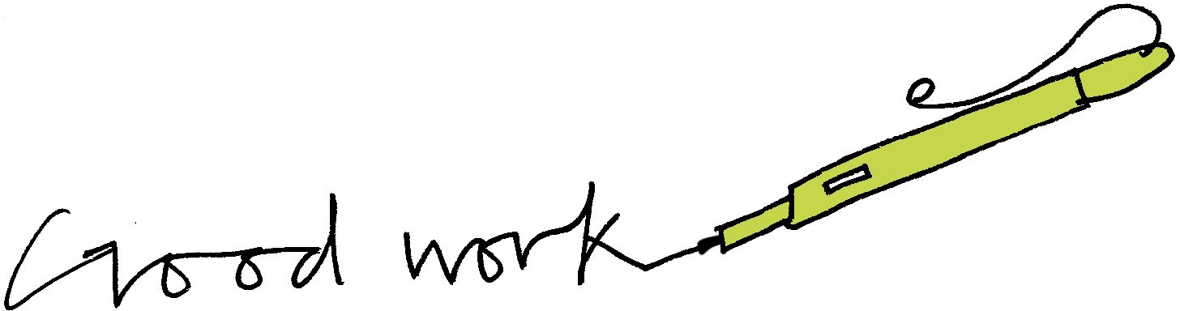
An important part of writing is giving feedback to the writer. Normally, in school, this is probably done by your teacher and sometimes by other children in your class. Read my paragraph of information writing underneath.
Correct up any errors and then leave me some feedback based on the toolkit from earlier in the booklet. Is it formal enough? Is there a topic sentence? Is it interesting? Does it engage the reader?

Diet:

Ogres clubs there pray to death and then feast on the carcasses. Many ogres keep the bones and use them to festoon their caves; skulls being their main bone of choice! Disgusting isn’t it. Their favourite thing to eat are definitely otter or beaver cub’s which they cruelly take from their mothers.

Feedback:

Extension writing choices
★ You are not finished yet! There are lots of different bits of writing you could do if you are enjoying this unit:
★ Write another report about a real animal (lion, great white shark)
★ Write another report about a different beast (vampire, ogre)
★ Write a fact-file for your monster
★ Write a newspaper report about a monster on the loose
★ Write a set of Instructions for How to Trap a Monster
★ Write a discussion text like Should Monsters be Allowed to Live on Earth?

Extension: WANTED Poster
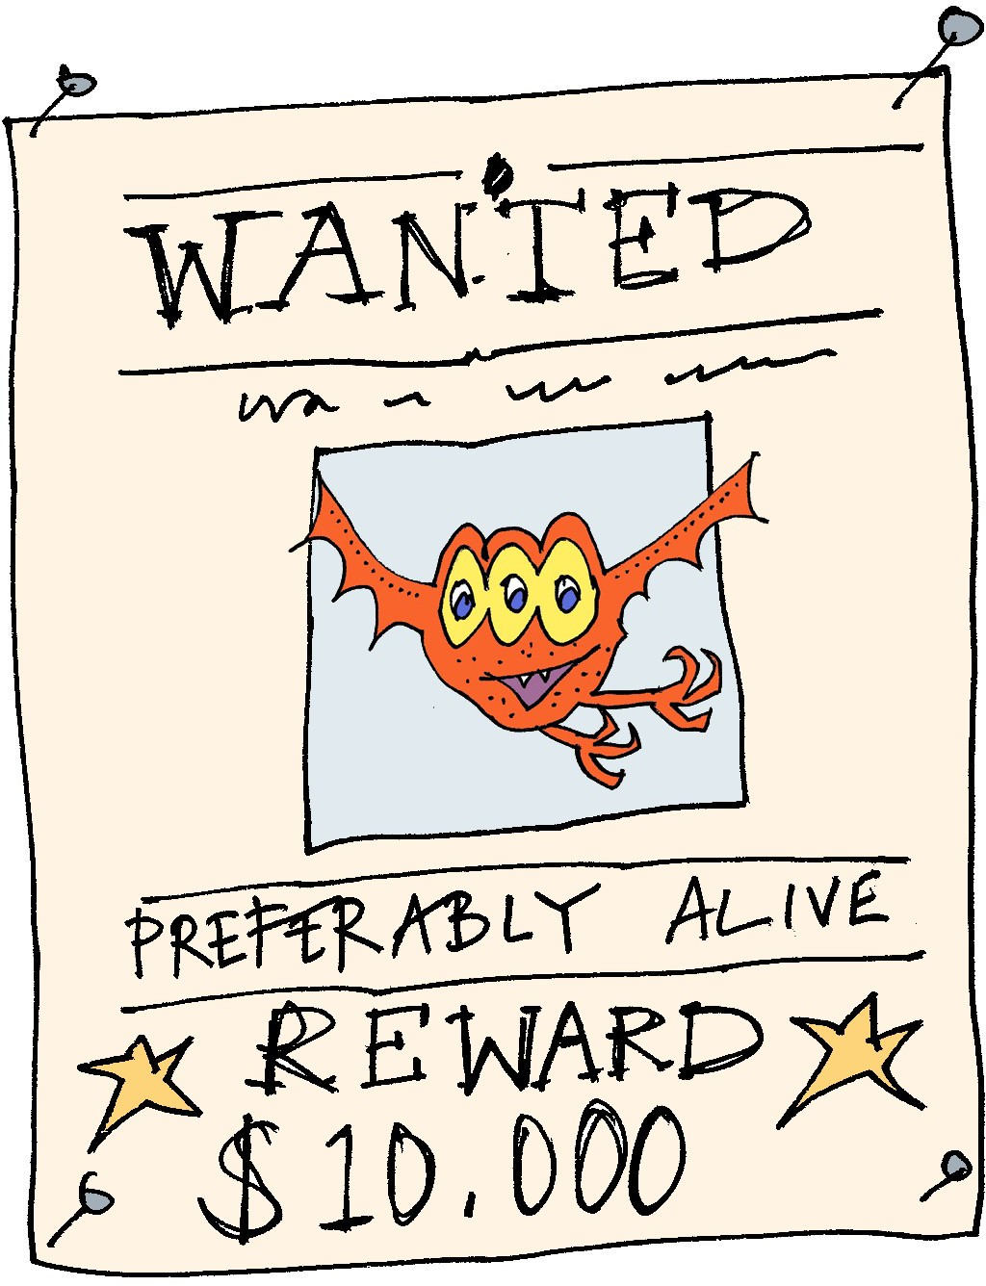
Imagine the monster or beast you have written about is on the loose! Design a WANTED poster calling on the public to help hunt down and capture them before it is too late. You might want to include:
★ A reward
★ Who to contact if they see the monster
★ What the monster has done – why they are dangerous
★ Where they were last spotted

Book recommendations
Below are books that I would recommend for Year 6 that feature a monster or a beast. If you have read some of them, why not do a book review?
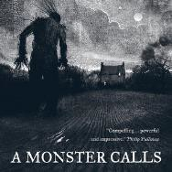  A Monster Calls by Patrick Ness | 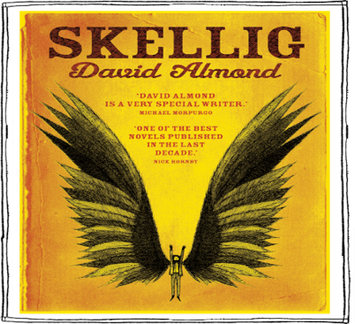  Skellig  by David Almond | 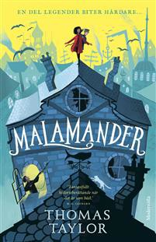  Malamander by Thomas Taylor
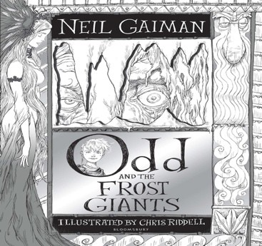  Odd & the Frost Giants by Neil Gaiman | 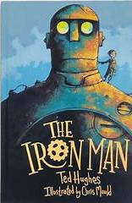  The Iron Man by Ted Hughes | 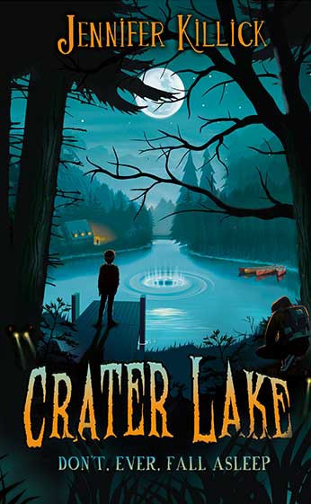  Crater Lake by Jennifer Killick
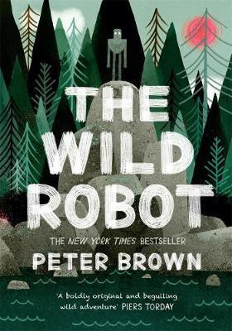  The Wild Robot by Peter Brown | 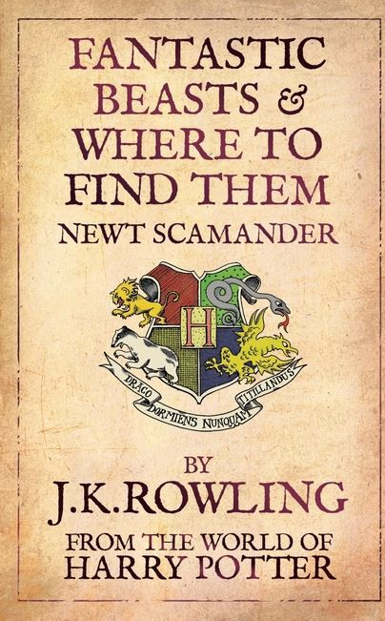  Fantastic Beasts by JK Rowling | 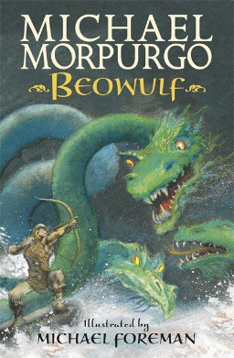  Beowulf  by Michael Morpurgo
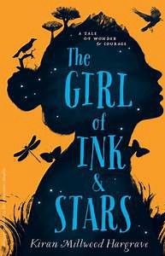  The Girl of Ink and Stars by Kiran Milwood  Hargrave | 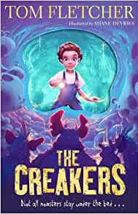  The Creakers by Tom Fletcher | 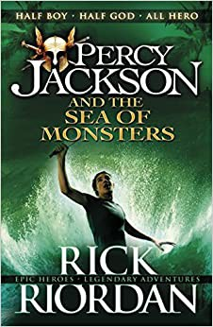  Percy Jackson and the Sea of Monster by Rick Riordan

