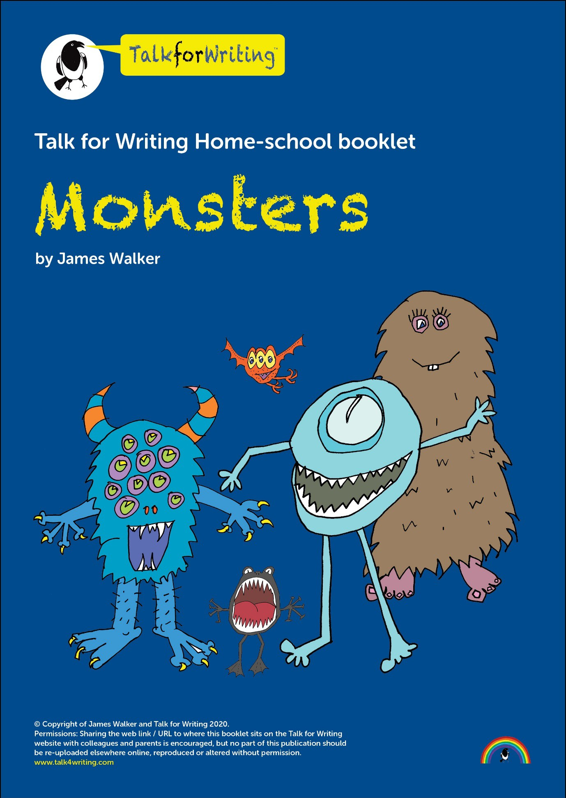


Monsters

A workbook by James Walker

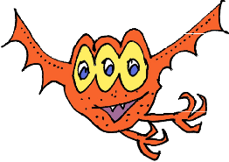
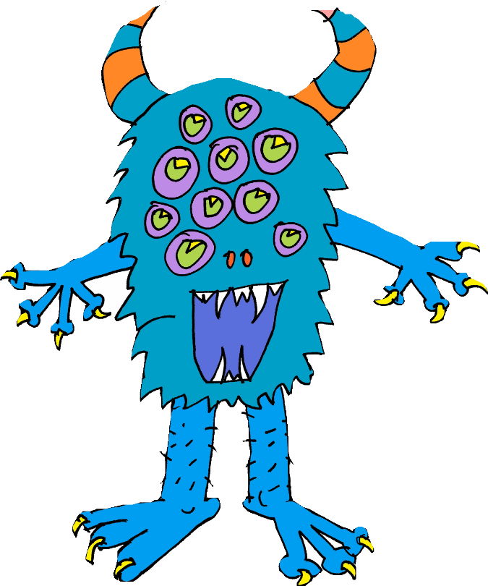

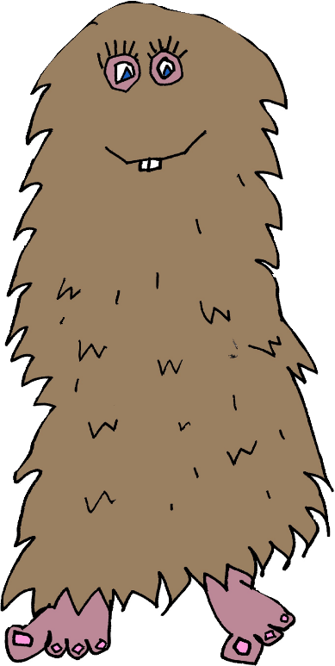



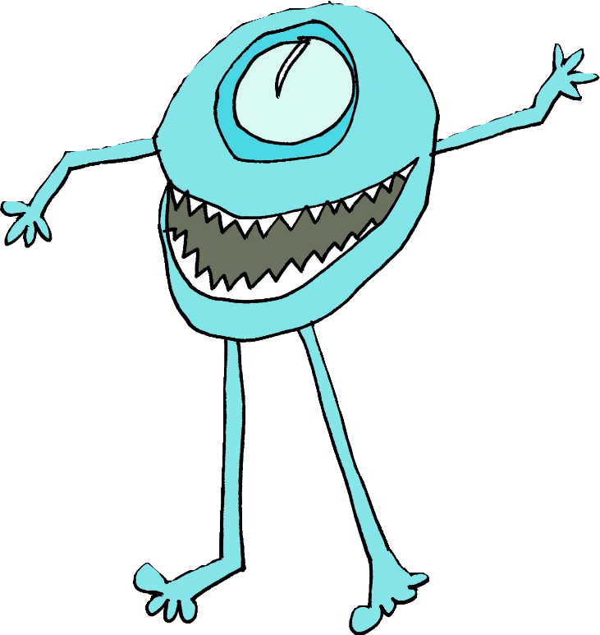
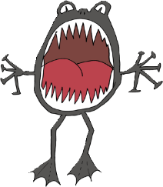



Professor Behemoth’s Monsterology

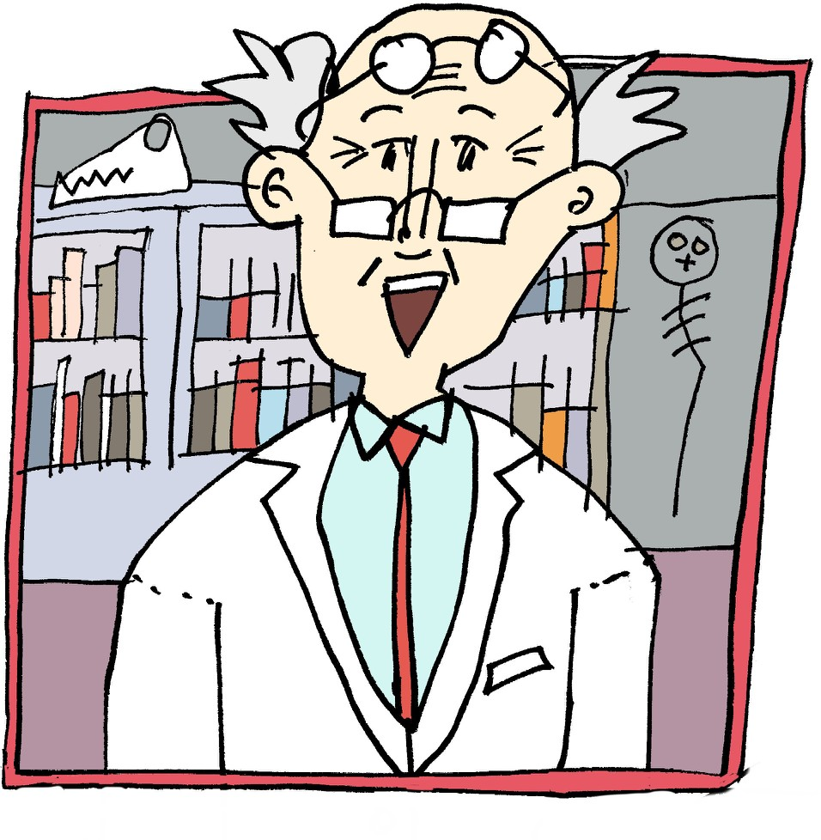
World famous monster expert Professor Behemoth is putting together a Monsterology of different types of monsters and beasts. He has spent years researching all sorts of weird and wonderful monsters and has a wide variety for his encyclopedia. Your job, in this booklet, is to provide the professor with another entry for his book; you’ll have to use your imagination unless you have actually seen a monster!

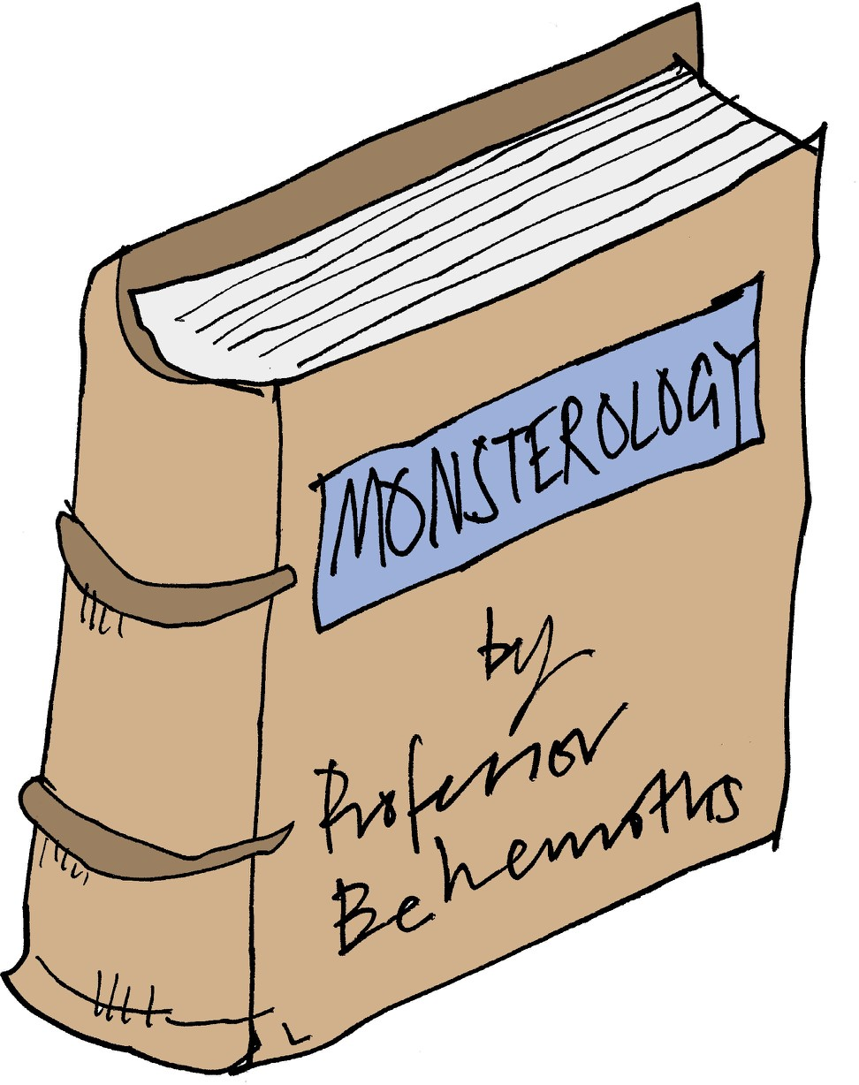
Information with a touch of ‘faction’
In this workbook, we are going to be writing an information text about a made-up monster or beast. Even though this is a non-fiction genre of writing, we can still be inventive and creative. I like calling it FACTION when teaching it (the form fits information about facts but the content is fiction).

To get us started, here is a model of a fictional information text about swamp monsters. As you are listening, you might want to think about which type of monster you will write about. Have a read below and then listen to me read it aloud here: https://soundcloud.com/talkforwriting/swamp/s-28ED2KJCK6n

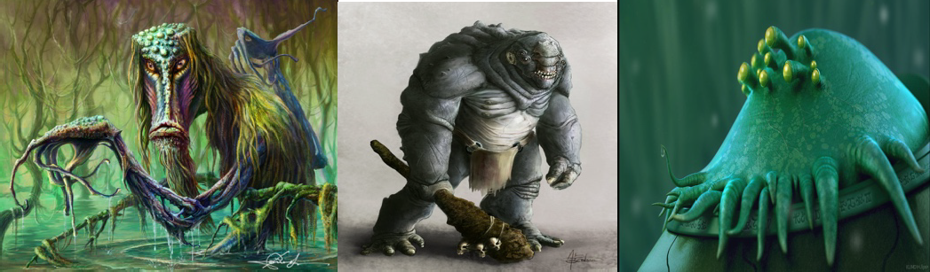
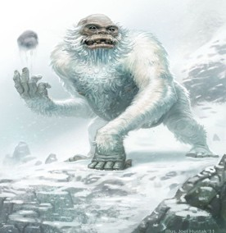

Swamp Monsters
Do you ever wonder what might be lurking in the murky swamps of our world? Rumour has it that the fabled swamp monster is not just a creature mentioned in myth and legend but it actually exists! Now is your chance to find out all that has been discovered about this unique being.
Swamp monsters are rumoured to inhabit the most remote and humid swamps of the Amazon rainforest. Living in total solitude, it is believed that there is, perhaps, only one swamp monster on our planet, making it a mystery how they reproduce. Dr Patrick Thurston
- world renowned monsterologist from Bristol University - could perhaps be the only living person ever to see this magnificent creature: “You cannot believe the pure majesty of the swamp monster. They seem as if they are ‘one with the swamp’ living in pure harmony with their habitat.”
Swamp monsters don’t just live in swamps they resemble them. Being experts in camouflage, they are indistinguishable from their environment. Their bodies are made from this environment: limbs of gnarled branches, incredibly long fingers and glowing, iridescent hair which changes colour to match their mood. The most incredible thing about a swamp monster is that they have translucent breathing tubes meaning they can stay underwater indefinitely but continue to breathe.
Have you ever wondered what a swamp monster eats? Their diet consists of herons, rats and even alligators which they hypnotise with their ever-staring, haunting eyes. Transfixed, any animal is helpless to the swamp monster who squeezes the life from them with its lean, powerful limbs. The swamp monster’s tongue has the ability to taste the air; this allows it to identify when its prey is close by.

If you are now tempted to try and spot a swamp monster, we advise extreme caution! This beautiful but deadly creature should be left in solitude to be studied only by experts trained in monsterology.

Monday: Match the vocabulary to its definition
You might not know all of the vocabulary that is in our model text. Don’t worry as this activity will help! Match the word to the correct definition and then check at the end of the booklet to see if you have them all right.

Word Definition

myth not distinguishable

translucent the state of living alone in seclusion

indistinguishable agreement or harmonious relations

resemble displaying lustrous colours like those of a rainbow

renowned a traditional or legendary story

majesty rugged, bent, twisted or weather-beaten

iridescent to be like or similar to

harmony permitting light to pass through but any objects on the other side are not clearly visible

gnarled to hold motionless with amazement

solitude supreme greatness

transfixed to be celebrated or famous

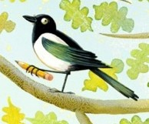
You could magpie some of these words and use them in your own writing later on.

Tuesday: Underlying pattern of information texts Let’s go back to the model text. I have picked out the underlying pattern for you by boxing up the structure for you; this will help guide your writing.
Remember this is just a guide and, if you are confident, you could add in extra paragraphs, different sections, diagrams etc.

Title | Swamp Monsters
Opening hook – to | Do you ever wonder what might be lurking in the murky
make the reader | swamps of our world? Rumour has it that the fabled swamp
interested in finding | monster is not just a creature mentioned in myth and legend
out more. Fascinating | but it actually exists! Now is your chance to find out all that has
fact for interest | been discovered about this unique being.
Habitat | Swamp monsters are rumoured to inhabit the most remote and
Information about the | humid swamps of the Amazon rainforest. Living in total
area the creature lives | solitude, it is believed that there is, perhaps, only one swamp
in | monster on our planet, making it a mystery how they
 | reproduce. Dr Patrick Thurston - world renowned
 | monsterologist from Bristol University - could perhaps be the
 | only living person ever to see this magnificent creature: “You
 | cannot believe the pure majesty of the swamp monster. They
 | seem as if they are ‘one with the swamp’ living in pure harmony
 | with their habitat.”
Appearance | Swamp monsters don’t just live in swamps they resemble them.
Information about | Being experts in camouflage, they are indistinguishable from
what the creature | their environment. Their bodies are made from this
looks like including | environment: limbs of gnarled branches, incredibly long fingers
evidence | and glowing, iridescent hair which changes colour to match
 | their mood. The most incredible thing about a swamp monster
 | is that they have translucent breathing tubes meaning they can
 | stay underwater indefinitely but continue to breathe.
Diet  Information about what the creature eats | Have you ever wondered what a swamp monster eats? Their diet consists of herons, rats and even alligators which they hypnotise with their ever-staring, haunting eyes. Transfixed, any animal is helpless to  the swamp monster who squeezes the life from them with its lean,
 | powerful limbs. The swamp monster’s tongue has the ability to taste
 | the air; this allows it to identify when its prey is close by.
Warnings and advice  to the reader | If you are now tempted to try and spot a swamp monster, we advise extreme caution! This beautiful but deadly creature should be left in solitude to be studied only by experts trained in monsterology.

Let’s look at the toolkit

Before we start thinking about our own ideas for our monster, we need to look closely at the text and see what writing tools/tips/tricks the author has used so we can do the same in ours. Here is a toolkit I have made for writing information texts.

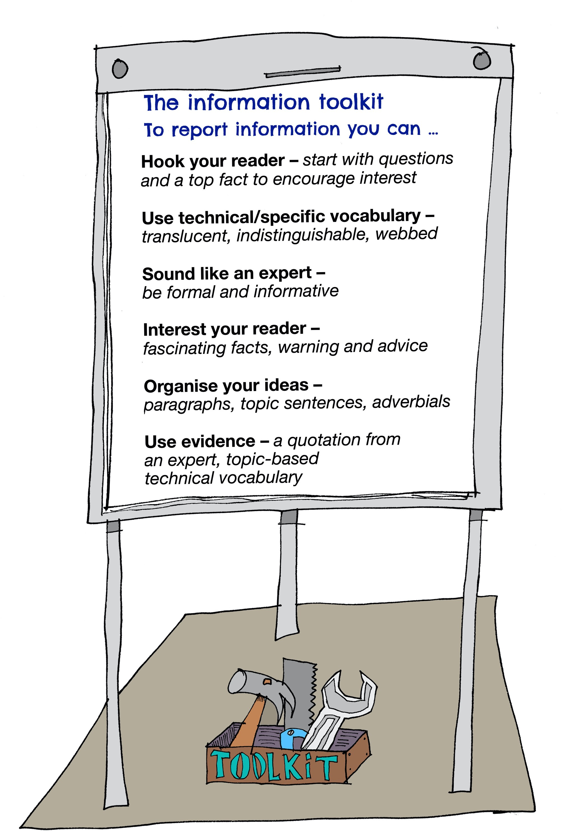

Formality
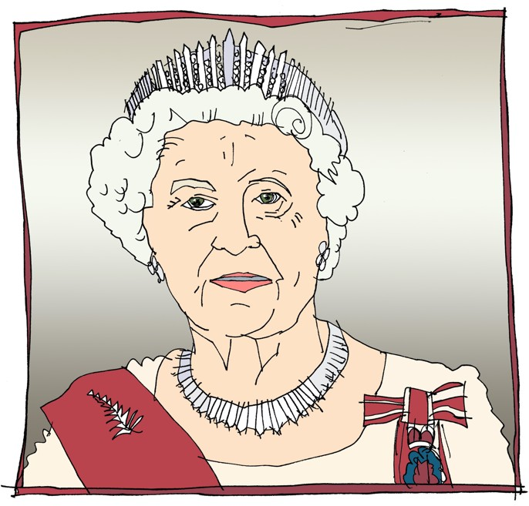
You might have heard your teachers talking about ‘being formal’. The best way to explain it in this type of writing is to: SOUND LIKE AN EXPERT.
Imagine you are David Attenborough narrating a TV show or your writing will feature in a non-fiction book from the library. We don’t need to make our reader laugh, persuade them or in fact give any opinion at all. Our main job is to give information as precisely as possible.
Here are two texts. Spot which is formal and which is informal!
  - Swamp monsters have a proper rancid diet. They love to eat all sorts of weird and unusual stuff like slugs – uuurrrggghhh! Also, they glug down the dirty swamp water by the gallon!
  - It has been discovered that swamp monsters have an unusual diet. In the main, these creatures are known to consume only gastropods. In addition, they have a preference for water from their swamps as it contains essential minerals.
Which one is informal and why? Which one is formal and why?
Now decide whether these are formal or informal sentences?
★ I really want you to come to my party – please come! formal/informal
★ Henry VII didn’t like his wife – he chopped off her head! formal/informal
★ The teacher-pleaser machine is a state-of-the-art contraption. formal/informal
★ Your presence is requested at the Queen’s celebration. formal/informal
★ At 6:00pm on the 24th December Mr Jones was arrested by the police and detained at the local police station.
formal/informal
Re-write each sentence the other way round so the formal ones become informal and the informal ones become formal!

Wednesday: Topic sentences
You might have noticed that the model text does not have sub-headings. Instead, in Year 6, we can use TOPIC SENTENCES. These are like little introductions to the paragraph allowing you to add more detail than you would in a simple heading.

Examples from our model:
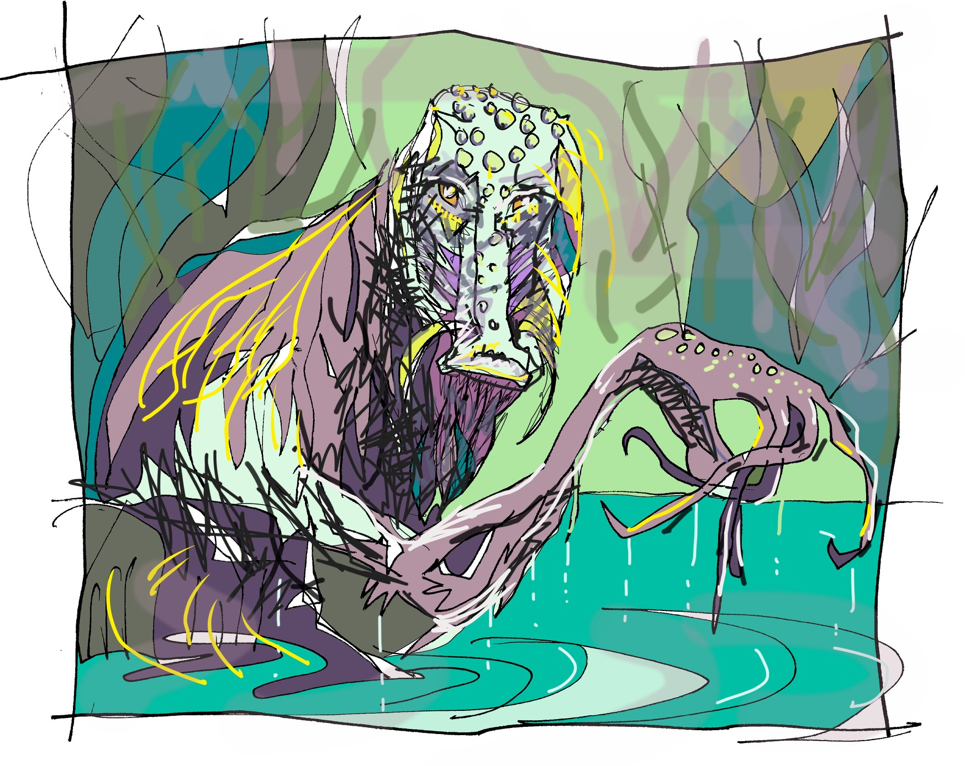
Swamp monsters don’t just live in swamps they resemble them.
This topic sentence introduces our APPEARANCE paragraph

Have you ever wondered what a swamp monster eats? This topic sentence introduces our DIET paragraph and uses another question to interest the reader.

Swamp monsters are rumoured to inhabit the most remote and humid swamps of the Amazon rainforest.
This topic sentence introduces the paragraph which is about DIFFERENT SPECIES and HABITAT.

★ Use these examples to have a go at writing some topic sentences of your own for the topics below

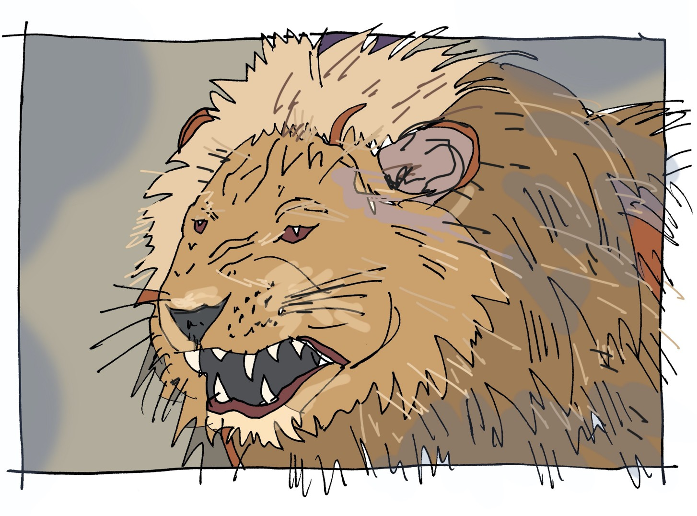
Topic sentences for the appearance, diet and habitat of a lion:

Topic sentences for the habitat, diet, and appearance of a swamp monster:

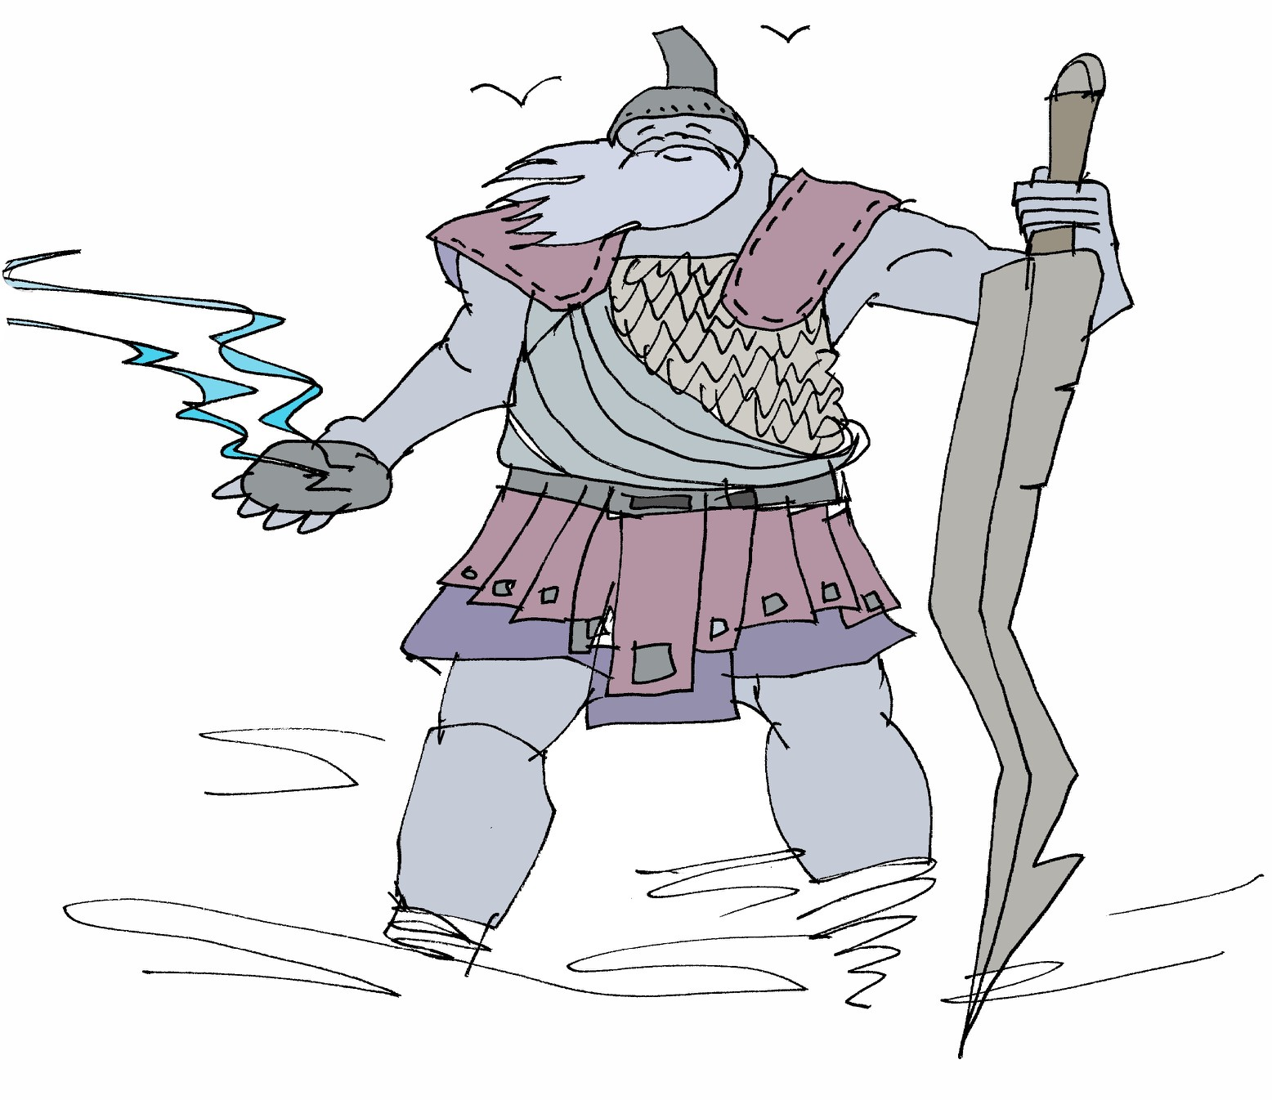
Topic sentences for the appearance, powers, enemies or abilities of a storm giant:

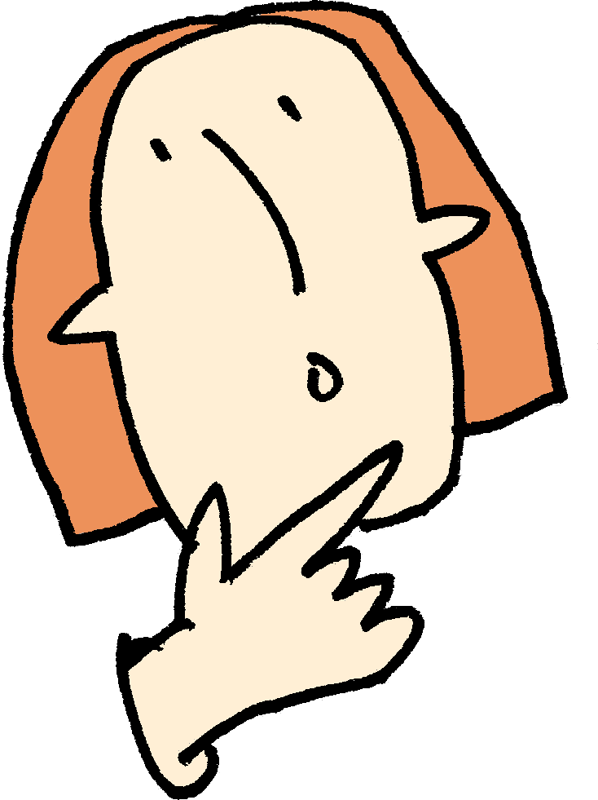
Thursday: New ideas
Now comes the fun part! You need to write an information text about a monster beast for Professor Behemoth’s Monsterology. The choices are endless and I am sure that you already have an idea about what you might do but here are some pictures that might inspire you.

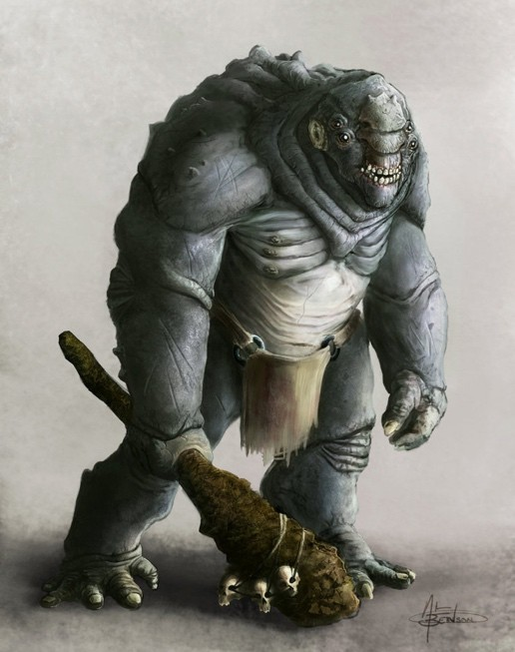
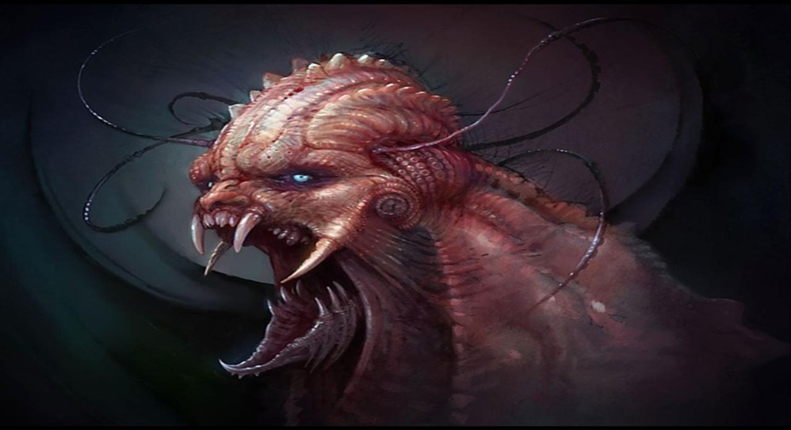
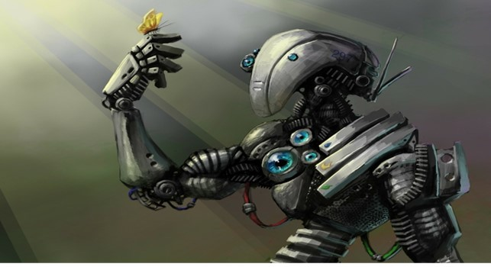

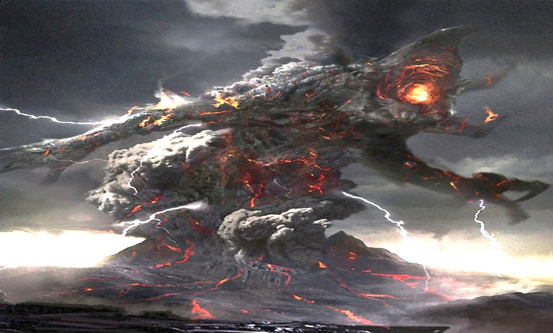
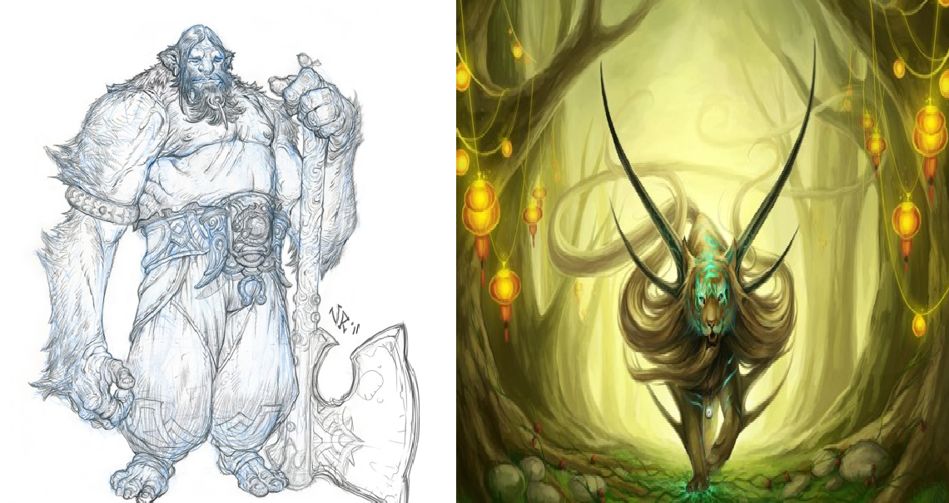

★ Coming up with ideas! I have given you a few ideas for what your different paragraphs could be about below and I am sure that you can think of others. Use the space to get as many ideas down as you can or use separate paper

Appearance | Diet
-  - |  | -  -
-  - |  | -  -
Habitat |  | Abilities
-  -  -  - |  | -  -  -  -
Friends/Enemies |  | Weapons/Powers
-  - |  | -  -
-  - |  | -  -

Quotations from an expert ??????????

- -
- -
- -
- -

Friday: Draw your monster

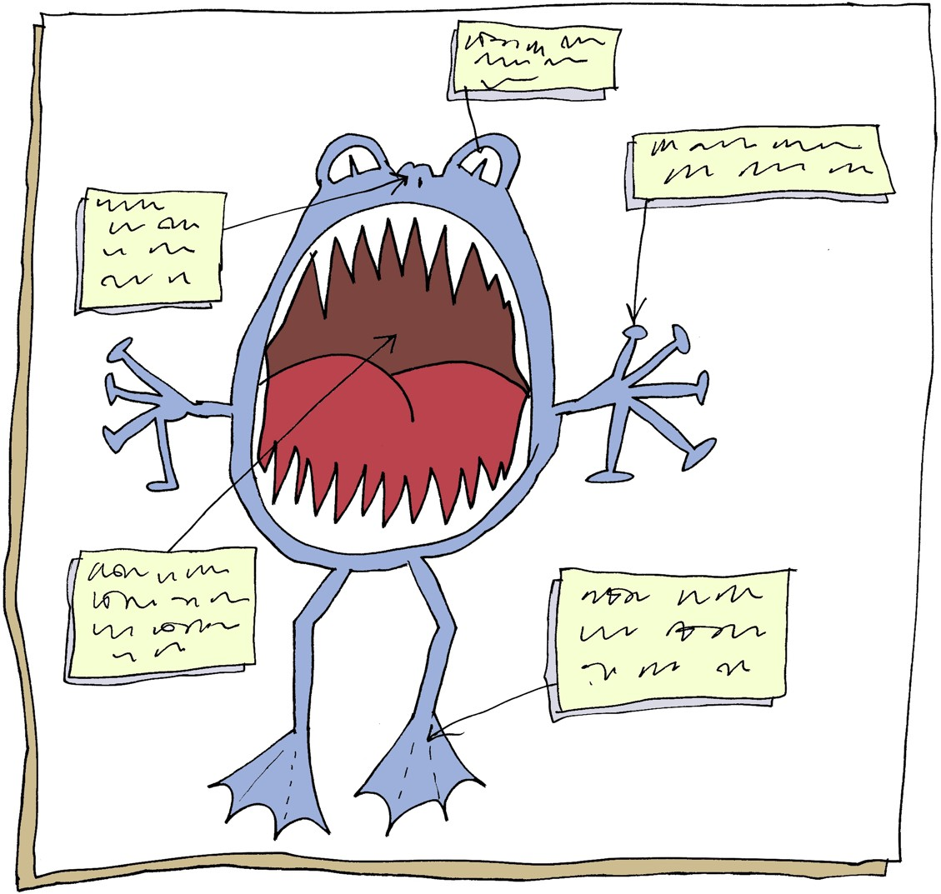

To help you get a real picture of what your monster is like, have a go at sketching them.

